Lesson 1

AN4 Demonstrate an understanding of the multiplication of polynomial expressions (limited to monomials, binomials and trinomials), concretely, pictorially and symbolically.

Recall from grade 9:
To multiply 5(7x) the coefficient of the monomial (7) is multiplied by the constant term (5).
So 5(7x) = 35x
To multiply a binomial or trinomial by a constant we use the distributive property. To use the distributive property each term of the binomial or trinomial must be multiplied by the constant term.

For example to multiply 4(5x-2) multiply each term in the brackets by 4
So 4(5x-2) = 4(5x) – 4(2)
= 20x -8
The same method is used for multiplying a trinomial by a constant
For example : -2(3x²+4x-5)= -2(3x²) + (-2)(4x)-(-2)(5)
= -6x² -8x +10

To multiply a monomial by a binomial or trinomial, we use the distributive property. This is the same method that we used to multiply a binomial or trinomial by a monomial.
For example:
Multiply 5x(-2x +3)
Both terms in the bracket have to be multiplied by the term in front of the bracket.
5x(-2x + 3)= 5x(-2x) + 5x(3)
= -10x² + 15x
The distributive property can also be used to multiply two binomials
EX: (x + 6)(x + 2)
Every term in the first bracket is to be multiplied by the terms in the second bracket.
Break the terms in the first bracket apart and place the terms of the second bracket beside eah term.
(x + 6) ( x +2)

x ( x + 2) + 6( x + 2) Then multiply
x² + 2x + 6x +12 Put like terms ( 2x and 6x ) together
x² + 8x + 12

Another example
(x – 3)(4x +2)
x( 4x + 2) – 3(4x +2)
4x² + 2x – 12x -6 *** Be careful with + and – signs***
4x² – 10x -6

Alternate Method : Rectangle Diagram
Ex: (x + 5) (2x -7)

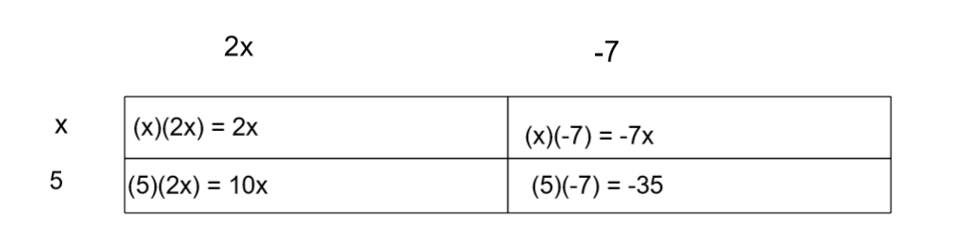

2

2x² -7x + 10x -35 = 2x² + 3x -35

Multiplying a constant and 2 binomials
Ex:
4(2x -3)(x +7)
(8x – 12)(x + 7) multiply the terms in the first bracket by the constant
8x(x +7) -12(x +7) then use the distributive property for 2 binomials
8x² +56x -12x -84 put like terms together
8x² +44x -84

For more examples see p161,169 & 170 of textbook

Practice Questions from textbook p.167 #12 & 13 & p.177 #9 & 10

