Wellness Wheel Activity

During this odd time it is important that we do a self-check on our overall health/wellness.

The goal is to stay balanced, find areas to continue to grow and stay well.

You can complete the questions and then fill in your wheel to get a sense of where you are. Look at the flat spots and try to find an activity that fills the void.

WELLNESS WHEEL ACTIVITY
Directions: Answer the following questions and score at the end of each section. Colour the section of the wheel with the appropriate score.
- Physical I am active for at least 30-60 minutes a day. Yes___ No___
I eat fresh fruits and vegetables, and include fibre in my daily diet. Yes___ No___
I eat breakfast every morning. Yes___ No___
I drink at least 4-6 glasses of water a day. Yes___ No___
I get enough sleep so that I feel rested and alert. Yes___ No___
Number of Yes responses _____ x2 = _____ Number of No responses _____ x0 = _____ Total _______

2. Social I get along well with my family. Yes___ No___
I develop and maintain strong friendships. Yes___ No___
I help others in need. Yes___ No___
I have friends who support a positive lifestyle. Yes___ No___
My behaviour reflects a positive attitude. Yes___ No___
Number of Yes responses _____ x2 = _____ Number of No responses _____ x0 = _____ Total _______

3. Emotional I have a good sense of humour. Yes___ No___
My sleep is restful, I receive adequate sleep. Yes___ No___
I am able to express my feelings appropriately. Yes___ No___
I relax my body and mind without using drugs. Yes___ No___
I feel positive about myself. Yes___ No___ Number of Yes responses _____ x2 = _____ Number of No responses _____ x0 = _____ Total _______

4. Intellectual I am interested in learning new concepts and skills. Yes___ No___
I listen to radio, watch TV, read a newspaper to be aware Yes___ No___ of current events.
I read 6 or more books a year. Yes___ No___
I am interested in understanding the views of others. Yes___ No___
I understand that I will be a lifelong learner. Yes___ No___ Number of Yes responses _____ x2 = _____ Number of No responses _____ x0 = _____ Total _______

- Spiritual I spend time thinking, wondering or writing about my life and its Yes___ No___ meaning (prayer, meditation, journal writing).
I am part of something greater than myself. I realize that my actions Yes___ No___ affect those around me as well as myself.
My beliefs demonstrate a respect for myself as well as others. Yes___ No___
I enjoy being outside and experiencing the wonders of nature Yes___ No___ (solitude, energy level, appealing to the senses).
I am optimistic. Yes___ No___
Number of Yes responses _____ x2 = _____ Number of No responses _____ x0 = _____ Total _______

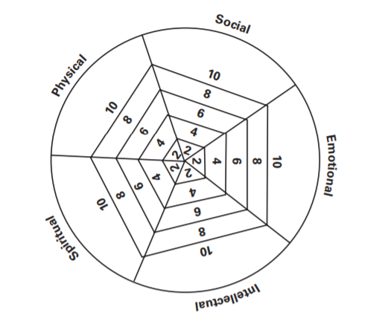

Identify two areas that are not where they should be or you feel that you need to improve. Implement two changes that will help with these areas of your wellness.

