Applicable to OSHA 10-Hour Card
Subpart I: PPE, Subpart D: Walking and Working Surfaces, Subpart Z: Hazard Communication, Subpart Z: Introduction to Industrial Hygiene, Bloodborne Pathogen, and/or Ergonomics

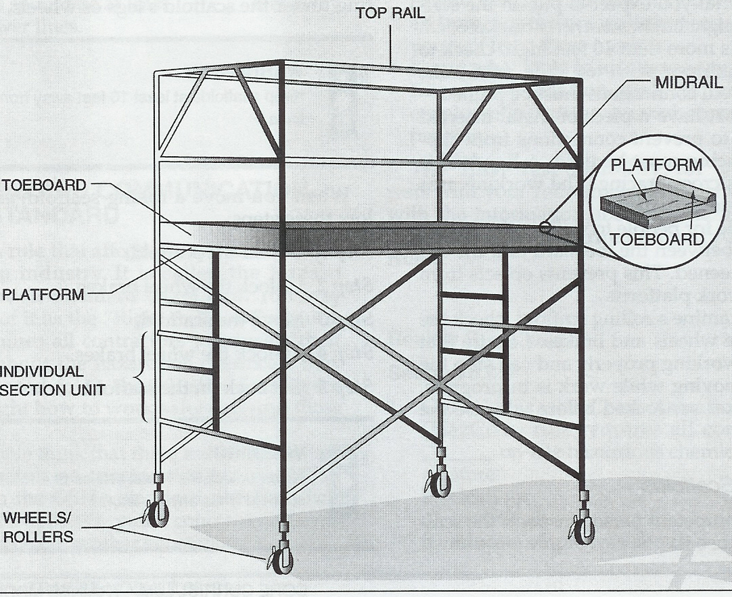
Typical Steel Staging

This manual is intended to be used as an introductory safety guide only. Instructor should add additional training as needed.

STUDY GUIDE  STEEL STAGING SAFETY |  |  | Page 1  Name:______________________________  Class Or Period______________________  Date Of Instruction: ____________________
_______ | 1. | Proper PPE must be used. Safety glasses and substantial footwear are required.
_______ | 2. | Study the operation, maintenance, or safety manuals for the machine, equipment, and tools to be used.
_______ | 3. | Never operate machines, equipment, or tools without instructor’s permission.
_______ | 4. | Secure/remove all loose clothing.
_______ | 5. | Remove all jewelry.
_______ | 6. | Only a competent person has the authority to supervise setting up, moving, and taking down scaffolding.
_______ | 7. | Only a competent person can give the go-ahead for using scaffolding on the job site after an inspection.
_______ | 8. | The three types of tags on scaffolding are green, red, and yellow. Green indicates it is safe to use.
_______ | 9. | You may use yellow-tagged scaffolding if you wear a safety harness attached to a lanyard. There may be other necessary safety procedures as well.
_______ | 10. | It is important to inspect every part of a scaffold closely before each use.
_______ | 11. | Never use a red-tagged scaffold as it is not complete.
_______ | 12. | Do not rely upon tags alone, always personally inspect the scaffold before using it.
_______ | 13. | Check for loose joints or bent, broken, or badly rusted tubes. These problems must be corrected before the scaffold can be used.
_______ | 14. | There should be firm ground under each leg of a scaffold before you put weight upon it.
_______ | 15. | Keep scaffolds at least ten feet away from all power lines.
_______ | 16. | Never unlock the wheel brakes of a rolling scaffold while anyone is on it.
_______ | 17. | If it is possible for people to walk underneath a scaffold, the space between the toeboard and the top rail must be screened. This prevents objects from falling off the work platform.

STUDY GUIDE  STEEL STAGING SAFETY |  |  | Page 2  Name:___________________________
_______ | 18. | Scaffold weight limits must never be exceeded.
_______ | 19. | On a rolling scaffold check the brakes and wheels before using, and always make sure the wheels are locked.

TEST  STEEL STAGING SAFETY |  | Page 1  Name:__________________________________  Class Or Period:__________________________  Date:________________ Score:_____________
_______1. | Proper PPE must be used. Safety glasses and _____ are required. |  |  | Select the correct word that completes each sentence. Then write the corresponding letter on the line preceding the sentence.
_______2. | Study the operation, maintenance, and safety _____ for the machine, equipment, and tools to be used. |  |  | A. use  B. green  C. ten feet  D. manuals  E. unlock  F. substantial footwear  G. exceeded  H. inspect  I. authority  J. broken  K. yellow-tagging  L. wheels  M. competent  N. permission  O. weight  P. red-tagged  Q. screened  R. remove  S. loose
_______3. | Never operate machines, equipment, or tools without instructor’s _____.
_______4. | Secure/remove all _____ clothing.
_______5. | ______ all jewelry.
_______6. | Only a competent person has the ______ to supervise setting up, moving, and taking down scaffolding.
_______7. | Only a _____ person can give the go-ahead for using scaffolding on the job site after an inspection.
_______8. | The three types of tags on scaffolding are green, red, and yellow. ____ indicates it is safe to use.
_______9. | You may use ____ scaffolding if you wear a safety harness attached to a lanyard.
_______10. | It is important to inspect every part of a scaffold closely before each ____.
_______11. | Never use a ____ scaffold as it is not complete.
_______12. | Do not rely upon tags alone, always personally _____ the scaffold before using it.
_______13. | Check for loose joints or bent, ____, or badly rusted tubes.
_______14. | There should be firm ground under each leg of a scaffold before you put ____ upon it.
_______15. | Keep scaffolds at least ____ away from all power lines.

TEST  STEEL STAGING SAFETY |  | Page 2  Name:___________________________
_______16. | Never _____ the wheel brakes of a rolling scaffold while anyone is on it.
_______17. | If it is possible for people to walk underneath a scaffold, the space between the toe board and the top rail must be _____.
_______18. | Scaffold weight limits must never be _____.
_______19. | On a rolling scaffold check the brakes and _____ before using, and always make sure the wheels are locked.

ANSWER KEY
STEEL STAGING SAFETY

Statement  Number | Correct Letter and Words | Statement  Number |  | Correct Letter and Words
1 | F substantial footwear | 11 |  | P red-tagged
2 | D manuals | 12 |  | H inspect
3 | N permission | 13 |  | J broken
4 | S loose | 14 |  | O weight
5 | R remove | 15 |  | C ten feet
6 | I authority | 16 |  | E unlock
7 | M competent | 17 |  | Q screened
8 | B green | 18 |  | G exceeded
9 | K yellow-tagged | 19 |  | L wheels
10 | A use

