STEM: Density Experiments
Week of Nov 1st - Online Learning
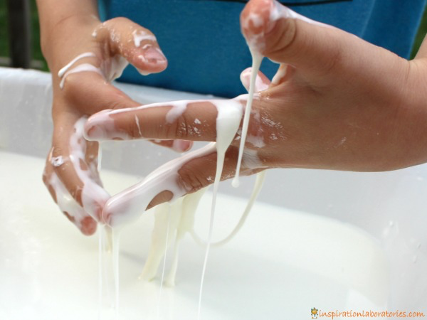
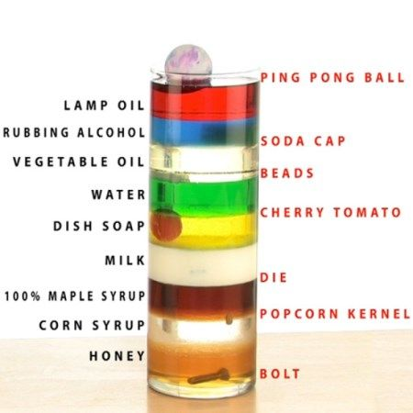

Follow-Up Assignment
Question 1: You just completed a science experiment with different liquids and products. In this short assignment your goal is to reflect on concepts such as density and mass by answering a few questions.

Outrageous Ooze: would you classify this substance as a liquid or a solid? (think about it;s properties). (2-3 sentences

Floating Stick Man: explain why the ink from the dry-erase marker floated instead of dissolved? (2-3 sentences

Seven-Layer Liquid Experiment: explain why the different liquids in our experiment did not mix (2-3 sentences)
Using the information below to help answer the review questions.
Use the following information to help with the quiz:
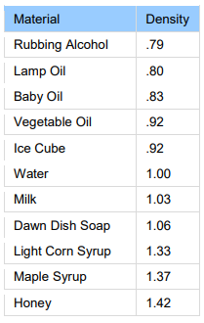
Density: Density is a measurement that compares the amount of matter an object has to its volume. An object with much matter in a certain volume has high density. An object with little matter in the same amount of volume has a low density. Density is found by dividing the mass of an object by its volume.

Matter: Matter is everything around you. Atoms and compounds are all very small parts that make up matter. Matter is defined as anything that has mass and takes up space (it has volume).

Volume: Volume refers to the amount of space the object takes up. In other words, volume is a measure of the size of an object, just like height and width are ways to describe size.

Mass: is the amount of matter or substance that makes up an object.

Changes in Density: In general, density can be changed by changing either the pressure or the temperature. Increasing the pressure always increases the density of a material. Increasing the temperature usually lowers the density.

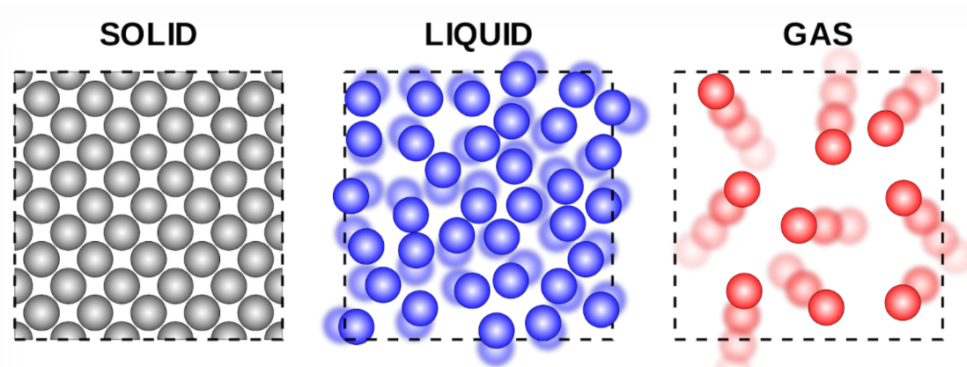

Your response to question 1: ____________________________________________________________________________________________________________________________________________________________________________________________________________________________________________________________________________________

Answer the following questions:
Bold or highlight the answers

1. Matter is everything that has mass and takes up
a) density
b) volume
c) solution

2. Solids are more dense than liquids
a) true
b) false
c) I don’t know

3. Volume measures the _________ of object
a) size
b) matter
c) solution

4. Choose the best answer to this sentence. “Matter consists of ___________”
a) solids and liquids.
b) solids, liquids, and gases.
c) solid, liquid, gases and solutions.

5. The amount of matter or substance that makes up an object.
a) solution
b) mass
c) volume

