[

**May 2013**

NSER Newsletter Title

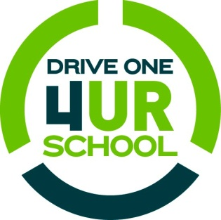

 **NSER Invites You…**

…to Drive One 4 UR School! This program is a fun, engaging way to help schools raise money to support their sports and extracurricular activities. Towne Ford has partnered with NSER to conduct a test-drive fundraising event. For every valid test-drive completed, Ford Motor Company will donate $20 to the participating high school, up to $6,000! So, the more people who test-drive a Ford vehicle at the event, the more money can be raised!

**When: May 11, 2013 from 9 am to 1 pm**

**Where: NSER High School**

**Who: Everyone!**

This will be a community wide event with many exciting activities going on such as:

C:\Documents and Settings\lorettag\Local Settings\Temporary Internet Files\Content.IE5\533NH4WM\MC900439863[1].wmfC:\Documents and Settings\lorettag\Local Settings\Temporary Internet Files\Content.IE5\XJU4UYR3\MC900200371[1].wmfJumping Castle & Face Painting

Car Wash

Bake Sale

BBQ

C:\Documents and Settings\lorettag\Local Settings\Temporary Internet Files\Content.IE5\4N0CKH26\MC900305665[1].wmfSilent Auction

C:\Documents and Settings\lorettag\Local Settings\Temporary Internet Files\Content.IE5\XJU4UYR3\MC900245137[1].wmfBike Raffle

Win a bike OR a $550 Incline Sports Credit

Raffle for a beautiful handmade quilt from Cathy Sherrard

**T.A.D.D**

This year marks the second year of TADD at NSER. TADD (Teens Against Drunk Driving) is a national organization founded upon three basic goals:

1. To assist in the elimination of impaired driving on our highways.

2. To raise the level of awareness among high school students as well as the community to the inherent dangers of impaired driving.

3. To promote alcohol awareness through education and per education programs.

Over the next couple of months the TADD Committee will be hosting some events in order to raise awareness about the goals of the committee, as well as to increase membership. Fundraising events will also take place, with the hopes of raising funds to support further TADD projects and send Committees members to the national TADD conference next year.

The first fundraising event will take place on Thursday, May 9th, from 6:00 to 9:00 p.m. at NSER. This will be a “Fun Night”, with games, movies and gym activities for all students in Grades 7 to 12. A small admission fee will be charged and students will be able to purchase treats. Also, prizes will be given away during the evening.

If anyone would like to donate to this fundraiser or would like to help out on this night, please contact either Mrs. Russell or Mrs. Ward-Cain at the school.

**Home & School Meeting**

**May 6th**

**7:00 pm**

**All are Welcome**

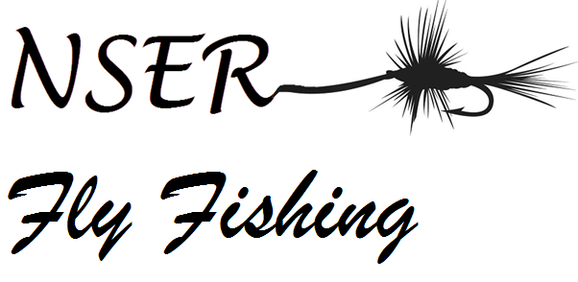

NSER will be hosting a unique event on May 31st at the MSA hatchery.  It includes a fly casting and fly tying competition as well as a number of different presentations focused on angling Atlantic Salmon on the Miramichi. It will be a cross curricular event that will expose all students attending to a broad range of educational experiences.  Environmental Science, Biology, Hospitality and Tourism, Physical Education (Wellness through Phys Ed) are all courses that could be connected directly to this event.  Students will not only be casting a fly rod and learning how to pursue this activity.  They will be exposed to experts in the field of conservation and fisheries management.  They will see various leisure and career opportunities associated with the outdoors.  Students suffering from Nature Deficit Disorder will learn how to safely spend quality time outdoors participating in a great lifelong physical pastime.

**May 31st--9:30 to 2pm  
No cost**

**Not open to general public (Only students)**

***School Calendar***

May 2 NBTA AGM (Schools Closed)

3 NBTA Council Day (Schools Closed)

20 Victoria Day

June 10-14 Exams

14 Prom

16 Baccalaureate/Grad Banquet

20 Graduation

21 Last Day for Students

24-25 Administration/Professional Learning Days

**NSER BO’N’GO Books**

**Buy one N’ get one Free**

**Books are $10 each**

**ON SALE NOW**

**at School Office**

**Coupons brought to you by these establishments & more.**

**McDonald’s, Crystal Palace, Jungle Jim’s, Boston Pizza, Kate’s Take-Out, KFC, A&W, Greco, Ed’s Subs,**

**Burger King, DQ, Pizza Shack**

*Congratulations to the Girls JV Volleyball Team for making it to Provincials*

The girls will be travelling to Hartland this weekend. We wish them well in their games and know they will be representing our school with pride.

***Good job girls!!!***

*Coach: Angela Murphy*

*and Kim Matchett*

C:\Documents and Settings\lorettag\Local Settings\Temporary Internet Files\Content.IE5\Z3VOS6J3\MC900436079[1].wmf

**Turnaround Achievement Award**

*We are very pleased to announce that Alex Mackenzie has been selected as our Turnaround Achievement Award Winner for 2013. This program recognizes one student from each school in the district who has shown the most effort, commitment and perseverance in turning around their life.*

*Alex will be recognized at a banquet at the Rodd Inn on May 27th at 6:00 pm.*

Year End

As the school year is winding down, there are things that you may be wondering about such as Honors criteria, Athlete of the Year etc…..Check out our school website at [www.nser.nbed.nb.ca](http://www.nser.nbed.nb.ca)

For more information

*Potential Grads*

Please complete your applications for available scholarships and meet the specified deadline. Applications are available in the guidance office. Any questions, please see Mrs. Ward-Cain.

C:\Documents and Settings\lorettag\Local Settings\Temporary Internet Files\Content.IE5\XJU4UYR3\MC900154572[1].wmf

Middle School Drama

will be taking their production

*"Lady Pirates of the Caribbean"*

on the road as they travel to Drama Festival in Fredericton on May 7 & 8.

Wish them well as they compete!



Theatre Arts 120 presents

***"Peter Pan",***

a heartwarming story about the boy who refused to grow up and the adventures of the three darling children as they travel to Neverland.

This performance will take place on June 3, 4 & 5 at 7pm.

The cost is $5.

All are welcome to attend!

On April 26th Rotary Interact students participated in the 30 Hour Famine to raise money for children suffering around the world. They raised $400!! If you would like to donate, please contact the school or email chantal.lavigne@nbed.nb.ca.

***Proper School Attire***

Warm weather is fast approaching and with that comes summer clothing.

We ask students to remember the dress code.

No short-shorts, No spaghetti straps, No midriffs, No halter tops, belly tops, tube tops, or muscle shirts. No low cut, tight, see-through revealing tops.

Shorts and skirts must be appropriate length.

Students will be asked to call home for proper attire, or given clothing from the school.

We thank you in advance for your cooperation.

***Visitors/Guests***

All visitors/guests in the building must report to the main office before proceeding to any other area. Vistors/Guests will be given a visitor tag and asked to sign in. While on school property, visitors/guests are expected to adhere to school policies.

C:\Documents and Settings\lorettag\Local Settings\Temporary Internet Files\Content.IE5\Z3VOS6J3\MC900030677[1].wmf

***Potential Grads***

Reminder…..

Graduation fees for 2013 are now due. The $50 fee can be paid at the office.

NSER We School is hosting a school wide clothing drive.  We are collecting used summer clothing for children ages 2 to 18 in an orphanage in Africa.  Also we are looking for the home rooms to fund-raise for new under-garments for the same children.  Collection will take place during the month of May

It’s In You To Give!

Approximately every minute of every day, someone in Canada benefits from donated blood. NSER is hosting an evening clinic on Thursday, May 16th from 5pm to 8pm. The evening hours will allow more parents and community members, as well as eligible students to attend and make this a successful event. If we wish to continue hosting a clinic at NSER, your participation is important!

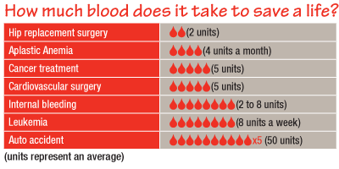

To donate, you must be at least 17 years of age, in general good health, at least 50kg and feeling well on the day of your donation. If you have had dental treatment, a cold, flu or sore throat or had any piercing or tattooing done recently, you may be excluded. Please visit the Canadian Blood Services website at <https://www.blood.ca/>. There are a number of other screening questions you will be asked on the day of the clinic but the entire process should take no more than an hour of your time. Small inconvenience for the potential life saving impact.

Please mark this clinic on your calendar and plan to attend. Please call the school at (506)836-7000 to book an appointment. Walk-in times are available.

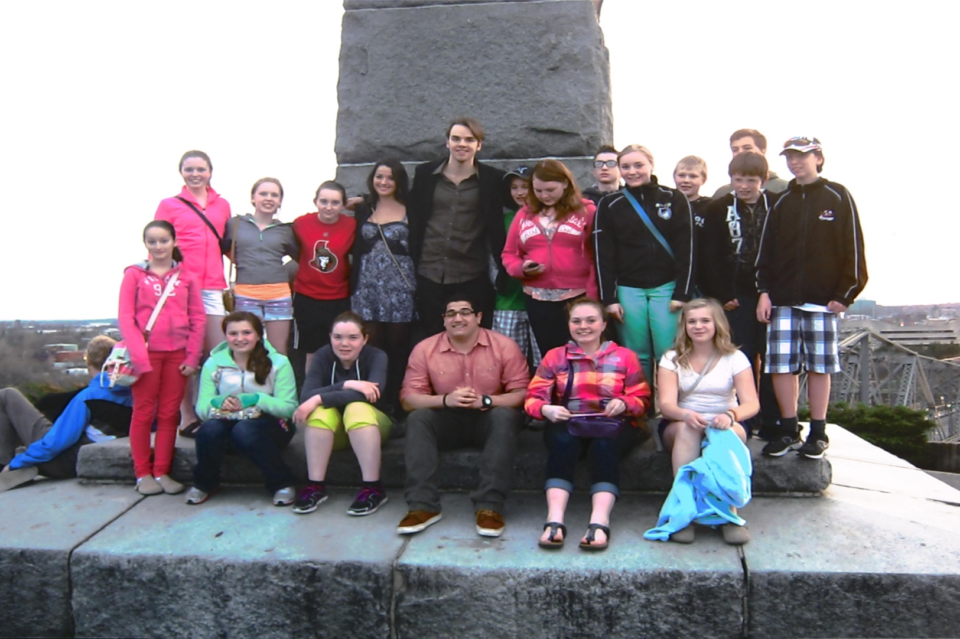

We School

16 students and 2 teachers, Mr. Linkletter and Mrs. Matchett have just returned from their amazing trip to Ottawa.  The students had a tour of the Parliament building, visited the Museum of Civilization, attended the Ottawa Senators/Philadephia Flyers game and attended National WE Day.  We are sure that the memories made and lessons learned will last a lifetime.  We would like to thank everyone who helped in any way with our fundraisers and at this time we would also like to thank the following for the generous donations towards our trip:

CMS  Portering, Lois Tozer, Miramichi Airport and Commission, Dr. Kruger, NSER Home and School, NB Construction and Safety and Peek a Boutique.

C:\Documents and Settings\lorettag\Local Settings\Temporary Internet Files\Content.IE5\HGU0JJ9E\MC900434623[1].wmfC:\Documents and Settings\lorettag\Local Settings\Temporary Internet Files\Content.IE5\EO8CQYM2\MC900434459[1].wmf