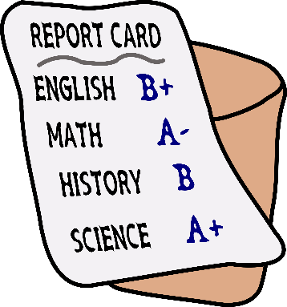
Report Cards will be distributed to all students on Friday, June 19th from 9:00 – 12:00.

Students are asked to please return all textbooks and Library books when they pick up their report card.

