Section 6.2 Quiz

1. Determine the tangent ratio of ∠A in each triangle.
a)
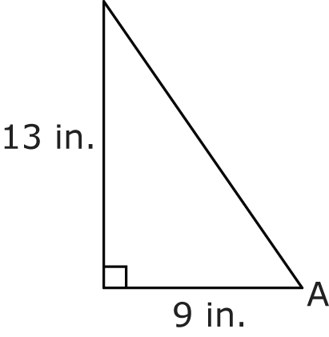
b)
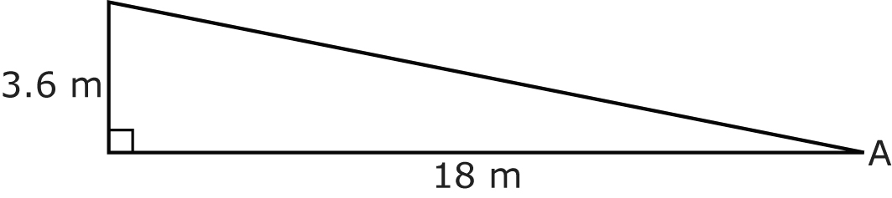
c)
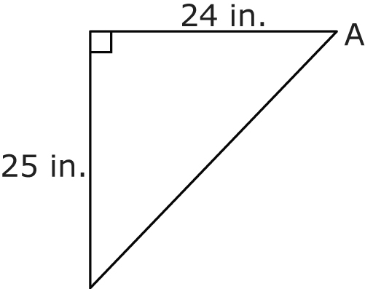
2. For each triangle in #1, determine the measure of ∠A to the nearest degree.
3. Determine the slope of each line.
a)
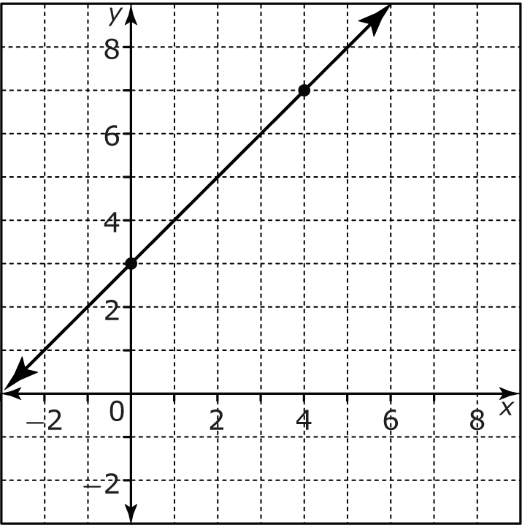
b)
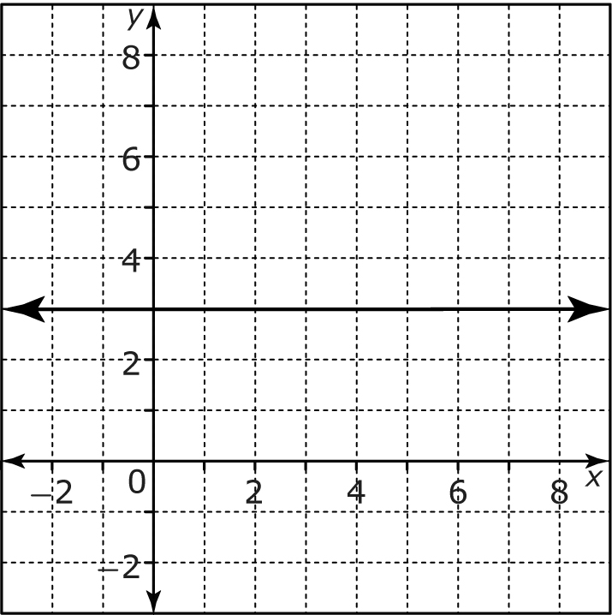
c)
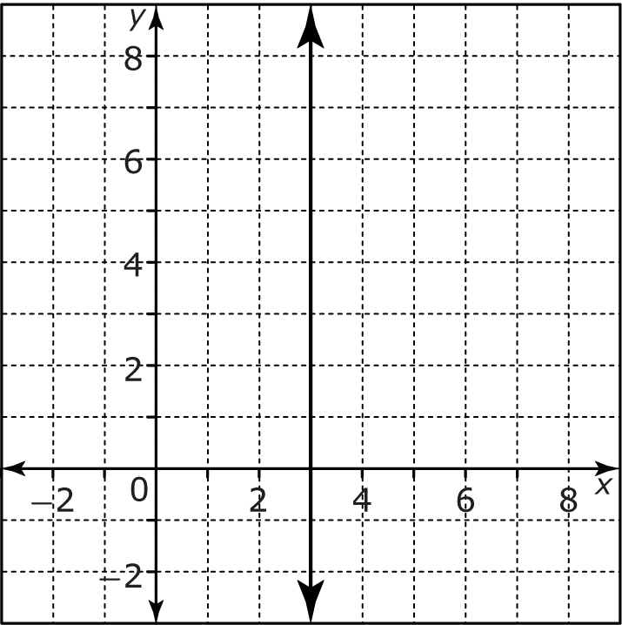
d)
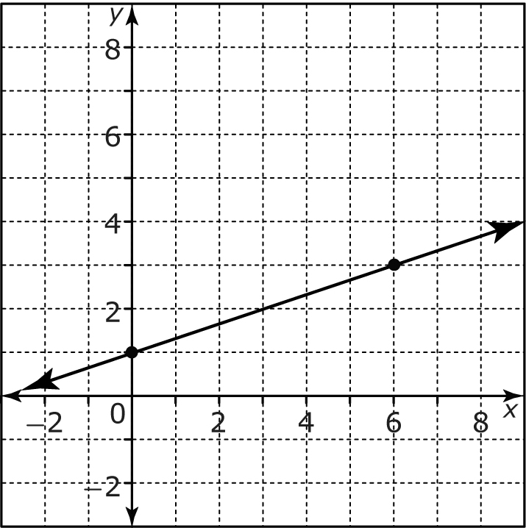
4. For each graph in #3, determine the measure of the angle of elevation. Express each answer to the nearest degree.
5. Suppose each line in #3 represents a road.
a) Which road would be the easiest to travel?
b) Which road would be impossible to travel? Why?
6. What angle does a ramp with
a slope of 1:15 make with
the ground?
7. A ramp has a steepness of 1 in.
for every 20 in. of run.
a) For the ramp to rise 1 ft, how far along the ground should
it be?
b) What is the angle of elevation of the ramp?
8. a) Explain the meaning of the sign shown.
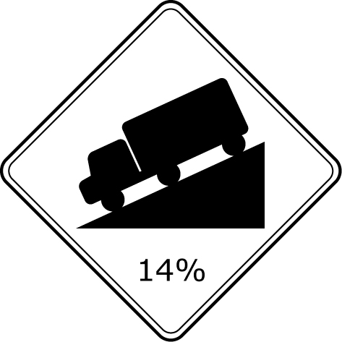
b) Write the slope of the road as a fraction.
9. Determine the angle of elevation of a road with each grade. Express your answers
to the nearest degree.
a) 10%
b) 3%
c) 8%
d) 25%
10. A driveway rises 6 inches
over 90 inches along the ground. What is the grade
of the driveway?

11. The table shows details of the
grades of roads. Complete
the table. Express slope
as a decimal to the nearest
hundredth.

Road | Rise | Run | Slope as a Fraction | Slope as  a Decimal | Percent Grade
Atlantic Avenue | 200 | 1000
Bay Bypass | 6 | 50
City Crescent |  |  | 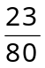
Downtown Drive |  |  | 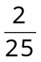
Harbour Highway |  |  |  | 0.09
Rural Road |  |  |  | 0.2
Suburb Speedway |  |  |  |  | 2%
Tickle Trail |  |  |  |  | 7.5%
12. Refer to the table you completed
in #11.
a) Which roads require a
warning sign?
b) Which roads could not
exist because the grades
are so steep?

