Lesson 3
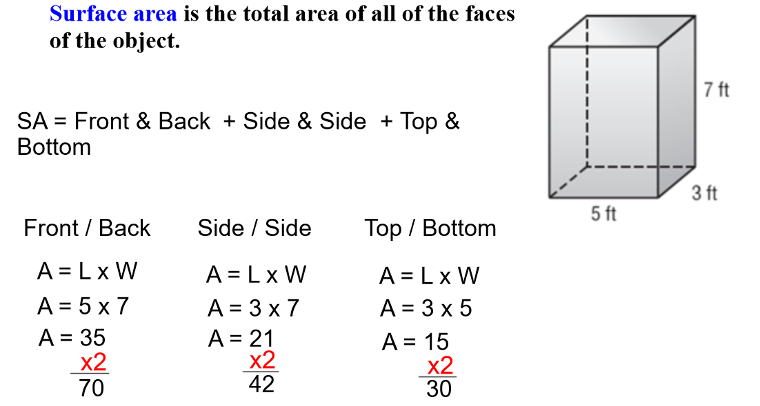
Goal: Solve problems involving surface area calculations using Imperial & SI measurements.

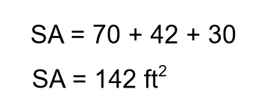

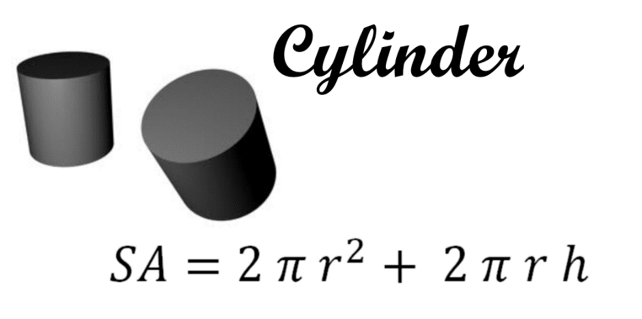

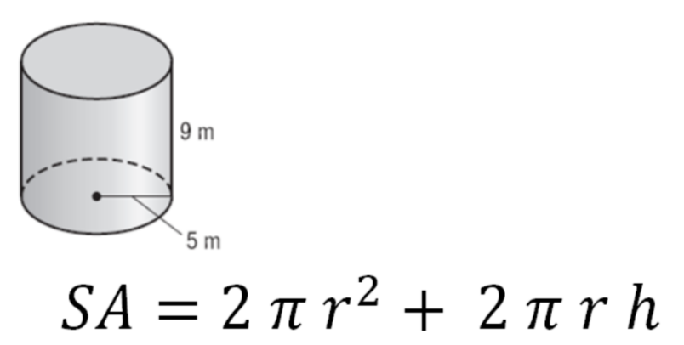

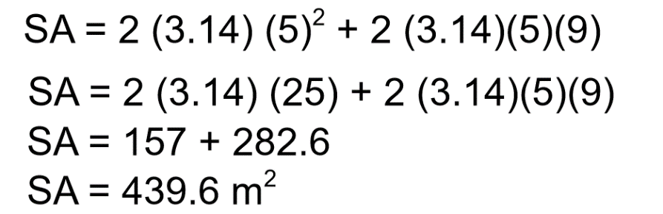

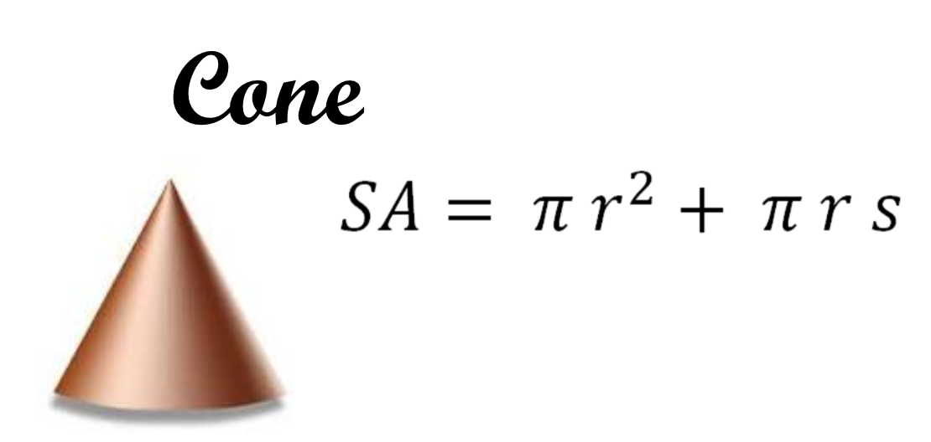

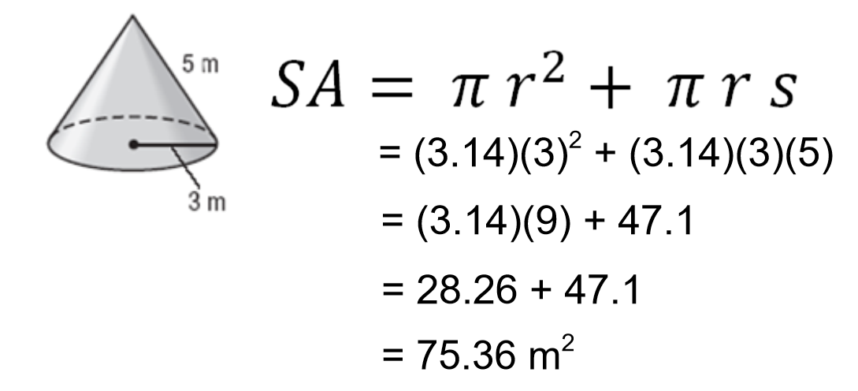

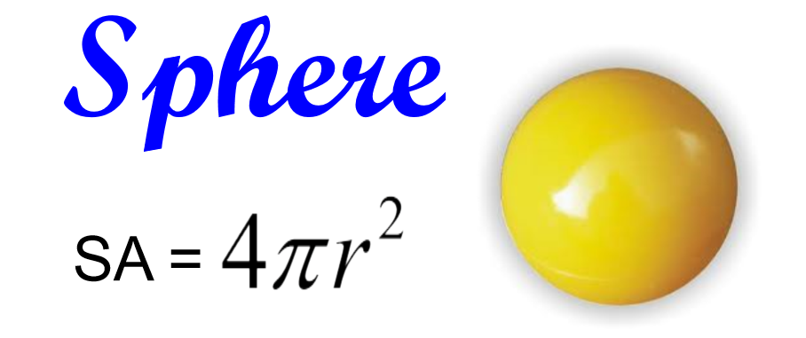

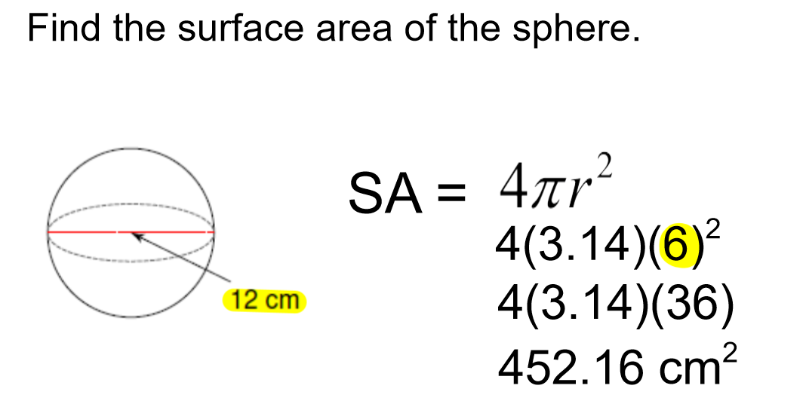

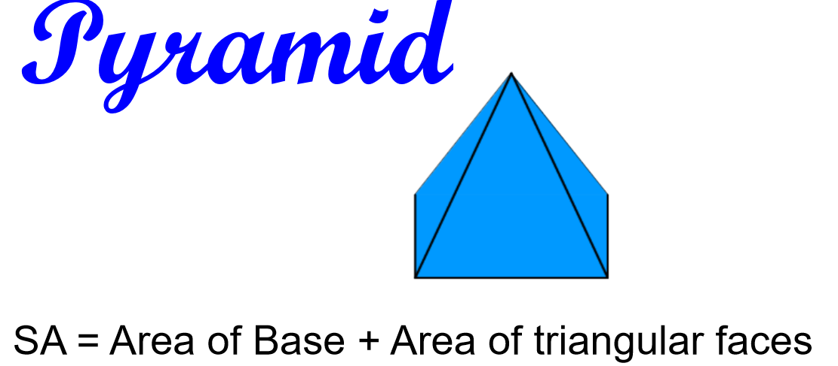

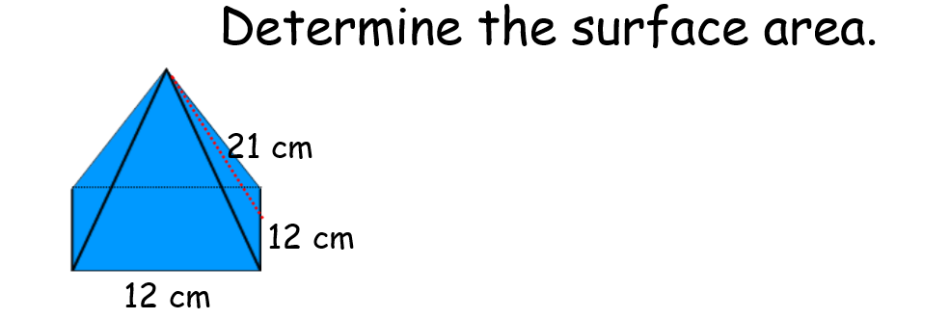

Surface area = Area of the base (square) + area of the triangular faces
= side x side + 4 x ( base x slant height / 2)
= 12 x 12 + 4 x ( 12 x 21 / 2)
= 144 + 4 x 126
= 144 + 504
= 648 cm²

Book Practice questions p. 171-172 #1, 3,4 & 5

