Lesson 4 – Surface Area Problems

Goal: Solve problems involving surface area calculations using Imperial & SI measurements

Example 1:
The lengths of the sides of regular tetrahedron and slant height are given. What is the surface area of the tetrahedron?
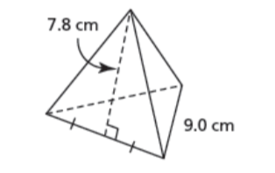

*** Note a regular tetrahedron is a triangular pyramid with all 4 sides being triangles of the same size****

Surface Area = 4 x ( Area of the triangular Side)
= 4 x ( $\frac{b x slant}{2}$ )
= 4 x ($\frac{9 x 7.8}{2}$)
= 4 x 140.4 cm² ( Don’t forget units!)

Example 2:
A right cone has a base radius of 2ft and a height of 7ft. Calculate the surface area of the cone to the nearest square foot.
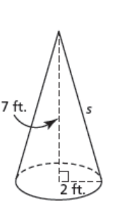

Surface Area of a cone = πr² + πrs

The slant has to be found before the surface area can be calculated.
Use Pythagorean theorem for this
S² = a² + b²
S² = 2² + 7²
S² = 4 + 49
S² = 53
S = √ 53
S = 7.3 ft

Surface Area = πr² + πrs
Surface Area = π(2)² + π(2)(7.3)
=12.56 + 45.84
=58.4
The surface area of the cone is approximately 58 ft².

Example 3:
The Great Pyramid of Giza has a square base with a side length of 755ft and an original height of 481 ft. What is the surface area of the great Pyramid.

Diagram:
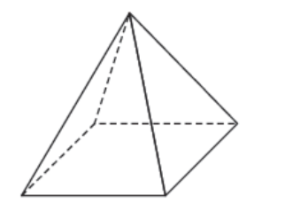
Height 481 ft

755 ft

We only need the lateral surface area. The pyramid is attached to the ground so the bottom is not include in the surface area calculations.

Surface Area = 4 x area of the triangular sides
= 4 x ($\frac{b x slant}{2}$ )
Use Pythagorean theorem to find the slant
S² = 481² + 377.5² ( half the side length to find slant)
S² = 231361 + 142506.25
S² = 373867.5
S =√ 373867.5
S = 611.44

Surface Area = 4 x ($\frac{b x slant}{2}$ )
= 4 x ($\frac{755 x 611.44}{2}$)
= 923274 ft²
The Great Pyramid of Giza had a surface area of 923274 ft².

