Lesson 5:
Goal: To solve volume problems using the Imperial and SI systems of measurement.

Note:
In Canada, we use the term imperial units to mean British imperial units.
The US also uses an imperial system, but the sizes of its units for volume and capacity are different from the British unit.
Take note of this on your conversion sheet.

Example 1:

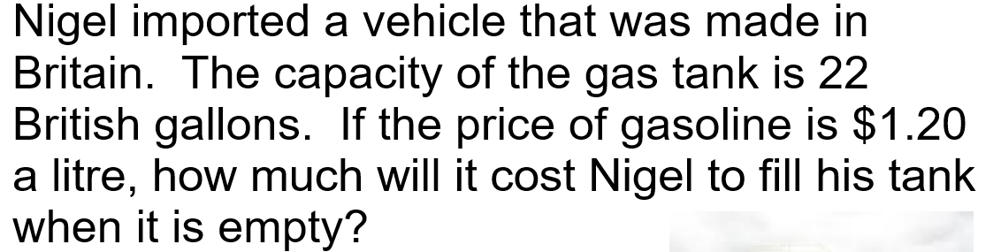
Answer:
1 gal = 4.5461 L
So 22 gal = 22 x 4.5461 = 100.0142 L
Cost to fill = 100.0142L x $1.20/L = 120.02
It cost $120.02 to fill Nigel’s tank.

Finding the volume of prisms & cylinders
Ex 2: A cylindrical shape swimming pool is to filled to $\frac{7}{8}$ capacity. How many litres of water will be required if the swimming pool is 18ft in diameter and 6ft tall. ( 1 L = 1000³)

Volume of a cylinder = πr²h
= π( 9)²(6)
= 1526.8 ft³
Converting ft³ to cm³
1 ft = 12in
12 in = 12 x 2.54 = 30.48
1 ft = 30. 48 cm
So (1ft)³ = (30.48 cm)³
1ft³ = 28316.85 cm³
1526.8ft³ = 28316.85 x 1526.8 = 43234161.38
Litres = 43234161.38 ÷ 1000
Litres = 43234.2 l
Only $\frac{7}{8}$ full so
$\frac{7}{8}$ x 43234.21 =37830 L
About 37830 L of water would be required.

Ex 3:
Jill built 12 wood planters for her garden. The inside of each planter measures 4’ long, 2’deep and 1.5’ wide. Soil costs $15.00/yd³. What would be the cost of soil for the planters?
Volume of 1 planter = l x w x h
= 4 x 1.5 x 2
= 12 ft³
The volume of 12 planters would be = 12 x 12 = 144 ft³
Convert this to yd³
1 yd = 3 ft
(1yd)³ = (3ft)³
1yd³ = 27ft³
So 144ft³ = 144 ÷ 27 = 5.33yd³
Cost = 5.33yd³ x 15.00/yd³ = $80
It would cost Jill $80 to fill all 12 planters.

Ex 4:
The sun approximates a sphere with a diameter 870 000 mi. What is the approximate volume of the sun?
Radius of the sun = 870 000 ÷ 2
= 435 000 mi
Volume of a sphere = $\frac{4}{3}$ πr³
= $\frac{4}{3}$π ( 435 000)³
= 3.4479 x 10¹⁷

The volume of the sun is 3.4 x 10¹⁷ mi³.

Finding the volume of pyramids and cones

The formula for volume of a pyramid is
V = $\frac{1}{3}$ Area of the base x height
NOTE: The height of the object is used not the slant height.
Ex 5:
Find the volume of the right square pyramid to the nearest in³.

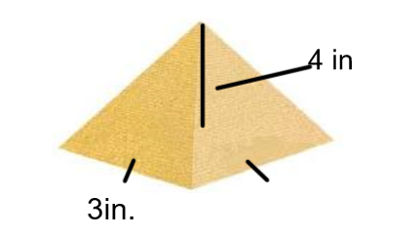

The base is a square so area of the base = s²
= ( 3)²
= 9
V = $\frac{1}{3}$ A_{b} x h
= $\frac{1}{3}$ (9) x 4
= 12 in³

Ex 6 : Find the volume of the cone below:

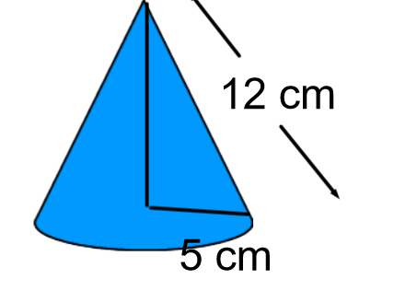

Volume of a cone = $\frac{1}{3}$ πr² x h
As with pyramids the h in the formula is the height of the object.
So we need to find h first in this case.
Using the Pythagorean Theorem
a² + b² = c²
5² + b² =12²
25 + b² = 144
b² = 144 -25
b² = 119
b =√ 119
b = 10.9
Volume = $\frac{1}{3}$π (5)² ( 10.9)
= 285.4 cm³
Extra Practice Questions from textbook p. 182 # 1 to 6

