Lesson 6:
Goal: To solve problems involving composite surface area and volume, where measurement given are in Imperial and SI units

Composite Surface Area:
Recall from grade 9:
A composite object is an object composed of 2 or more shapes. To find the surface area, find the area of the objects and take away the overlap.
Ex 1:
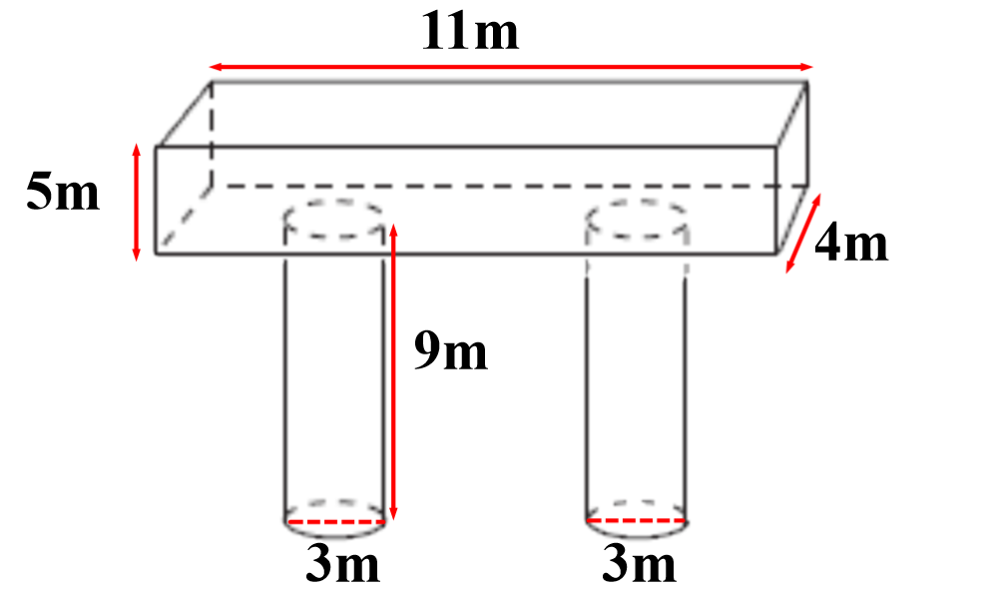
.

Surface Area of the top = 2LW +2LH+ 2WH
= 2(11)(4) + 2(11)(5) + 2(4)(5)
= 88 + 110 + 40
= 238
Surface area of the two cylinders = ( 2πr² + 2πrh) x 2
= (2π(1.5)² + 2π(1.5)(9)) x 2
= (14.14 + 84.82) x 2
= 198
There are 2 overlaps
Area of 1 overlap = πr² x 2
= π(1.5)² x 2
= 14.14
Total overlap = 14.14 x 2
= 28.28
Surface Area = 198 – 28.28
= 169.7 m²

Ex 2:
A rocket has a cylindrical body and a cone shaped nose. The cylinder is 75 cm long with a radius of 8 cm. The cone has a slant height of 15 cm and the same radius as the cylinder. What is the surface area of the rocket?

Answer:

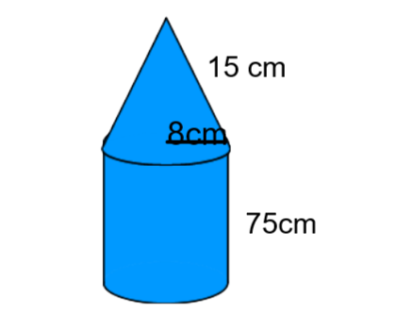
The bottom of the cone is covered so we only need the lateral surface area of the cone
SA cone = πrs
= π(8)(15)
= 377
SA of cylinder ( without the top) = πr² + 2πrh
= π(8)² + 2π(8)(75)
= 3971
Total surface area = 377 + 3971
= 4348 cm²
Composite Volume:
To find the volume of a composite shape , find the volume of each shape and then add them together.

Ex 3:
Find the volume of the rocket in Ex 2.
Volume of cone = $\frac{1}{3}$ πr² h
Since we know the slant but not the height , it must be found first.
a² + b² = c²
8² + b² = 15²
64 + b² = 225
b² = 225 – 64
b =√ 161
b = 12.7 cm

Volume of cone = $\frac{1}{3}$ πr² h
= $\frac{1}{3}$π(8)²(12.7)
= 851.2
Volume of cylinder = $π$r²h
= π(8)²(75)
= 15079.6
Total volume = 852.2 + 15079.6
= 15931.8 cm³
The volume of the rocket is 15932 cm³.

Ex 4:
Find the volume of

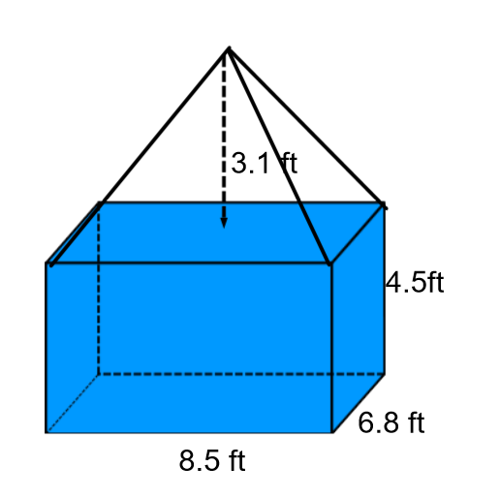
Volume of prism = L x W x H
= 8.5 x 6.8 x 4.5
= 260.1

Volume of pyramid = $\frac{1}{3}$ Area of Base x H
=$\frac{1}{3}$ ( 8.5 x 6.8) x 3.1
= 59.7
Total Volume = 260.1 + 59.7
=319.8 ft³
Extra Practice questions can be found on p. 59 – 60 of Foundations & Pre Calculus Math 10 ( Orange book from last term)
The link to this book is on my teacher page.
We will be using it for the section on trigonometry also.

