Home Learning 2020
Grade 7
Math #2

Here is what we have set up for Math this week, a little different than the progressions we have been following all year but the following will help you achieve the majority of the grade 7 outcomes without falling behind for next year.

You can still go at your own pace, do what you can do and move along and seek help when needed. I’m just an email/Skype away!

No matter where you left off when we were last together, we will all start at the beginning of this new journey together. I will be posting a new concept/Progression every so often but again remember to go AT YOUR OWN PACE!!! Don’t rush through it just to get to the next one. Take your time.

Our first progression will be Algebra. Algebra is one of my favourite Math concepts and we use it every day, even if we don’t realize it! Have fun with it. I have also included a few additional resources you can use to help you along the way. Or fire me off an email and I will help you through it the best way I can!

Algebra – follow this link, https://courseware.cemc.uwaterloo.ca/27?gid=76 , (University of Waterloo – Grade 7 & 8 Mathematics – Equations and Pythagorean Theorem) and follow through lessons 1-8 only, in order. These modules start with the very basics of algebra and increasingly get harder. Complete the lessons, exercises and seek extra help if needed. Once complete, you can send me an email if you want, that you are done and with any questions you may have. I don’t expect this to completed in one week!

This site is pretty user friendly and covers the outcomes for Grade 7 Algebra perfectly! The only thing that I would caution you on is that when you go to click to the next “slide” after the video is complete, click the big BLUE NEXT button on the lower right side, not the “Next Unit Item”.

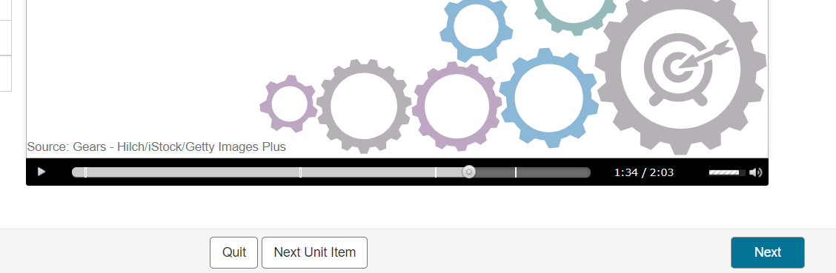

Also, remember to use Google Chrome or any browser other than Microsoft Explorer as it will not support it.

Here are a few other useful sites you can use for help with explanations or for extra practice:

*******

Braingenie!! https://braingenie.ck12.org/ Keep using Braingenie for extra practice and even to go back and solidify some of those concepts you started into already! Remember word problems is where we ALL need some practice!
Your user name is your first and last name and the password is Password1
~ If you need it reset fire me off a message and I will do so as soon as I get the message!
Example:
MaxForan Password1

*******

Learn Alberta is another great tool for video explanations. (No password or username required) Follow these links to watch videos and switch to “Interactive” to play a few games with the information from the video.

http://www.learnalberta.ca/content/mejhm/index.html?l=0&ID1=AB.MATH.JR.PATT&ID2=AB.MATH.JR.PATT.ALG&lesson=html/video_interactives/algebra/algebraSmall.html

http://www.learnalberta.ca/content/mejhm/index.html?l=0&ID1=AB.MATH.JR.PATT&ID2=AB.MATH.JR.PATT.ALG&lesson=html/object_interactives/algebra/use_it.html

http://www.learnalberta.ca/content/mejhm/index.html?l=0&ID1=AB.MATH.JR.PATT&ID2=AB.MATH.JR.PATT.LINE&lesson=html/video_interactives/linearequations/linearEquationsSmall.html

Spy Guys - http://www.learnalberta.ca/content/mesg/html/math6web/index.html?page=lessons&lesson=m6lessonshell11.swf

*******

You may want to find some fun sites on your own too! Just google and play around with the different sites you find. If you find a good one, share it! This is all totally new learning for all of us !!

Parents, please reach out at any time. I’m here for your child’s learning and I want to try and make this transition as “easy” as possible!

Have fun and be sure to drop me a line about anything!!

Mrs Foran, Mrs Silliker & Mrs Russell

elaine.foran@nbed.nb.ca

