Home Learning 2020
Grade 7
Math #3

Another week, another Math Home Learning opportunity! Remember, do what you can do and DON’T STRESS OVER IT! These are only opportunities/suggestions for you to work on while we are away from our regular Math class. There is no formal assessment but I am always available (phone, email, video) to give some help and guidance.

This week I put together some Math Word Problems from all different stages of the curriculum. I have them broken down by curriculum strand and have hints in italics after each question. DO NOT THINK YOU HAVE TO DO ALL OF THESE! I wanted to have a variety of questions available for the various levels we are all at in our Math learning. So, I repeat, YOU DO NOT HAVE TO DO EVERY QUESTION…unless you want to. I have also included an answer sheet and answer key for these problems so that you can keep track of your questions and check your answers.

Remember to follow CUBES and read each question carefully!

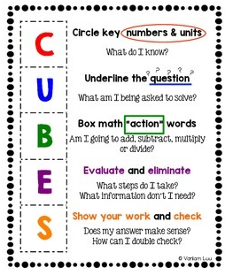

*******

Math Games – This site is good for practice of your algebra skills! Especially when it comes to creating and solving equations and expressions. You should look and play around with this site to have fun with some of your mad Math skills. No username or passwords are needed. There is also an option to print worksheets and the option to practice only the concepts you need the practice with.

https://ab.mathgames.com/algebra

Remember, contact me at ANYTIME and do what YOU can do at YOUR own pace. Continue with the Waterloo site for Algebra and give some of those word problems a T-R-Y!

Have a great week! Miss seeing your faces!

Mrs. Foran, Mrs. Silliker & Mrs. Russell

Elaine.foran@nbed.nb.ca

