Home Learning 2020
Grade 7
Math #4

Here is another Math Learning Opportunity for you to try at home.

DreamBox! DreamBox Learning is a K-8 digital Math program that independent studies have found to raise student achievement and better prepare children for future success. You can access DreamBox Learning from any computer, 24 hours a day, 7 days a week. All you need is a high-speed connection. It is also available for installation on an iPad.

Follow the link below and create an account for a free trial. The free trial is good for 90 days but needs to be created by April 30th. Parents can see progress as students go through the levels and keep track of their learning accomplishments. This is much more animated and interactive than BrainGenie.

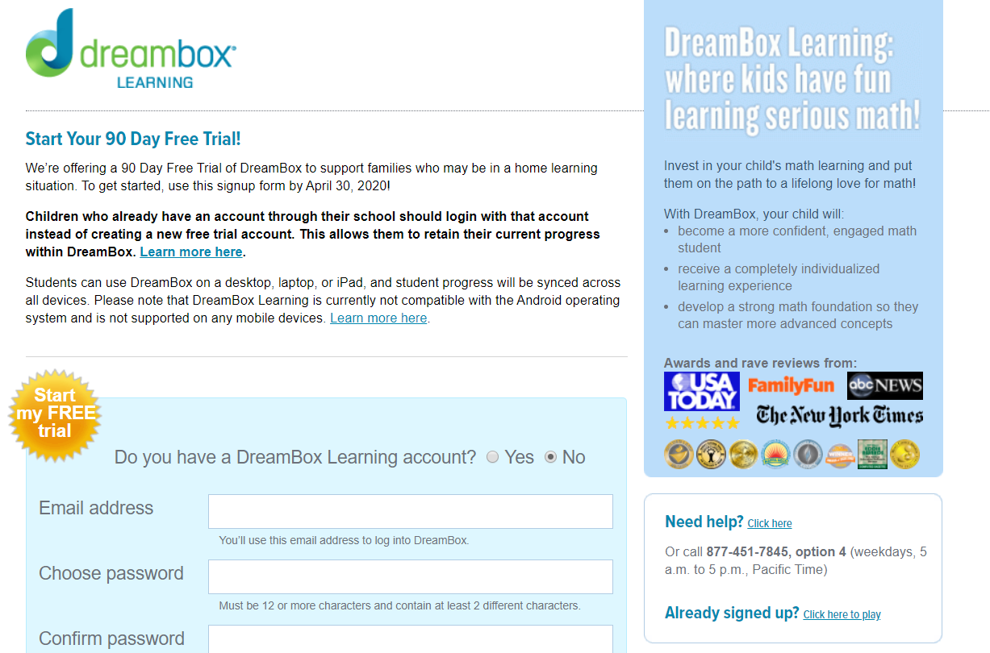
https://store.dreambox.com/register

Continue with the Algebra on the Waterloo site, word problems and Braingenie if you like and keep me posted with your progress and problems you encounter. If there is anything else you have been doing Math related, let me know! I would love to see what you have been up to.

Hope you are all doing well and washing your hands!!

Mrs. Foran, Mrs. Silliker & Mrs. Russell

