**GMF**

**Measurement**

**M1** Demonstrate an understanding of the Système International (SI) by describing the relationships of the units for length, area, volume, capacity, mass and temperature.

**M2** Demonstrate an understanding of the Imperial system by: describing the relationships of the units for length, area, volume, capacity, mass and temperature.

**M3** Solve problems, using SI and Imperial units, that involve linear measurement using estimation and measurement strategies.

**Lesson 1:** Demonstrate an understanding of the Imperial Measurement System by solving measurement problems where measurements are given in Imperial units.

In Canada, we use two different systems of measurement: the Systeme International d’unites (SI or metric system) and the Imperial System.

Until now most of the measurement calculations ( in grade 8 & 9) have been performed using SI.

**SI Review**

* Base unit for measuring length is the metre (m) and for measuring volume it is the litre (L)
* The SI is a decimal system. To convert between units multiply or

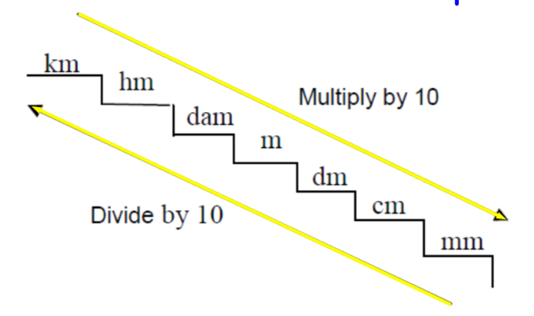**TRY THESE:**

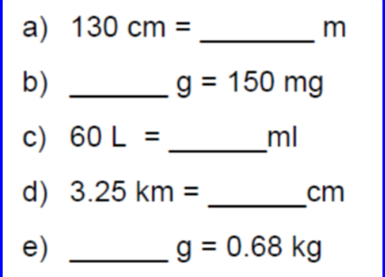

**The Imperial Measurement System**:

* The base unit for measuring length is the foot(ft) and for volume it is the pint(pt).
* The Imperial System is not a decimal system.

The table below shows some common Imperial Units.

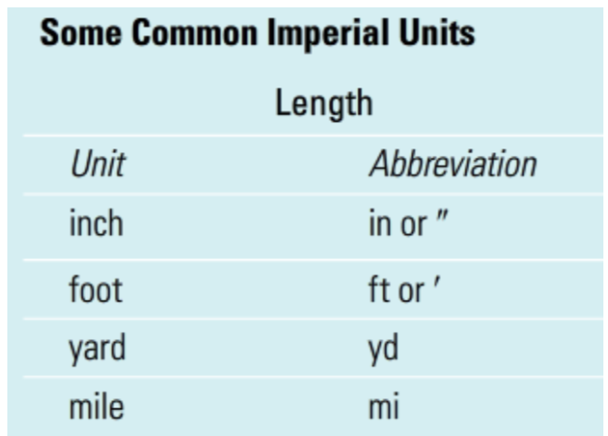

To convert from one imperial unit to another imperial unit, you use a unit conversion factor.

Some common length conversion factors are given below.

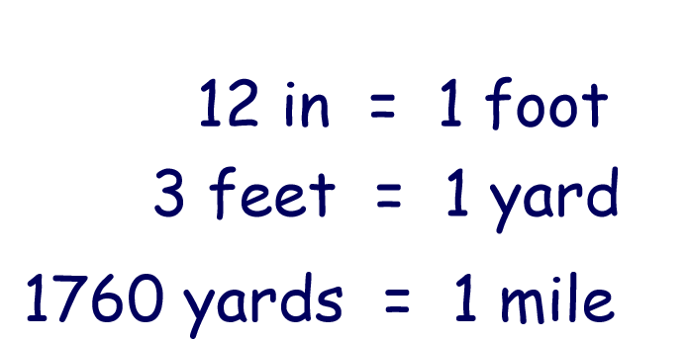

Conversion examples:

Convert:

1. 24 in to ft

(b)4 mi to yd

(c) 63 ft to yd

(d) 96 in to yd

Answers:

NOTE: In converting from bigger units to smaller units multiply by the conversion factor. In converting from smaller units to larger units divide by the conversion factor.

1. Inches are smaller than feet so

24 in = 24 ÷ 12 = 2 ft *** Don’t forget to include units in all answers***

1. Miles are bigger than yards so

4 mi = 4 x 1760 = 7040 yd

1. Feet are smaller than yards so

63 ft = 63 ÷ 3 = 21 yd

1. Two conversions are required to get inches to yards

Inches to feet 96 in = 96 ÷ 12 = 8ft

Feet to yards 8 ft = 8 ÷ 3 = 2⅔ yd

**TRY THESE:**

Convert:

1. 18 in to feet

(b)48 ft to yd

(c) 9680 yd to mi

(d) 12 yd to in

(e)0.5 mi to feet

Answers:

1. 1.5ft (b) 16yd (c) 5.5 mi (d) 432 in (e)2640 ft

Word Problems:

Ex 1:

Joe is a carpenter who is replacing the baseboard around the 4 walls of his living room. The dimensions of the rectangular living room are 18’ x 15’ . The door is along one of the 18’ walls and measures 72” wide. Baseboard costs $4.50 a linear foot and must be purchased in whole feet. How much will it cost Joe to replace the baseboard in his living room?

Answer:

The first step to solving any measurement problem is to draw a diagram and label it.

18’

15’

72”

Baseboard goes around the bottom of the room. To find the amount of baseboard required we need to find the perimeter of the room minus the opening of the door. Since the cost is given per foot this measurement needs to bee in feet.

The only measurement not in feet is the door opening. Converting this into feet:

72”= 72÷12= 6’

The formula for perimeter of a rectangle is P = 2L + 2W

So the amount of baseboard required is P= 2 (18) + 2(15) – 6

= 36 + 30 – 6

= 60’

Cost = 60’ x $4.50/ft

= $270

The cost for the baseboard is $270.

Ex 2: If Jack runs 7 laps of the track below, how far as he run?



Solution:

The ends of the track are two semi circles. Putting them together will form a circle.

The formula for Circumference of a circle is C = 2πr or C = πd

For the track C =π (30)

= 94.2 yd

The distance around the track = 94.2 + 40 + 40

= 174.2 yd

So 7 laps

Distance = 174.2 x 7 = 1219.4 yd

Jack ran 1219.4 yd.

Practice Questions from the book p. 150-151 #1 to 8

**Lesson 2:** Demonstrate an understanding of Imperial Measurement and SI measurement conversions by solving measurement problems where conversions between the two measurement systems are necessary.

Conversions between measurement systems can be done using the proper conversion factors. ( See your formula sheet from the previous section)

Examples:

Convert:

1. 54 cm to inches

(b)3m to yards

(c) 8 km to miles

(d) 9 ft to m

(e) 4’9’’ to cm

Answers:

1. There are 2.54 cm in 1 inch so

54cm = 54 ÷ 2.54 =21.3 in.

1. There are 1.0936 yd in 1 m so

3m = 3 x 1.0936 =3.3 yd

1. There are 1.6093 km in a mile so

8 km = 8 ÷ 1.6093 = 5.0 km

1. There are 3.2808 ft in a m so

9ft = 9 ÷ 3.2808 = 2.7 m

1. First change 4’ 9” to inches

4’ = 4 x 12 = 48”

So 4’9” = 48” + 9”= 57”

There are 2.54 cm in an in. so

57” = 57 x 2.54 = 144.8 cm

**TRY THESE:**

Convert:

1. 7 in to cm
2. 15 mi to km
3. 18 yd to m
4. 25 ft to m
5. 68 cm to feet

Answers:

1. 17.8 cm (b) 24.1 km (c) 16.5m (d) 7.6 m (e) 2.2 ft

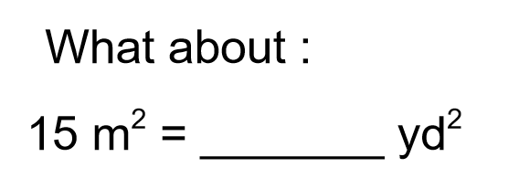

These units are squared so to make the conversion we have to square the linear conversion factor ( see sheet)

1 m = 1. 0936 yd so

(1m)2 = (1.0936 yd)2

1m2 = 1.2 yd2

A m2 is bigger than a yd2 so multiply by the conversion factor

15 m2 = 15 x 1.2 = 18 yd2

Word Problems:

Ex 1:

Susan wants to replace the carpet in her living room with hardwood floor. The dimensions of the living room floor are 12 ft x 18 ft. Hardwood flooring costs $42.00 / m2 and can only be bought by a whole m2 .

1. How much flooring does she need?
2. What will be the cost of the flooring?

Answer: 18ft

Diagram 12 ft

Method 1:

Do conversions first

18 ft = 18 ÷ 3.2808 = 5.49 m

12 ft = 12 ÷ 3.2808 = 3.66 m

Then find the area

A = L x W

A = 5.49 x 3.66

A = 20.1 m2

Method 2:

Find the area first

A = L x W

A = 18 x 12

A = 216 ft2

Then do the conversions

1 m = 3.2808 ft

1 m2 = ( 3.2808 ft)2

1m2 = 10.7636 ft2

216 ft2 = 216÷10.76 = 20.1 m2

Susan will need 20.1m2 of flooring.

1. Flooring must be bought by a whole m2 so Susan will need 21 m2 of flooring.

Cost = 21m2 x $42/ m2

= $882

The flooring will cost Susan $882.

Ex 2:

Carter wants to go to Mathville to visit Keona. James tells Carter Mathville is 340 mi away. Carter figures he should be able to travel at an average speed of 80 km/h . How long will it take for Carter to get to Mathville?

Answer:

340 mi = 340 x 1.6093 = 547.16 km

Time = distance ÷ speed

= 547.16 ÷ 80

= 6.83 h

= 6 h and 50 min

It will take Carter 6 h and 50 min to get to Mathville.

Practice questions from the textbook p. 159-160 # 1 to 7