Financial & Workplace 110
Week 1 Lesson 1

Goal: Be able to use the relationship between slope and angle of elevation to solve problems.

Slope Review:
Slope = $\frac{Rise}{Run}$ or Slope = y₂ – y₁
X₂ – x₁

Example :
A road rises 20m for every 120m of horizontal distance. Determine the slope of the road.
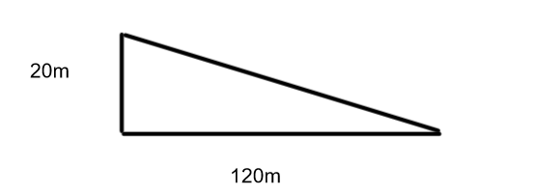

- Express the slope as a fraction.
- Express the slope as a decimal.
- $\frac{Express the slope as a percent.}{}$

$$Answer:$$
- Slope = $\frac{Rise}{Run}$

Slope = $\frac{20m}{120m}$

Slope = $\frac{1}{6}$ (Always reduce fractions)

- $\frac{1}{6}$ = 0.1666.. = 0.167

- 0.167= 0.167 x 100% = 16.7%

Relationship Between Slope and Angle of Elevation

Recall:

The angle of elevation is the angle is the angle between the horizontal and the line of sight. For an object such as a ramp, it is the angle between the horizontal ground and the ramp.

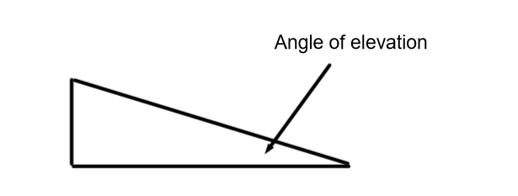

Examples:

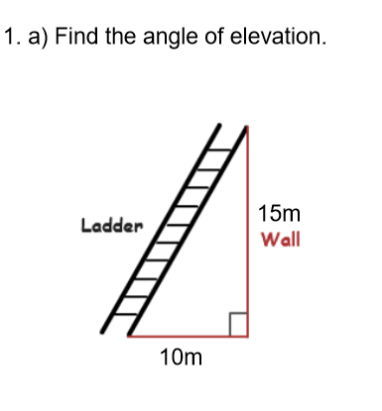

***** Label the diagram*****

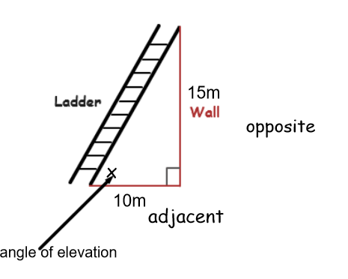

We know the opposite and adjacent sides so we will use the tangent ratio to find the angle of elevation (x).

Tan x = $\frac{opp}{adj}$
Tan x = $\frac{15}{10}$
Tan x = 1.5
X = tan⁻¹ 1.5
X = 56.3°
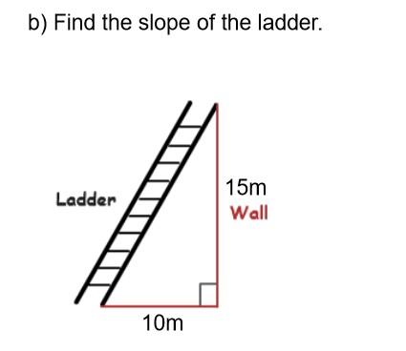

Slope = $\frac{Rise}{Run}$

Slope = $\frac{15}{10}$
= $\frac{3}{2}$
= 1.5

*** From this we see that ***

Tangent of the angle of elevation = Slope
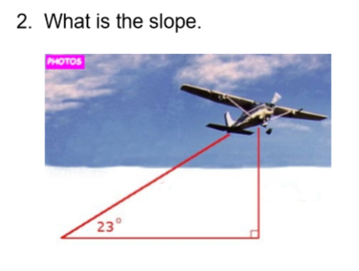

Tan 23° = 0.42
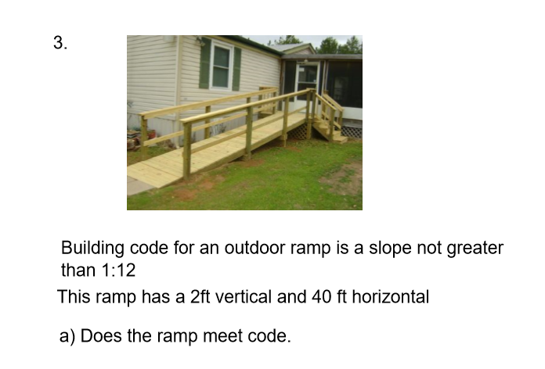

Answer:

Slope = $\frac{Rise}{Run}$
= $\frac{2}{40}$
= $\frac{1}{20}$
= 0.05

Slope for code = $\frac{1}{12}$
= 0.083

Since 0.05 < 0.083 the ramp meets code.

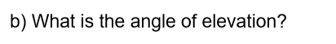
Tan x = 0.05
X = tan⁻¹ 0.05
X = 3°
The angle of elevation is 3°.

Practice Questions from the book

p. 278-279 # 1 to 6

