Financial & Workplace 110
Week 1 Lesson 2

Goal: Be able to use slope as percent grade to solve problems.

The grade of a road is the slope of the road and is usually expressed as a percent.
Warning signs are usually placed in areas where the grade is 6% or greater.
Examples:
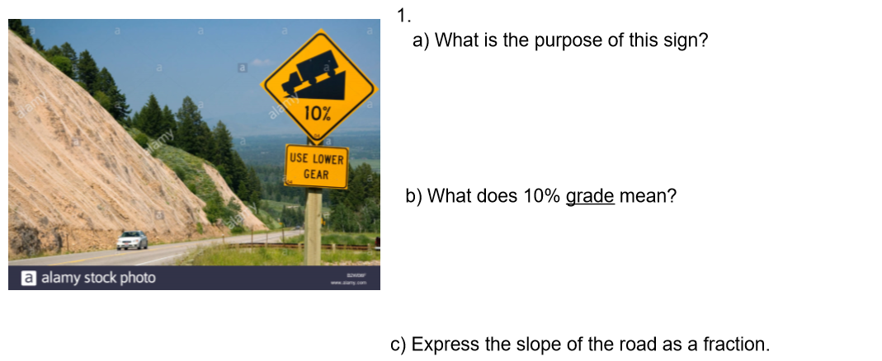

Answers:
- (a) The sign warns drivers that they are approaching a steep hill or decline. They should lower their speeds. Large trucks with loads should uses a lower gear.

(b) The slope of the road is 10% or 0.10.
(c) 10% = $\frac{10}{100}$ =$\frac{1}{10}$ ( always reduce fractions)

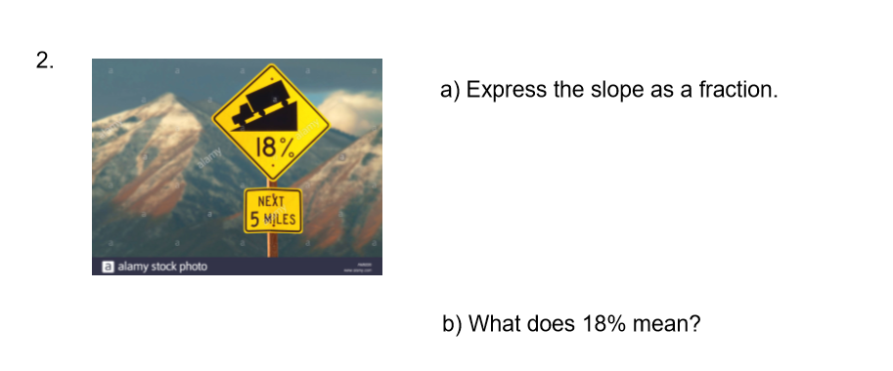

- Slope = $\frac{18}{100}$ = $\frac{9}{50}$
- The road drops 18 units for every 100 units horizontally.
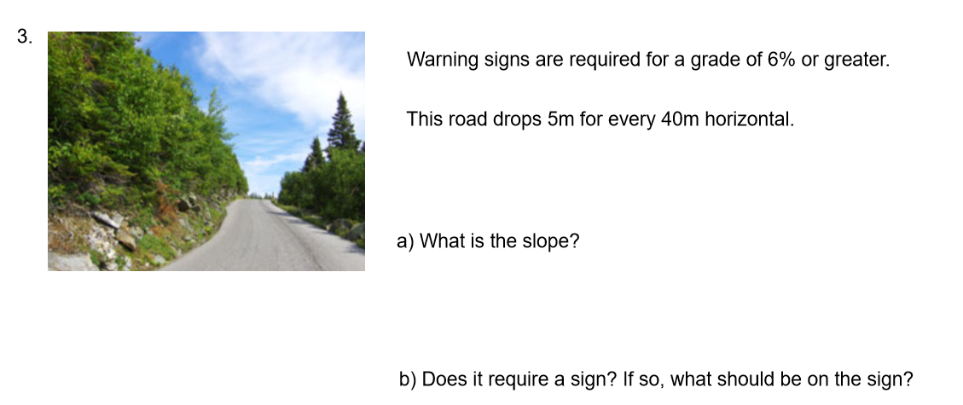

- Slope = $\frac{5}{40}$ = $\frac{1}{8}$
- Percent grade = 1 $÷$ 8 = 0.125
= 0.125 x 100% = 12.5%
A warning sign is required.
Grade is 13%.

Practice questions from book
p. 282 #1 to 9

