Extra Practice 6.3 Answers

BLM 6–8 Section 6.3 Extra Practice

**1. a)** AB: rise 4, run 1;CD: rise 0, run 4; EF: rise 4, run 0; GH: rise 1, run 2;  
IJ: rise 3, run 4

**b)** AB = 4; CD = 0; EF = undefined;   
GH = ; IJ = 

**2.** **a)**  **b)**  **c)** 0 **d)** 

**3. a)** 1 **b)** 3 **c)** 

**4. a)**

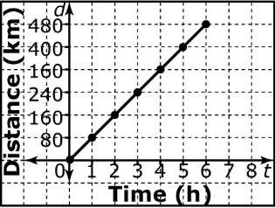

**b)**  **c)** slope = average speed

**5. a)**

|  |  |  |
| --- | --- | --- |
| **Time Worked (h)** | **Amount Earned ($)** | **Rate of Change** |
| 0 | 0 |  |
| 1 | 13 | 13 – 0 = 13 |
| 2 | 26 | 26 – 13 = 13 |
| 3 | 39 | 39 – 26 = 13 |
| 4 | 42 | 42 – 39 = 13 |
| 5 | 65 | 65 – 42 = 13 |

**b)** ; $13/h **c)** 

**d)** Both start at 0 h and $0.

**e)** different rates of change

**6.** 

**7.** Table A: constant rate of change of 2; Table B: not constant

**8.** $12/h

**9. a)** every 10 min

**b)** ; ; ; ; ; 0

**c)** 1 km/10 min; 1 km/5 min;   
1 km/10 min; 1 km/5 min; 1 km/10 min;   
0 km/10 min