Financial & Workplace 110
Week 2 Lesson 3

Goal: Be able to solve problems where slope is expressed as a rate of change.

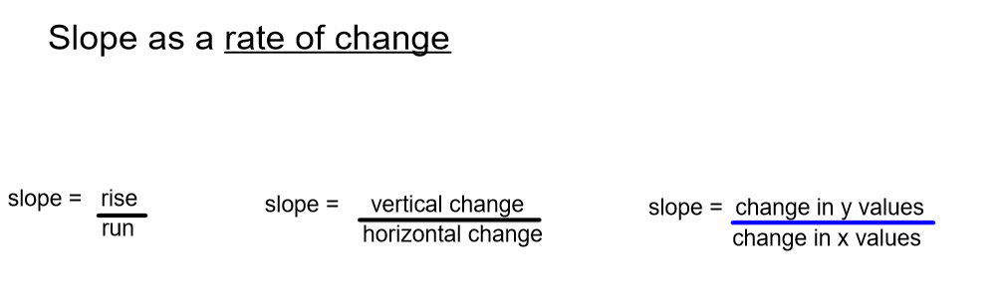
Recall from grade 10 that when we are given a table of values of a linear relation

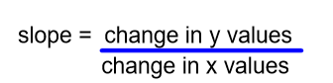

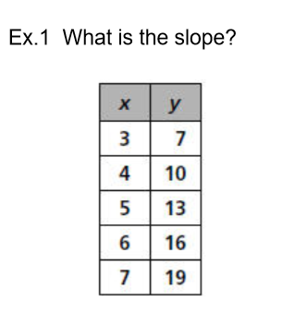

X’s increase by 1 y’s increase by 3

Slope = $\frac{3}{1}$ = 3
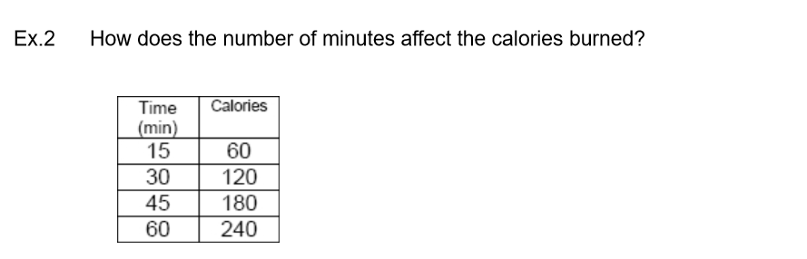

Time ( x ) increases by 15 Calories (y ) increase by 60

Slope = $\frac{60}{15}$ = 4
The rate is 4 calories/minute.

Extra Practice Questions from textbook
p. 290 # 1 – 4(b,c)
p. 294 #1 -4,5(b), 6 & 7

