SAMPLE CHAPTER TEST SOLUTIONS

Part A: True or False?

1. (T)
Side QR is opposite ∠P.
Side p, or QR, is in the interior of ∠P.

2. (T)
Side PQ is the longest side.
PQ = r
Side r is the hypotenuse.

3. (T)
r² − p² = q²
From the Pythagorean theorem.
r² = q² + p²
Subtract p² from both sides.
r² − p² = q²

4. (F)
∠P = 53°
53° + ∠Q = 90°
∠Q = 90° − 53°
∠Q = 37°

5. (F)
cos ∠Q = $\frac{adj}{hyp}$
cos ∠Q = $\frac{p}{r}$

6. (T)
cos ∠P = $\frac{q}{r}$
$\frac{q}{r}$ = sin ∠Q

7. (F)
∠P + ∠Q + ∠R = 180°
∠P + ∠Q = 180° − ∠R
∠P + ∠Q = 90°

8. (T)
tan ∠Q = $\frac{opp}{adj}$
tan ∠Q = $\frac{q}{p}$

9. (T)
tan ∠P = $\frac{opp}{adj}$
tan ∠P = $\frac{p}{q}$

10. (F)

PR is opposite ∠Q, or adjacent ∠P.

Part B: Short Answer

11. a)
tan A = $\frac{6.3}{5.9}$
tan A $≈$ 1.1
b)
∠A = tan⁻¹ $\left(\frac{6.3}{5.9}\right)$
∠A $≈$ 47°

12. 9² + 12² = b²
81 + 144 = b²
225 = b²
b = $\sqrt{225}$
b = 15
Alternative Solution
Since 9 equals 3 multiplied by 3 and 12 equals 3 multiplied by 4, the hypotenuse is 3 multiplied by 5 equals 15, multiples of the 3-4-5 right triangle.

13. a) sin 12° = $\frac{l}{9.6}$
l = 9.6 sin 12°
l = 2
b) ∠L + ∠M + ∠N = 180°
12° + 90° + ∠N = 180°
102° + ∠N = 180°
∠N = 180° – 102°
∠N = 78°

14. a) PS = 2 + 2
PS = 4
$$\frac{6}{x}=\frac{4}{2}$$
4x = 12
x = $\frac{12}{4}$
x = 3
b) ∠P = tan⁻¹ $\left(\frac{6}{4}\right)$
∠A = 56°
c) 2² + 3² = PQ²
4 + 9 = PQ²
13 = PQ²
PQ = $\sqrt{13}$
PQ $≈$ 3.6

Part C: Extended Answer

15. AB² + AD² = BD²
10² + 8² = BD²
100 + 64 = BD²
BD² = 164
PQ = $\sqrt{164}$
PQ $≈$ 12.8
It is approximately 12.8 m from one vertex to the opposite.

16.
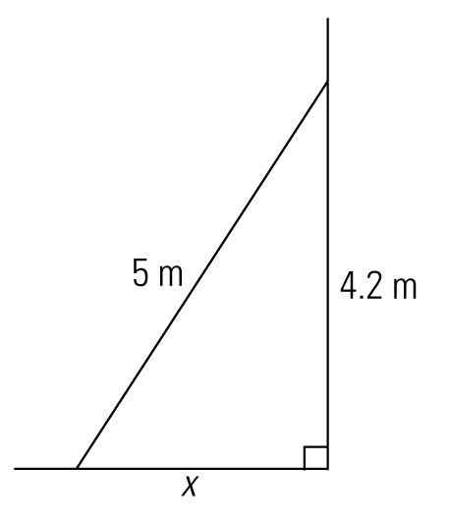
4.2² + x² = 5²
x² = 5² – 4.2²
x = $\sqrt{25 –17.64}$
x = $\sqrt{7.36}$
x $≈$ 2.7
The base of the ladder is approximately 2.7 m from the house.

17. a² + b² = c²
a² + 36² = 45²
a² + 1296 = 2025
a² = 2025 – 1296
a² = 729
a = $\sqrt{729}$
a = 27
The vertical distances between the centres is approximately 27 in.
Alternative Solution
Students may realize that 45 equals 9 times 5 and 36 equals 9 times 4, so this represents a 3-4-5 right triangle and the other leg would be 9 times 3 equals 27 in.

18. Change 4′9″ to feet by first changing 9″ to a fraction of a foot.
$$\frac{9}{12}=\frac{3}{4}$$
$\frac{3}{4}$ = 0.75 ft
sin 32° = $\frac{4.75}{r}$
r sin 32° = 4.75
r = $\frac{4.75}{\sin{32°}}$
r $≈$ 9.0
The rafter is approximately 9 ft long.

19.
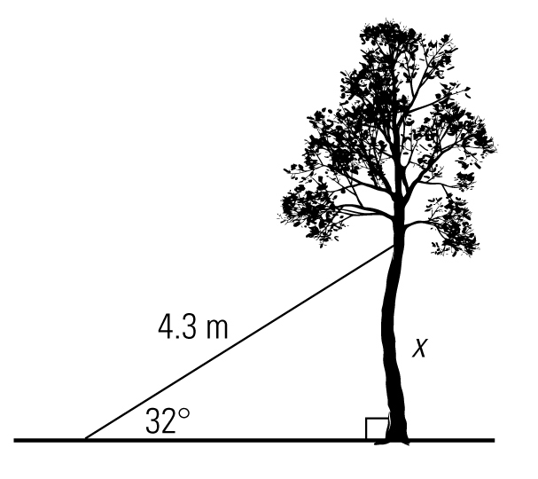
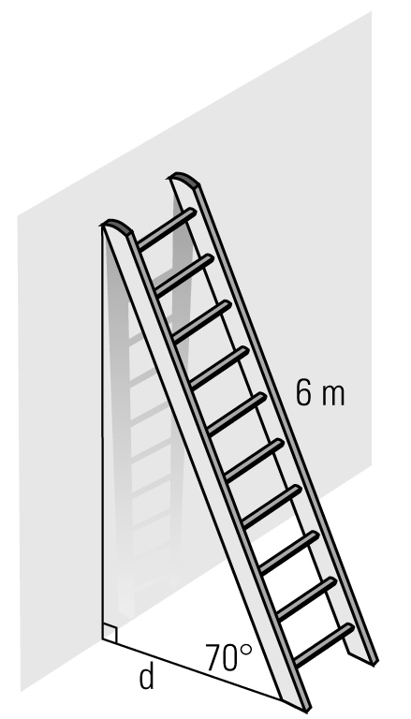
sin 32° = $\frac{x}{4.3}$
x = 4.3 sin 32°
x = 2.3
It would be about 2.3 m up the tree.

20. cos 70° = $\frac{d}{6}$
6 cos 70° = d
r $≈$ 2.1
It is approximately 2.1 m from the wall.

21.
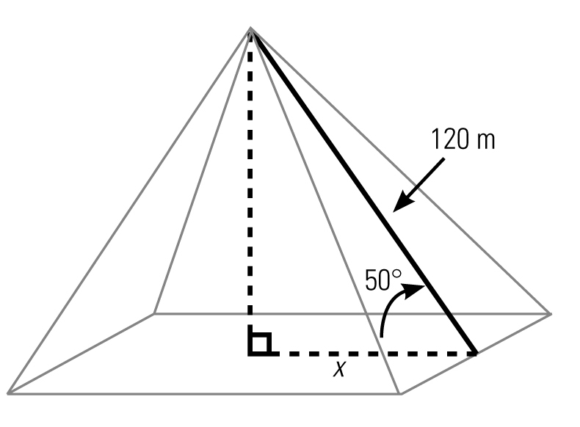
cos 50° = $\frac{x}{120}$
120 cos 50° = x
x $≈$ 77.1 m
The width of the pyramid is therefore approximately 2 $×$ 77.1 m or 154.2 m.

22. Since this is a 45-45-90 triangle, AC equals BC, which equals 120 yards.

Alternative Solution
tan 45° = $\frac{AC}{BC}$
tan 45° = $\frac{AC}{120}$
AC = 120 tan 45°
AC = 120
Therefore, it is 120 yards across the river.

23.
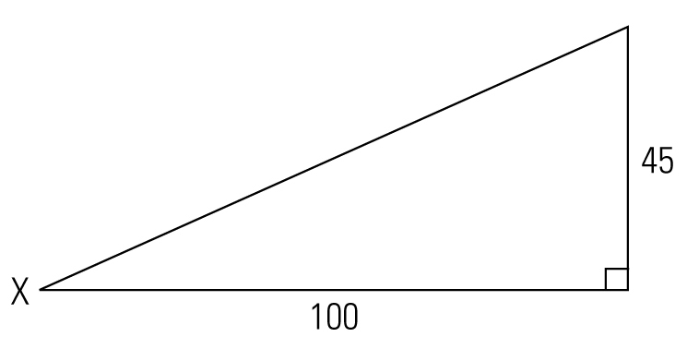
tan X = $\frac{45}{100}$
X = tan⁻¹ $\left(\frac{45}{100}\right)$
X $≈$ 24°
Therefore, the angle of elevation is approximately 24°.
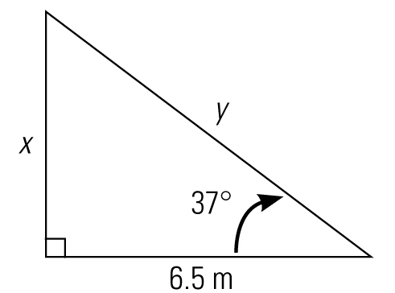
24. a) Let the height of the stump be x.
tan 37° = $\frac{x}{6.5}$
x = 6.5 tan 37°
x $≈$ 4.9 m
The tree broke 4.9 m from the ground.
b) Let the length of the piece that broke off be y.
cos 37° = $\frac{6.5}{y}$
y cos 37° = 6.5
y = $\frac{6.5}{\cos{37°}}$
y $≈$ 8.1 m
4.9 + 8.1 = 13
The tree was 13 m tall.
Note: Students should not use the Pythagorean theorem to determine the length of the broken piece, as they will be compounding rounding errors.

