Lesson 12
RF7 Determine the equation of a linear relation, given: a graph, a point and the slope, two points, a point and the equation of a parallel or perpendicular line, a scatter plot.

General Form of the Equation
INVESTIGATE:
Joe has some loonies and some toonies in his pocket. The total amount of change he has is $12.
Make a table of values to show all the possible combinations of coins Joe could have.
Let x represent the number of loonies Joe has and y represent the number of toonies he has.
x | y
0 | 6
2 | 5
4 | 4
6 | 3
8 | 2
10 | 1
12 | 0

From this an equation for the relation can be written: x + 2y = 12

This is the Standard Form of the equation.
In standard form
- x and y terms are on one side of the equation and the constant is on the other side
- The coefficients of the variables of the variables and the constant term are integers.

To get the equation into General Form the constant term should be moved to the left.
x + 2y = 12
x + 2y -12 = 12 -12
x + 2y – 12 = 0
General Form of the Equation
Ax + By + C = 0 is the general form of the equation of the line, where A is a whole number, and B and C are integers.

Example 1:
Write each equation in general form
- -2x + 3y =7 (b) y = -⅔ + 4 (c) y-2 = ⅗( x + 3)

Answers:
- Going from standard form to general form, move the constant to the left side of the equation.
-2x + 3y = 7
-2x + 3y -7 = 7-7
-2x + 3y – 7 = 0 *** This is still not general form- the number in front of the first term must be a positive number***
To get rid of the negative multiply the whole equation by -1. This changes all signs.
-2x + 3y -7 = 0 x -1
2x – 3y + 7 = 0
- Going from slope-intercept to general form

y = -⅔x + 4 *** Multiply and get rid of the fraction first***
3y = (3)-⅔ x+ (3)4
3y = -2x + 12 Move all terms to the left
3y + 2x – 12 = -2x + 12 + 2x -12
3y + 2x -12 =0 Put variables in alphabetical order and make sure the coefficient of x is a positive number.
2x + 3y -12 = 0

- Going from point- slope to general form

y- 2 = ⅗( x + 3)
y-2 = ⅗x + $\frac{9}{5}$ Multiply and get rid of the brackets

(5)y – (5)2= (5)⅗x + (5)$\frac{9}{5}$ Multiply and get rid of the fractions
5y – 10 = 3x + 9 Move all terms to the left
5y – 10 -3x -9 = 3x + 9 -3x -9
5y -3x -19 = 0 Put terms in order
-3x + 5y -19 = 0 Multiply by -1 so the x term is positive
3x – 5y + 19 = 0

Example 2:

Determine the slope of the line with the equation

2x -4y – 16 = 0

When an equation is given in general form it is not possible to immediately find the slope, unlike slope intercept form, where we know the slope is the coefficient of x .
What needs to be done is to change from general form to slope- intercept form. This is the reverse procedure to what was done in EX 1 (b)
2x – 4y – 16 = 0 The y must be isolated so move the x term and constant to the right
2x – 4y – 16 -2x + 16 = 0 -2x +16
-4y = -2x + 16 Then divide all terms by -4
$\frac{-4y}{-4}$ = $\frac{-2x}{-4}$ + $\frac{16}{-4}$
y = ½ x -4
The slope of the line is ½ .

Graphing Using x and y intercepts.
The x co-ordinate of the point where a graph intersects the x axis is called the x-intercept or horizontal intercept.

The y co-ordinate of the point where a graph intersects the y axis is called the y intercept or vertical intercept.
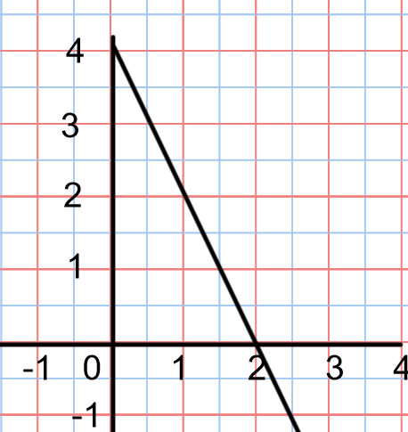

For the graph, the x intercept is 2 or the point (2,0). The y intercept is 4 or the point (0,4)

We can graph any line if we know the x and y intercepts.
Note the y co-ordinate of any x intercept will always be 0. We can use this fact to find the x intercept of any line.
For example:
Find the x intercept of 3x + 2y = 6
Let the y value = 0 and solve for x
3x + 2y = 6
3x + 2(0) = 6
3x = 6
x = 2
The x intercept of the line is 2 .
The x co-ordinate of the y intercept will always be 0. This fact can be used to find the y intercept in a similar method to the one used to find the x intercept.
To find the y intercept of 3x + 2y = 6 let x=0 then solve for y.
3(0) + 2y = 6
2y = 6
y = 3
The y intercept is 3.
This information can then be used to graph the equation.
Put both points on a graph and join the points.

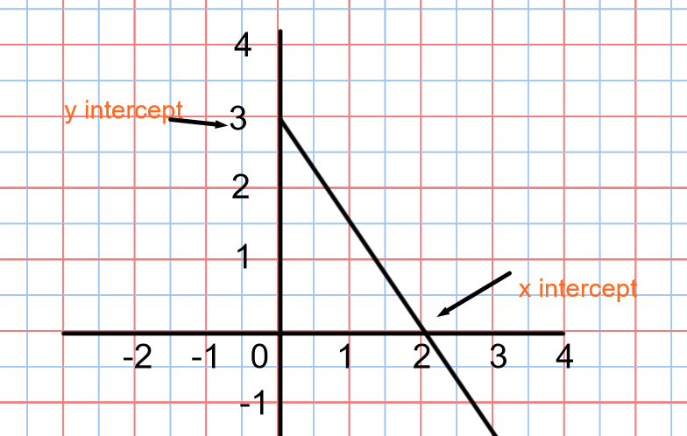

This method can be used to graph an equation in general form.

Example 3:
- Determine the x and y intercepts of 2x – 4y + 8 = 0
- Graph the line.
Answer:
To find the x intercept let y = 0
2x – 4y +8 = 0
2x – 4(0) + 8 = 0
2x + 8 = 0
2x + 8 -8 = 0-8
2x = -8
x= -4
The x intercept is -4.
To find the y intercept let x =0
2x -4y + 8 = 0
2(0) -4y + 8 =0
-4y +8 = 0
-4y +8 -8 = 0-8
-4y = -8
y = 2
The y intercept is 2
(b)
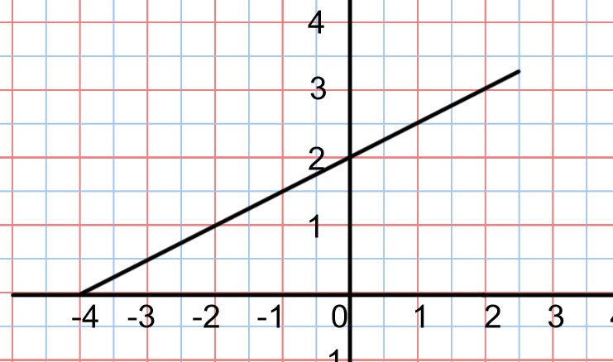

Determining an equation from a graph of generated data
Ex 4:
Peanuts cost $2 per 100g bag and raisins cost $1 per 100g bag. Owen has $ 10 to purchase both these items.
- Generate some data for the relation.
- Graph the data.
- Write an equation for the relation in general form.

Answers:

- If Owen buys only peanuts at $2/100g bag he can buy 5 bags = 500g of peanuts.
If Owen buys only raisins at $1/bag he can buy 10 bags of raisins = 1000g of raisins
If Owen buys 2 bags of peanuts it will cost $4 so he will have $6 to spend on raisins . So he could buy 600g of raisins
If Owen buys 4 bags of peanuts it will cost $8 so he will have $2 to spend on raisins. He could buy 200 g of raisins.

- Graph the points from (a)
(500,0) (0,1000) (200,600) (400, 200)
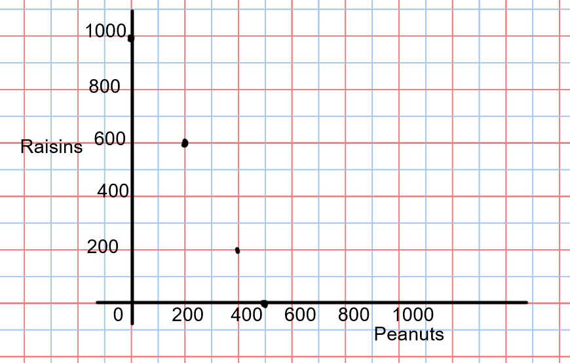

Note the points are not joined. It is not possible to buy part of a bag of peanuts or raisins. This is an example of discrete data. If the points were joined however they would form a straight line. The relation is linear.

- To write an equation in general form from a graph it is necessary to get the equation of the line in either slope intercept or slope point form first, Then rearrange the equation you have found into general form
Recall the first step in getting an equation in slope intercept form or slope point form is to find the slope.
Pick any 2 points on the graph, for example ( 0,1000 & ( 500,0)
m = $\frac{y2-y1}{x2-x1}$
= $\frac{0-1000}{500-0}$
= -2
The slope is -2 and the y intercept from the graph is 1000.
The equation of the line in slope- intercept form would be
y = -2x +1000
Change this to general form
y+ 2x -1000 = -2x + 1000 +2x – 1000
2x + y + 1000 = 0

Practice Questions from textbook : p.384-385- #4 to 16 & 17 to 25

