Home Learning 2020
Grade 7
Math #10 FINAL WEEK

It’s here! The last week of home learning! For your final learning opportunity, we are going to the Khan Academy site to test your knowledge of grade 7 math skills. This course challenge is a great way to show you have mastered the Grade 7 Math Outcomes. You will find the challenge here https://www.khanacademy.org/math/cc-seventh-grade-math
- Search Khan Academy for Math Grade 7 in your browser or follow this link. https://www.khanacademy.org/math/cc-seventh-grade-math

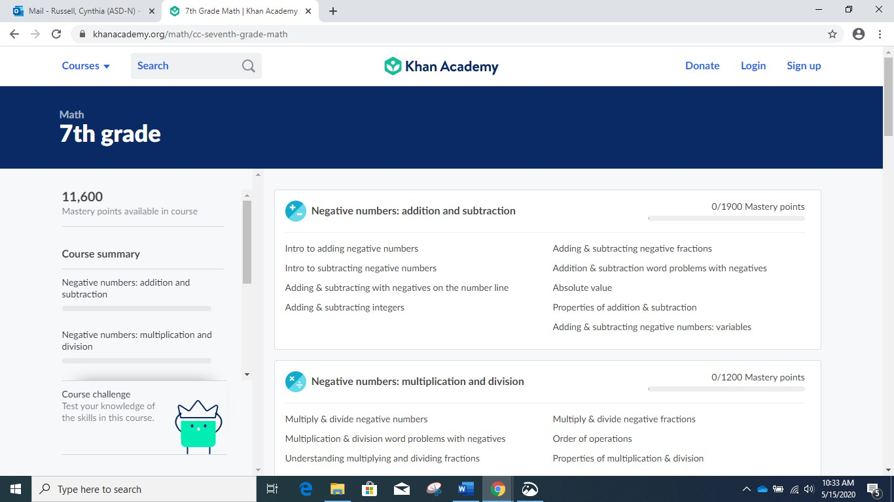

- Just click on the course challenge, circled above, and you are set to go. The test should take 30- 45 minutes and as long as you are logged in, you can spread the challenge out over a few days. You also can retake the challenge to try to beat your score.

It would be a good idea to keep working on your Math over the summer
using any of the resources from our Home Learning.

Stay well and take care of you!!

Mrs Foran
Elaine.foran@nbed.nb.ca

