Home Learning 2020
Grade 7
Math #9

CRUNCH TIME! I must admit, I miss seeing your faces every day! I can’t believe we are moving into the full year Math review. The set up of our regular personalized Math program is awesome because if you had trouble with some of these grade 7 outcomes, we will be able to look at them together as you move through the progressions next year in grade 8. You won’t fall behind or “miss” anything!

Last week you were given the Khan Academy site to use as a resource for a review. It is perfect for a review of grade 6, test of grade 7 and a tiny taste of grade 8 outcomes for New Brunswick. How many points did you get? Keep going with that and below you will find ANOTHER resource that you can also use to continue your review.

NetMath: https://activities.scolab.com/ready-set-math-confirmed/#!/curriculum/NBRVO104/grade/grade-7-(nb)/subject/all-subjects

Once you follow the above link, make sure that you have New Brunswick selected as your province and select Grade 7 (NB). It seems to always want to default to Quebec and Grade 3. I can’t figure out a way to avoid that with the link. This site is broken down by the same four strands the NB Curriculum is: Numbers, Patterns & Relations, Shape & Space, and Statistics & Probability.

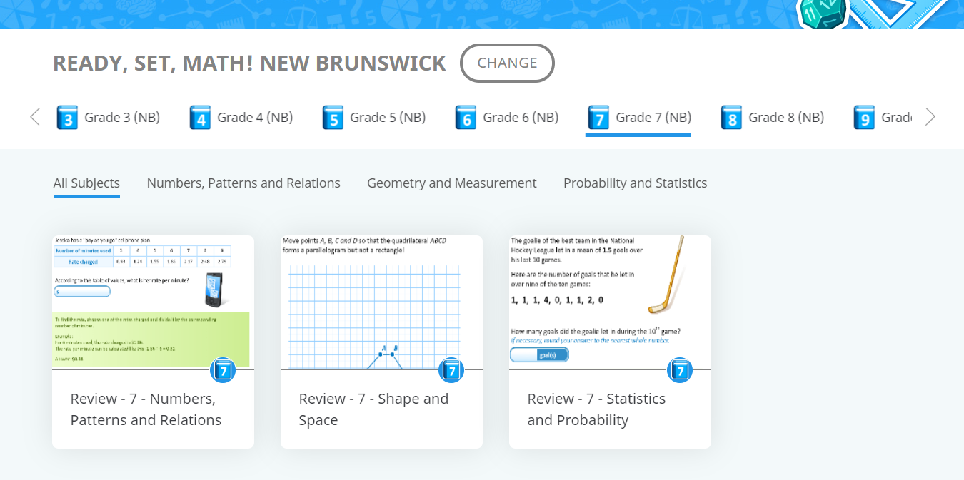

You are also encouraged to send some of your work to us for feedback. I would love to see how you are doing with your Math. Take a picture of your work, send it, and I’ll gladly look it over and offer some feedback.

I hope you are all doing well and looking after each other.
Take care and keep 6 feet apart!

Mrs Foran

Elaine.foran@nbed.nb.ca

