Representing Views of 3-D Objects

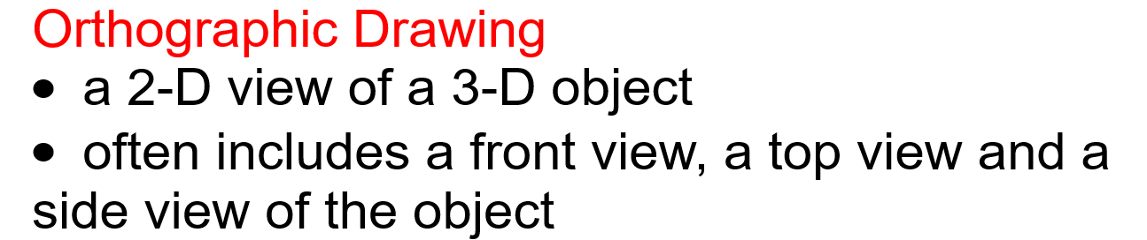

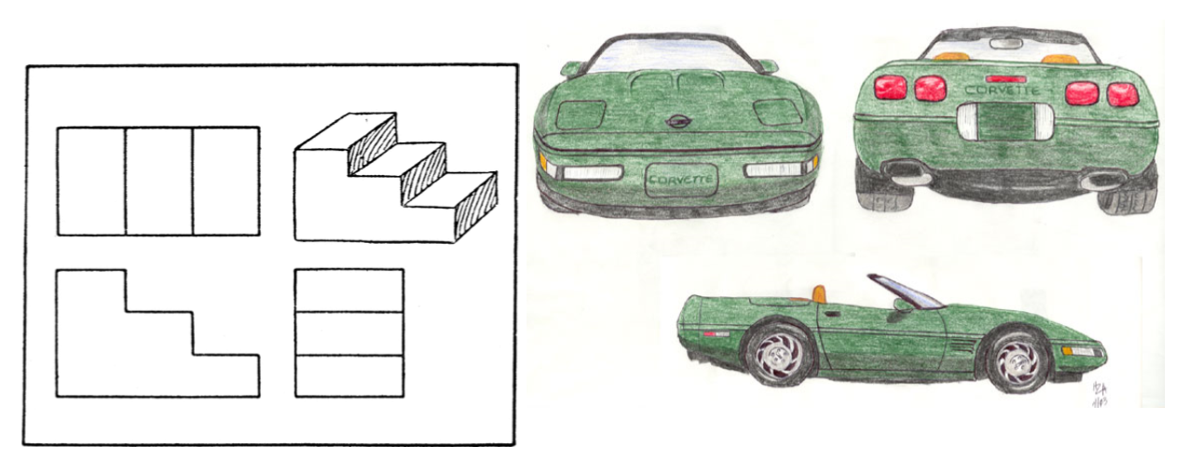
Example:

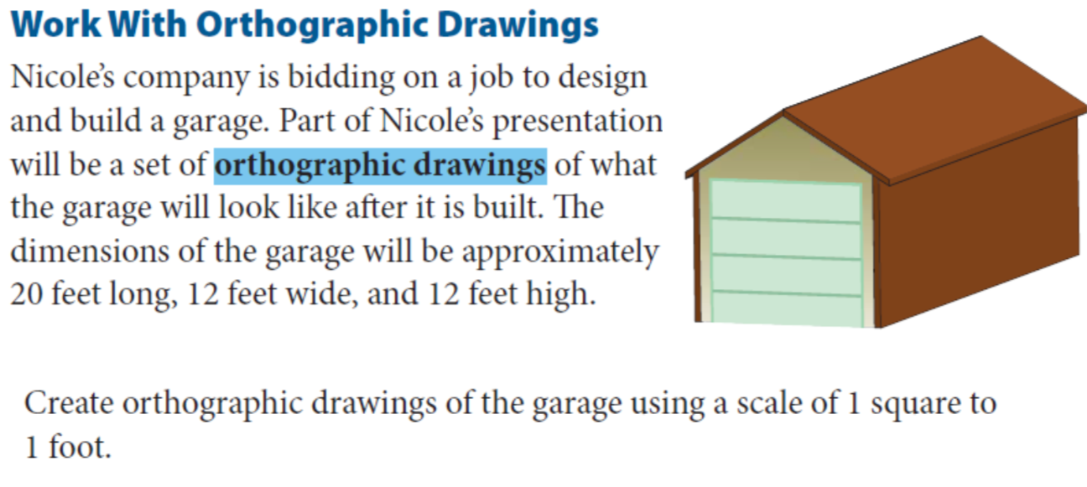
Answer
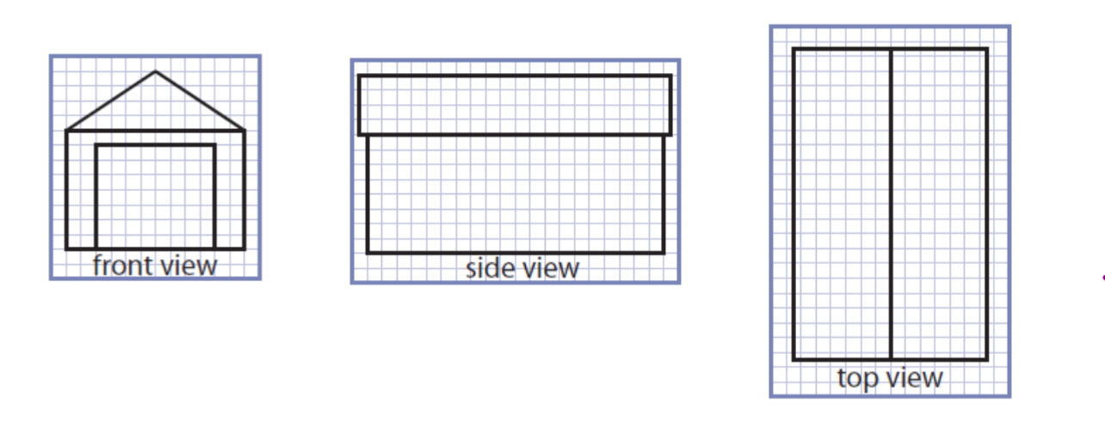
TRY THIS ONE!

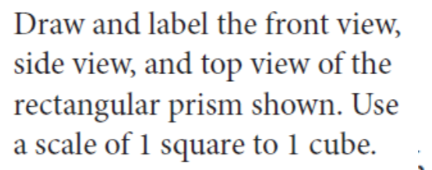

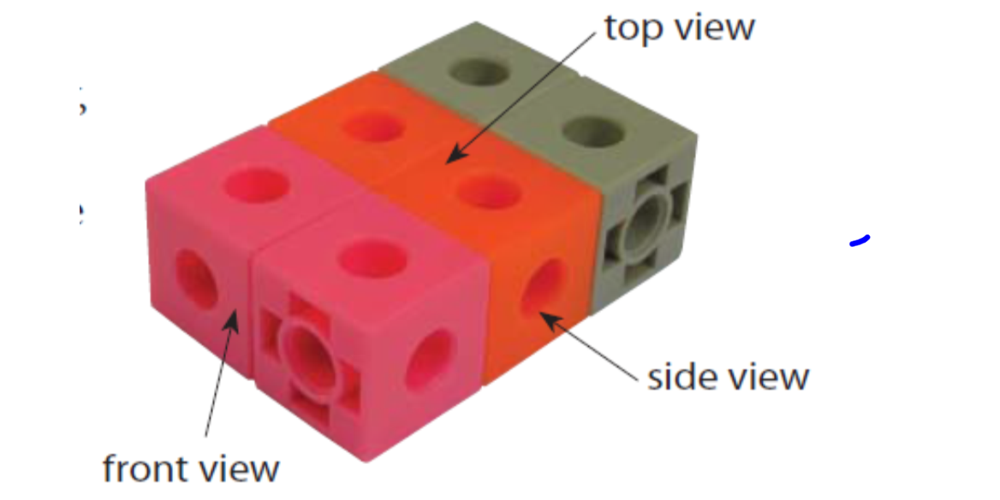
Answer:

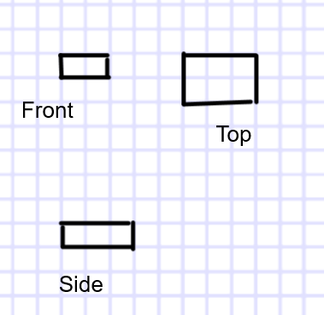

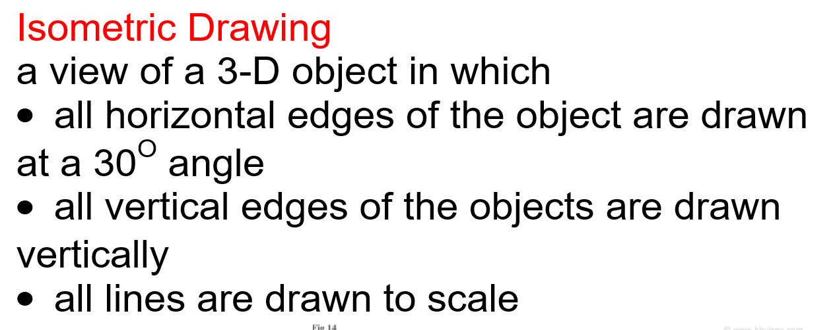

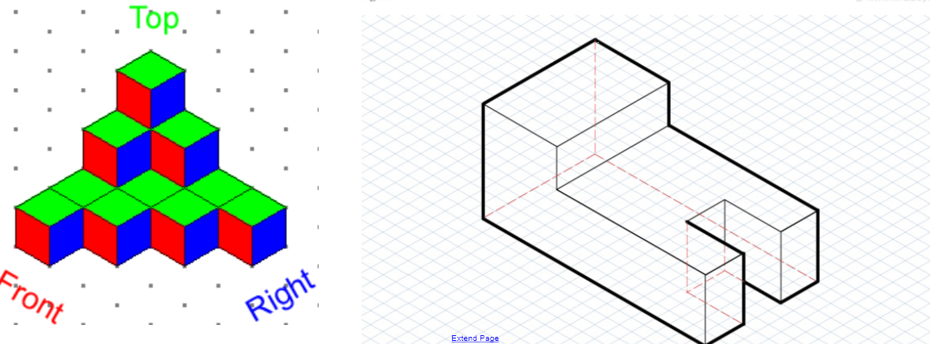

Example:
Sometimes people get a better view of what an object looks like if it is drawn in 3-D. To get this effect isometric drawings can be used. The dimensions of the garage are 20 feet long, 12 feet wide and 12 feet high.

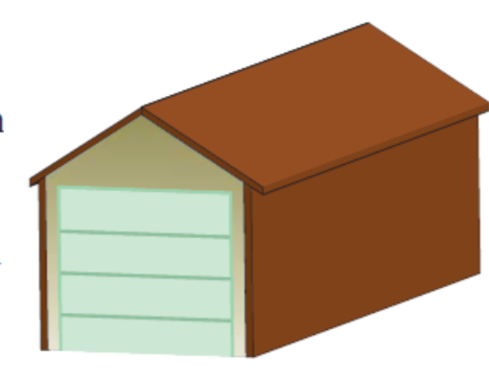
The scale used on the isometric dot paper is the distance between two adjacent dots represents 4 feet.

Step 1: Draw a vertical line between two dots to represent the left side of the garage.
Step 2: Connect the bottom of this line to a dot that is at a 30° angle from it. This distance represents 4 feet along the base of the garage. Extend this line to represent the 12 foot width of the garage.
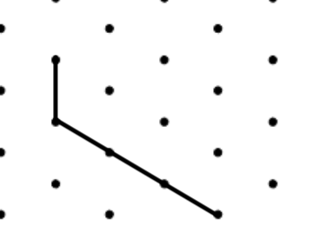
Step 3: From the endpoint of this line, draw a line to represent the 20 foot length of the garage.

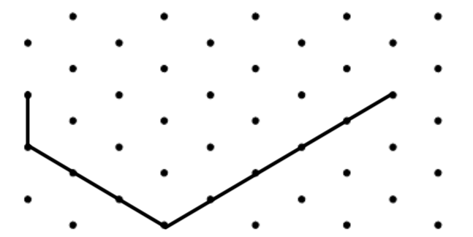
Step 4:
The height of the garage, below the roof is 8 feet. Draw three lines to represent the height of the garage.

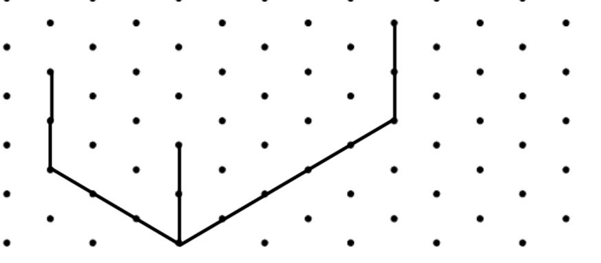
Step 5: Keeping in mind the distance between the adjacent dots represent 4 feet, complete the diagram of the garage.

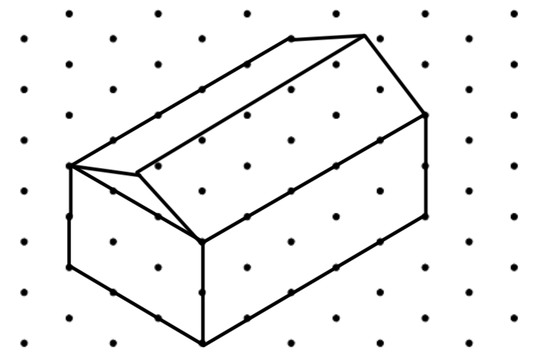
TRY THIS ONE!

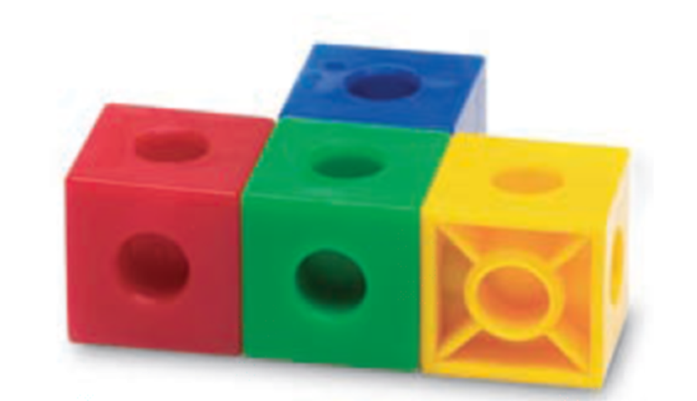
Scale the size between two adjacent sides is the length of 1 cube.

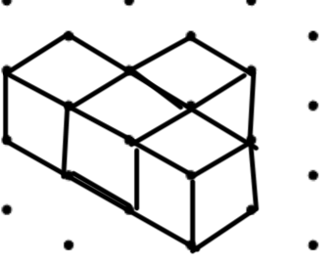
Extra Practice Questions p. 76-77 #1 to 3, 7 to 10
p. 81-82 #2,5,6

