BLM 4.21 Answers
Extra Practice 2 – Master 4.21
Lesson 4.2
1. a) i) Yes
iii) As x increases by 1, y increases by 7.
b) i) No
ii) As x increases by 2, y does not increase by a constant number.
c) i) Yes
iii) As x decreases by 2, y increases
by 3.
d) i) No
ii) As x increases by 1, y does not increase by a constant number.
2.
a) | x | y |  | b) | x | y |  | c) | x | y
 | 1 | 6 |  |  | 1 | 7 |  |  | 4 | 9
 | 2 | 10 |  |  | 3 | 3 |  |  | 2 | 14
 | 3 | 14 |  |  | 5 | –1 |  |  | 0 | 19
 | 4 | 18 |  |  | 7 | –5 |  |  | –2 | 24
 | 5 | 22 |  |  | 9 | –9 |  |  | –4 | 29

a) As x increases by 1, y increases by 4.
b) As x increases by 2, y decreases by 4.
c) As x decreases by 2, y increases by 5.
3.
a) | x | y |  | b) | x | y |  | c) | x | y
 | –2 | 2 |  |  | –2 | –3 |  |  | –2 | 9
 | –1 | 3 |  |  | –1 | –1 |  |  | –1 | 7
 | 0 | 4 |  |  | 0 | 1 |  |  | 0 | 5
 | 1 | 5 |  |  | 1 | 3 |  |  | 1 | 3
 | 2 | 6 |  |  | 2 | 5 |  |  | 2 | 1

a) | b)
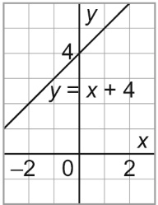 | 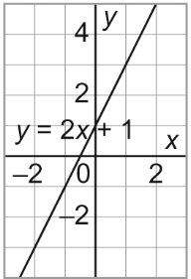
c)
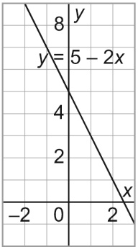

4. a)
Time, n hours | Total Cost, C ($)
1 | 130
2 | 180
3 | 230
4 | 280
b) Yes, as the time in hours increases by 1, the total cost increases by $50.
c) C = 50n + 80
d) $430

