Compound Interest

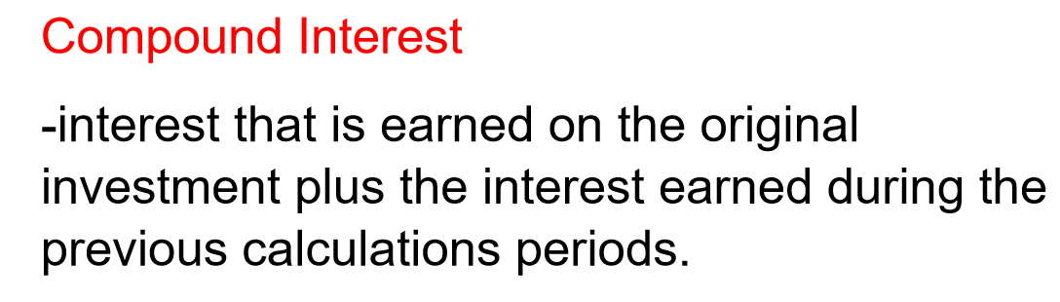
Compound Interest Formula:

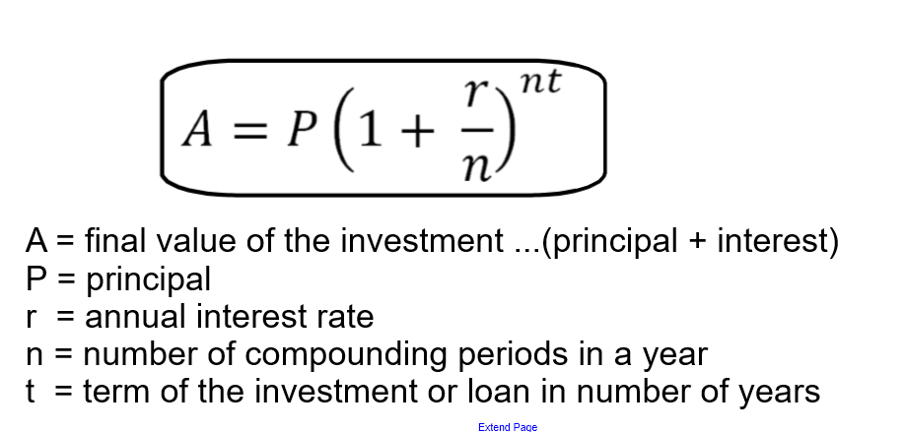
Example 1:
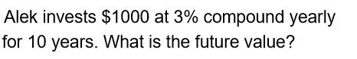

Answer:
It is a good idea to list what we know in the formula before trying to use the formula.
FV ( or A) = ? n = 1 ( compounded yearly = once per year)
P = 1000 t = 10
R= 3% = 0.03

Write down the formula, then fill in the known values.

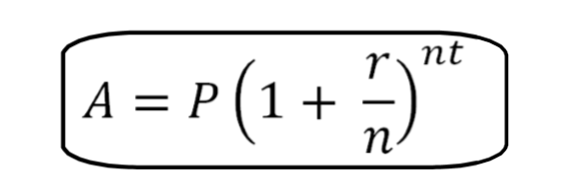
A = 1000( 1 + $\frac{0.03}{1}$ )^{1x10}
= 1000(1.03)¹⁰ ***Follow order of operations***
= 1000 ( 1.343916..)
= 1343.92
The future value of Alek’s investment is $1343.92.

Example 2:
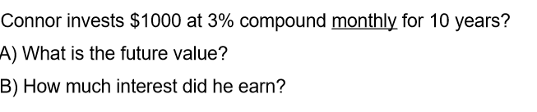

- P = 1000
R = 3% = 0.03
n = 12 ( monthly = 12 times per year)
t = 10
FV = ?

FV = P( 1+ $\frac{r}{n}$ )^{nxt}
FV = 1000( 1 + $\frac{.03}{12}$)^{12x10}
FV = 1000( 1.0025)¹²⁰
FV = 1000(1.3493535…)
= 1349.35
The future value of Conner’s investment is $1349.35.

(b) FV = P + I
So
I = FV – P
I = 1349.35 – 1000
= 349.35
Conner earned $349.35 in interest.

Example 3:

Emma invested $3000 at an interest rate of 2.8%.a compounded semi annually for 5 years.

- What amount of money did Emma have after 5 years?
- How much interest did Emma earn?

Answer:
P = 3000
R= 2.8%= 0.028
n= 2 ( semi annually = twice a year)
t= 5
FV = P( 1+ $\frac{r}{n}$ )^{nxt}
FV = 3000( 1 + $\frac{0.028}{2}$)^{2x5}
FV = 3000(1.014)¹⁰
FV = 3000(1.1491574…)
FV =3447.47
Emma had $3447.47 after 5 years.

- I = FV – P
I = 3447.47 – 3000
I = 447.47
Emma earned $447.47 in interest.

Example 4:

Joey borrowed $4000 to buy a used car. He was charged interest at a rate of 8%/a compounded quarterly. If the loan was for 3 years’ how much money did Joey need to repay?

Answer:

P = 4000
r = 8% = 0.08
n = 4 ( quarterly = 4 times per year)
t= 3

FV = P( 1+ $\frac{r}{n}$ )^{nxt}

FV = 4000( 1 + $\frac{.08}{4}$ )^{4x3}
FV = 4000(1.02)¹²
FV = 4000(1.2682417…)
FV =5072.97

Joey needed to repay $5072.97 after 3 years.

****Extra Practice Questions from the book****
p.236-237 #1 to 6

