Compound Interest YOU MUST SHOW YOUR WORK
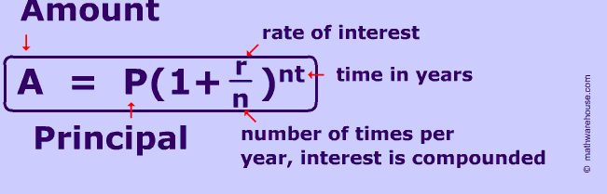
- Complete the following by finding the value for n and i.
 | Rate/a | Time  a = years | Compounded | r  n | nt
a.) | 6% | 2 a | Annually
b.) | 10% | 5 a | Semi-annually
c.) | 8% | 10 a | Quarterly
d.) | 12% | 3 a | Monthly
e.) | 6% | 2.5 a | Monthly
f.) | 6% | 4.25 a | Quarterly

- Determine the amount of the future value
 | Principal | Rate | Time | Compounded | Amount
a.) | $250 | 12% | 2 a | Monthly
b.) | $500 | 8% | 12a | Quarterly
c.) | $1000 | 3.5% | 5 a | Annually
d.) | $2000 | 6% | 15 a | Semi-annually
e.) | $4000 | 6% | 2.5 a | Monthly
f.) | $8000 | 10% | 40 a | Annually

- What is the amount of a $5000 Canada Savings Bonds if invested for 5 a, interest is compounded semi-annually at a rate of 5%/a?

- Calculate the amount and the interest earned on $1000 deposit if invested under the following conditions for a 3 year period.
- 6%, compounded annually

- 6% compounded semi-annually

- 6% compounded quarterly

- 6% compounded monthly

