Khan Academy for Math Grade 7
Follow these steps and you should be working in no time.
- Search Khan Academy for Math Grade 7 in your browser or follow this link. https://www.khanacademy.org/math/cc-seventh-grade-math

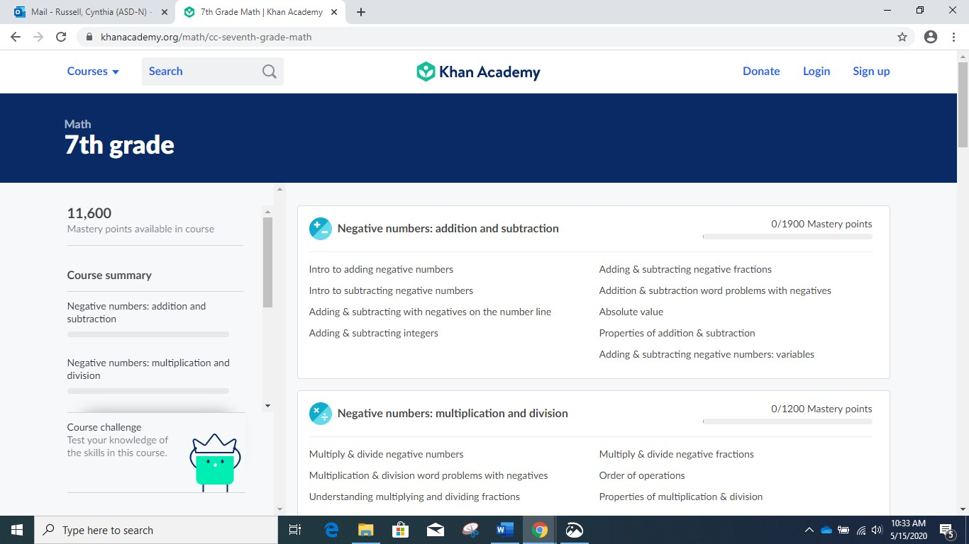

- Click sign up on this page and it will take you to page below. Click learner and add your birth date. The next screen will ask you for an email address, your name and a password. By logging in you will be able to track your progress and collect points for your review.
- Now you are ready to start. Simply press the Get Started for the first unit -Negative numbers addition and subtraction.

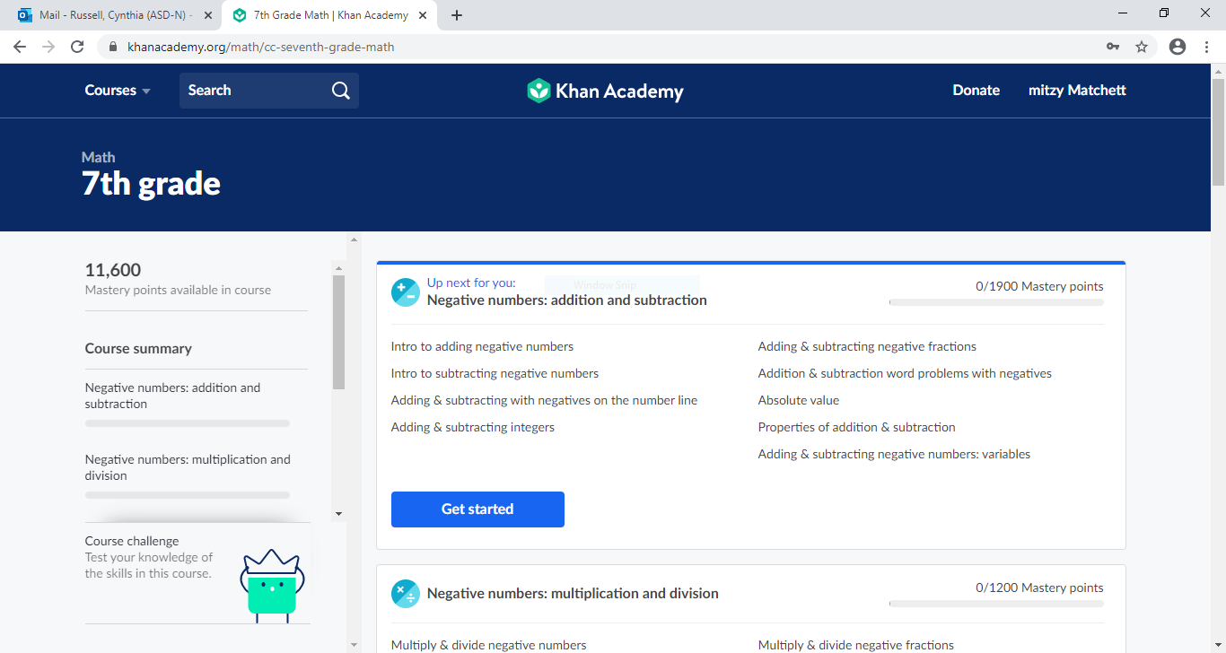

- The first section is intro to adding negative numbers. For each section there is a learn section on the left of the box, and a practice section. If you feel confident go straight to the practice and just go to the learn section if you run into a problem.

On the far left of the page is your skill summary and your point total which will help keep track of your progress.

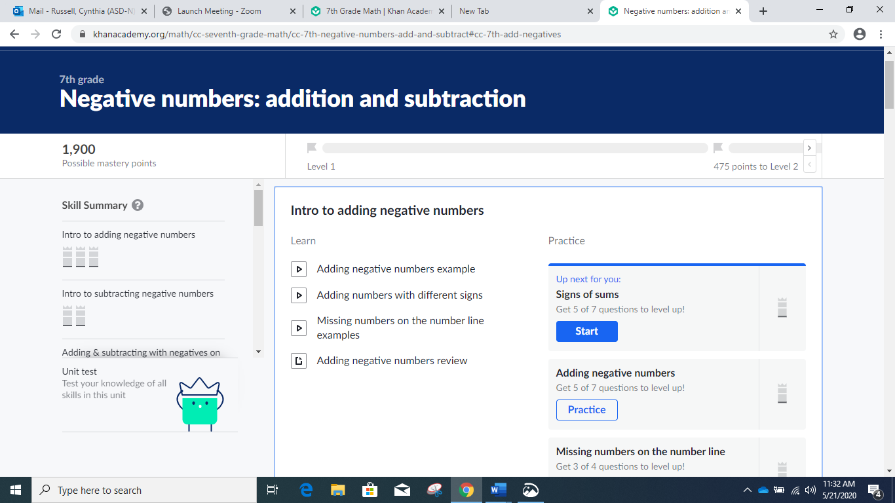

- You may be able to speed through some sections and others may be more challenging but remember this will be your best review of Grade 7 and preparation for next year’s grade 8 work!

