Lesson 11
RF7 Determine the equation of a linear relation, given: a graph, a point and the slope, two points, a point and the equation of a parallel or perpendicular line, a scatter plot.

Slope-Point Form of the Equation for a Linear Relation

Determine the equations of the line.
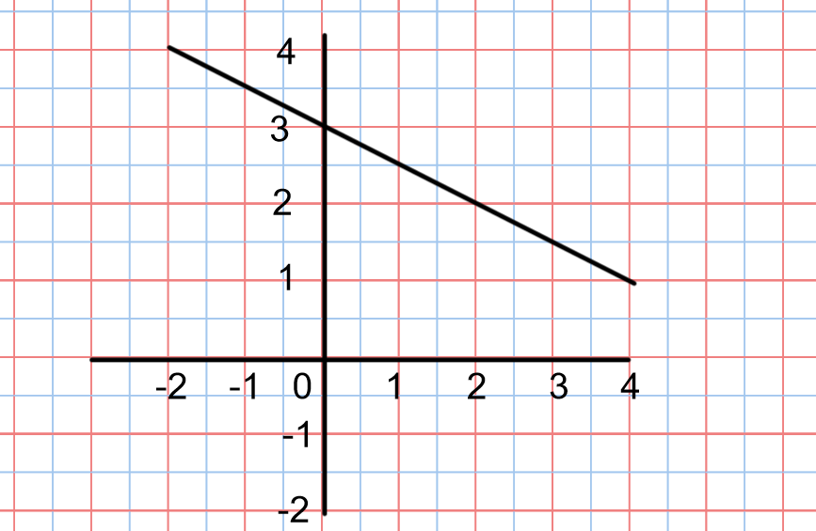

Recall from the previous lesson, to find the equation of the line in slope-intercept form ( y= mx +b) we need to find the slope and the y intercept
To find the slope form a graph use
m = $\frac{rise}{run}$ or choose two points and use m = $\frac{y2-y1}{x2-x1}$
Using (2,2) and (4,1)
m = $\frac{-1}{2}$
The y-intercept(b) is the point on the graph where the graph crosses the y axis.
b = 3
The equation of the graph is : y = $\frac{-1}{2}$ x + 3

Now try this one:

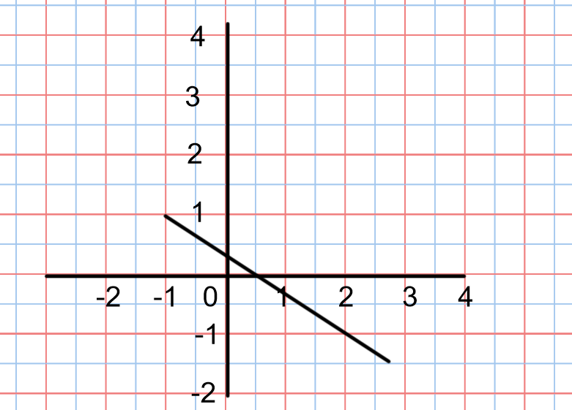

The slope can be found using two points on the graph.
(-1, 1) and (2,-1) are two points on the graph.
m = $\frac{-1-1}{2-(-1)}$
= $\frac{-2}{3}$
Now there is a problem- It is not possible to determine the y intercept exactly from the graph.
The slope and one of the points can be used to find the y intercept.

y = mx +b
Fill in the slope y = $\frac{-2}{3}$ x + b
Fill in the co-ordinates of one of the points for x and y .
Filling in (-1.1) gives
1 = $\frac{-2}{3}$ (-1) + b
1 = $\frac{2}{3}$ + b
1 - $\frac{2}{3}$ = $\frac{2}{3}$ - $\frac{2}{3}$ + b
$\frac{1}{3}$ = b
Equation
y = $\frac{-2}{3}$ x + $\frac{1}{3}$

Putting the equation in Point-Slope form is another way to write the equation of a line when the y intercept can’t be directly found from the graph.

Point-Form of the Equation of a Linear Function
The equation of a line that passes through P(x₁,y₁) and has a slope of m is:
y – y₁ = m( x – x₁)

Example 1:
- Write the equation in slope-point form for the line below.
- Write the equation in part (a) in slope-intercept form. What is the y-intercept of the line?

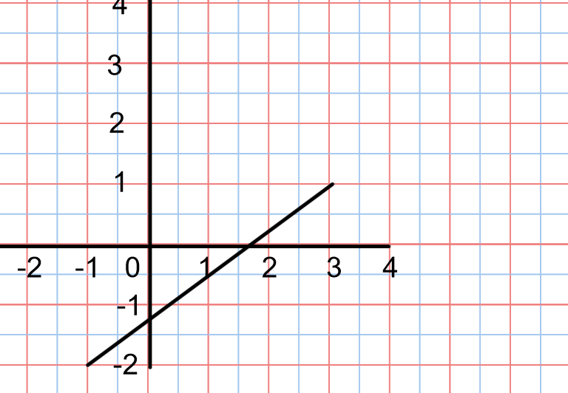

- Answer:
Find 2 points on the line and find the slope.
Two points on the line are ( -1,-2) and (3,1)

m = $\frac{1-(-2)}{3-(-1)}$
= $\frac{3}{4}$

Now pick one of the points and write the equation of the line using

y – y₁ = m( x – x₁)

Using (-1,-2) the equation would be : y- (-2) = $\frac{3}{4}$ ( x – (-1))
Don’t leave double negative signs so the equations becomes
y + 2 = $\frac{3}{4}$ ( x + 1)
Using (3,1) the equation would be : y -1 = $\frac{3}{4}$ ( x -3)

- To get the equation from (a) into slope-intercept form it must be rearranged so that y is by itself on one side of the equation.
***NOTE: It doesn’t matter which of the equations you use from (a) the answer will be the same equation in (b) when it is in slope intercept form***

Using y -1 = $\frac{3}{4}$ ( x -3)
First multiply and get rid of the brackets
y -1 = $\frac{3}{4}$ x - $\frac{9}{4}$
Move -1 to the right by +1 on both sides of the equations
y -1 +1 = $\frac{3}{4}$ x - $\frac{9}{4}$ +1
Now deal with the fractions and simplify the equation.
DO NOT CHANGE THE FRACTIONS TO DECIMALS!!!!
y = $\frac{3}{4}$ x - $\frac{9}{4}$ + $\frac{4}{4}$
y = $\frac{3}{4}$ x - $\frac{5}{4}$
The intercept of the line is $\frac{-5}{4}$.

Example 2:
Find the equation of the line in Slope-Point Form that passes through point P( 5,2) and Q( 7,-6)

Answer:
Find the slope m = $\frac{y2-y1}{x2-x1}$
m = $\frac{-6-2}{7-5}$
m = $\frac{-8}{2}$
m = -4
Now write the equation of the line in the form y – y₁ = m( x – x₁)

Using P(5,2) gives y – 2 = -4(x – 5) or

Using Q(7,-6) gives y-(-6) = -4(x -7)
Which simplified is y + 6 = -4(x -7)

TRY THESE:
For each of the following give the equation of the line in slope-point and slope intercept form.

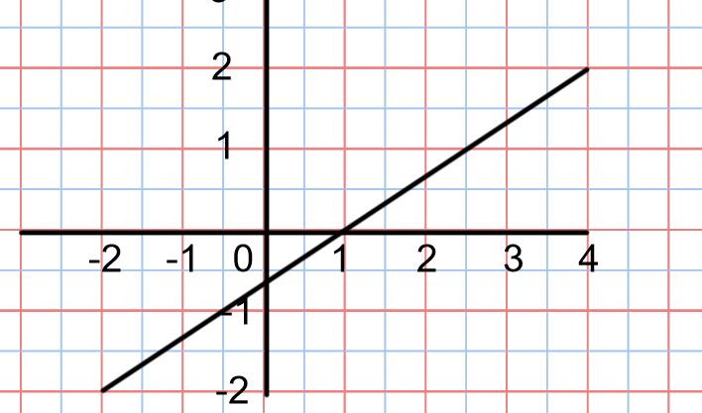

- The line passing through K( -7,-3) and L(-4 ,6)

Answers:
- Slope- Point Slope- Intercept
y + 2 = ⅔(x+2) or y -2 = ⅔(x-4) y =⅔x - ⅔

- y + 3 = 3(x+7) or y -6 = 3(x + 4) y = 3x + 18

Example 3:
- Describe the graph of the linear function with the equation:
y + 3 = ⅗ ( x – 1)

- Graph the equation
Answer:
- The equation is in slope- point form. The slope is located in front of the brackets with the x co-ordinate. The slope of this line is $⅗$.
The x co-ordinate of the point is 1. The y co-ordinate is -3.
The description of the line would be: The line passes through point(1,-3) with a slope of ⅗.

- Graph
Mark the point (1,-3) on the graph. Use the slope to locate the next point.

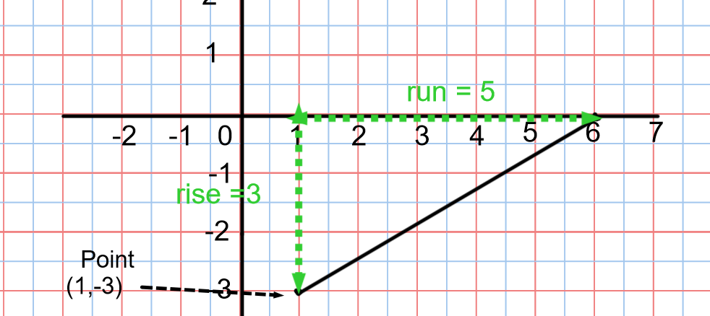

Example 4:
The sum of the angles , d degrees, in a polygon is a linear function of the number of sides, n, of the polygon. The sum of the angles in a triangle is 180°. The sum of the angles in a quadrilateral is 360°.
- Write a linear equation to represent the function.
- Use the equation to determine the sum of the angles in a dodecagon.
Answer:
- A triangle has 3 sides and the angle sum is 180°. This information can be written as an ordered pair, (3,180). Similarly a quadrilateral has 4 sides and an angle sum of 360° so this information can be written as (4,360)
Find the slope

m = $\frac{y2-y1}{x2-x1}$
m = $\frac{360-180}{4-3}$
m = 180
The equation would be y-180 = 180( x- 3) or y – 360 = 180(x -4)

- A dodecagon has 12 sides, so substitute 12 in the x for one of the equationand solve for y.

y – 180 = 180( x -3)
y – 180 = 180 ( 12-3)
y – 180 = 180 (9)
y – 180 = 1620
y -180 +180 = 1620 + 180
y = 1800
The angle sum in a dodecagon is 1800°.

Example 5:
Write an equation of the line that passes through (4,5) and is
- Parallel to the line y= ⅔x -5
- Perpendicular to the line y = ⅔x -5
Answer:
- “Parallel to” always means has the same slope
y= ⅔x -5 is in slope intercept form
The slope of the line is ⅔. For a line to be parallel it also has a slope of ⅔.
The equation is
y – 5 = ⅔( x -4)

- To find the slopes of perpendicular lines use the negative reciprocal
The negative reciprocal of ⅔ is $\frac{-3}{2}$ .
The equation is
y – 5 = $\frac{-3}{2}$ ( x – 4)

Practice Questions from textbook : p.372-374 #4 to 14 & 18 to 25

