Lesson 11
Goal: To use trigonometric ratios to solve problems with right triangles.

Solving Problems with 1 Right Triangle

The Angle of Elevation of an object above the horizontal is the angle between the horizontal and the line of sight of an observer.

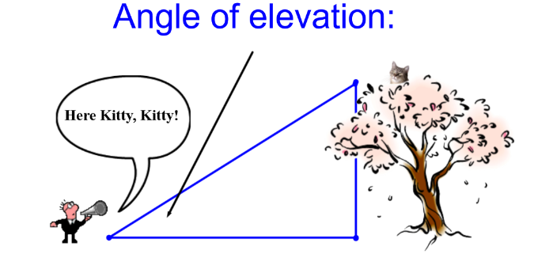
The Angle of Depression is the angle between the horizontal through eye level and a line of sight to a point below eye level.

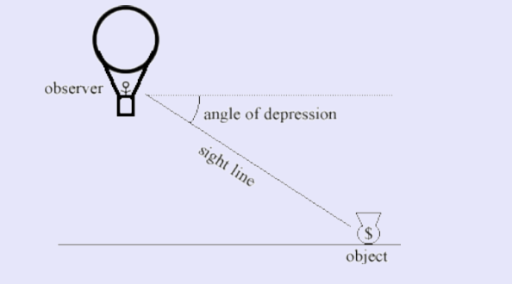

Example 1:

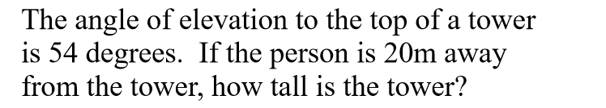

Draw and label a diagram

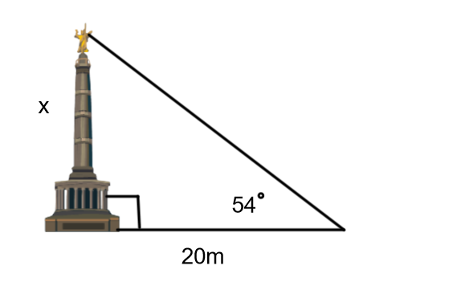
Next decide what trig ratio to use.
Using the angle of elevation as the reference angle, we know the side adjacent to it and we need to find the opposite side. Tangent ratio should be used.
tan 54° = $\frac{x}{\begin{aligned}20 \\ \end{aligned}}$
then solve 20 tan 54°= x
27.5 m = x
The tower is 27.5 m tall.

Example 2:

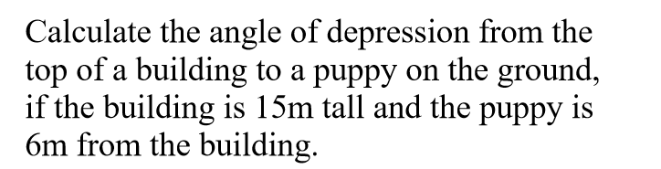
Draw and label a diagram:

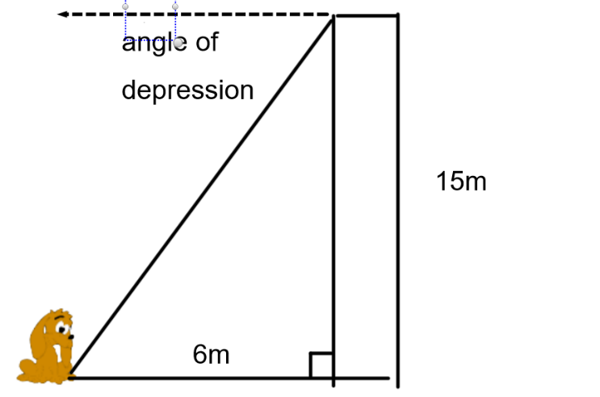

****Note when dealing with angle of depression- The angle of depression from the top of the building to the dog on the ground is equal to the angle of elevation from the dog to the top of the building ( assuming a flat ground). These angles are called alternate angles. From grade 9 we know that alternate angles between parallel lines are equal. ***

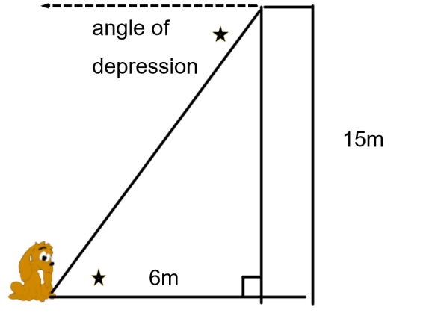Ꝋ
If we fine the angle of elevation we will know what the angle of depression is.
To decide what ratio to use, use as the reference angle.
The opposite and adjacent sides are known so tangent ratio is used to find the angle.
tan Ꝋ = $\frac{15}{6}$
tan Ꝋ = 2.5
Ꝋ = tan⁻¹ 2.5
Ꝋ = 68.2°
The angle of depression is 68.2°.

Example 3:
Determine the perimeter of the triangle.
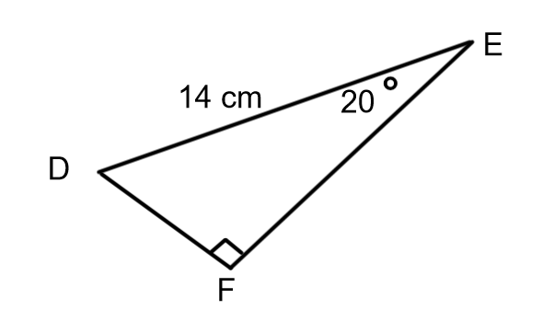

To find the perimeter of the triangle we need to find the missing sides. DF is the side opposite to the known angle and 14 cm is the hypotenuse. The sine ratio can be used to find DF
sin 20° = $\frac{DF}{14}$
14 sin 20°= DF
4.8 = DF
Use Cosine ( or the Pythagorean Theorem) to find EF
cos 20° = $\frac{EF}{14}$
14 cos 20$°$ = EF
13.2 =EF
Perimeter = 14 + 13.2 + 4.8
= 32
The perimeter of the triangle is 32 cm.

Solving Problems with 2 Right Triangles

Ex 4:
Find the length of BC.
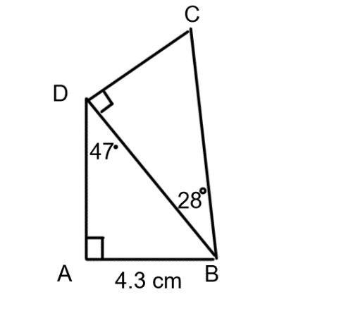
Side BC is in ∆BCD. The only measurement we know in this triangle is one angle. To find BC we need one side of ∆BCD.
Side BD is a common side to both triangles. Use ∆ABD to find the length of BD .

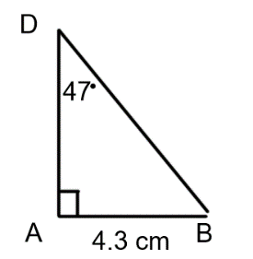
BD is the hypotenuse and AB is the opposite side to the known angle. Sine can be used to find BD.

sin 47° = $\frac{4.3}{BD}$
BD sin 47°= 4.3 Cross multiply and solve
BD = $\frac{4.3}{\sin{47}}$
BD = 5.9
Now look at the other triangle
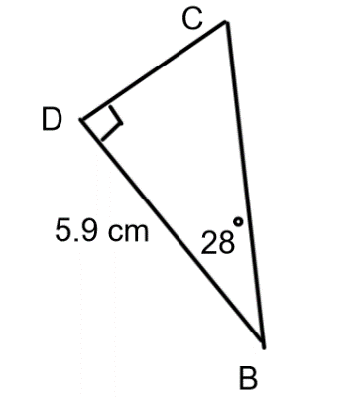
BC is the hypotenuse and BD is the adjacent side to the known angle so the cosine ratio can be used to find BC.
cos 28°= $\frac{5.9}{BC}$
BC cos 28°= 5.9
BC = $\frac{5.9}{\cos{28}}$
BC = 6.7
BC is 6.7 cm long.

Ex 5:
A communication tower is 35m tall. From a point due west of the tower, Camden measures the angle of elevation to the top of the tower to be 72°. Matthew is due east of the tower and measures the angle of elevation to the top of the tower as 47° from his location. How far apart are Camden and Matthew?

Answer:
Draw a diagram

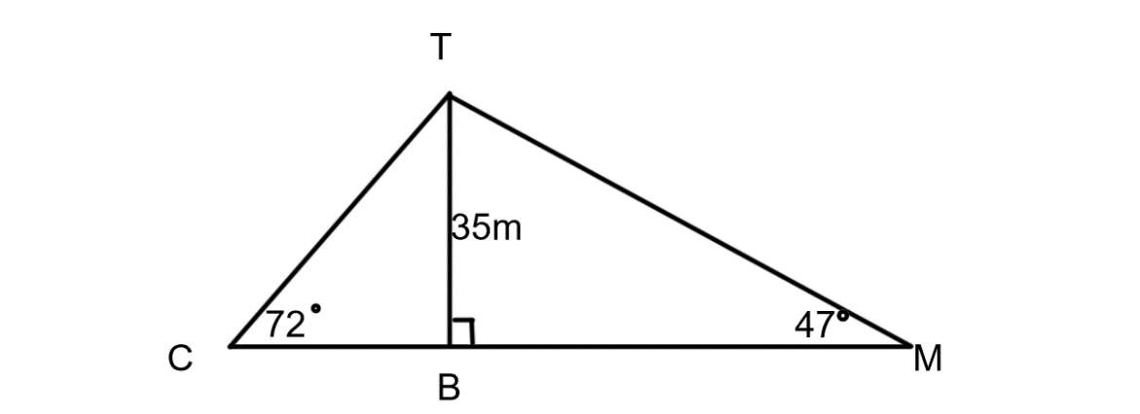
The total distance needed is length CM. To find CM find lengths CB and BM and add them together.

tan 72° = $\frac{35}{BC}$
BC x tan 72°= 35
$\frac{BC x\tan{72}}{\tan{72}}$ = $\frac{35}{\tan{72}}$
BC = 11.4

tan 47$°$ = $\frac{35}{BM}$
BM x tan 47° = 35
$\frac{BM x\tan{47}}{tan47}$ = $\frac{35}{\tan{47}}$
BM = 32.6
BC + BM = 11.4 + 32.6 = 44
Camden and Matthew are 44m apart.

Practice Questions:
From Foundations & Pre-Calculus Mathematics 10 (orange book from last term) do p.118-119 #3 to 12.

This link for this book can be found on my teacher page

