Lesson 8
RF3 Demonstrate an understanding of slope with respect to rise and run, line segments and lines, rate of change, parallel lines, perpendicular lines.

The slope of a line is a measure of the steepness of a line.
Slope of a line on a grid can be found using
Slope = $\frac{Rise}{Run}$
The rise of a line is the change in the dependent (y) variable.
The run of a line is the change in the independent (x) variable.
Slope can also be called rate of change. The letter m is used to represent slope.

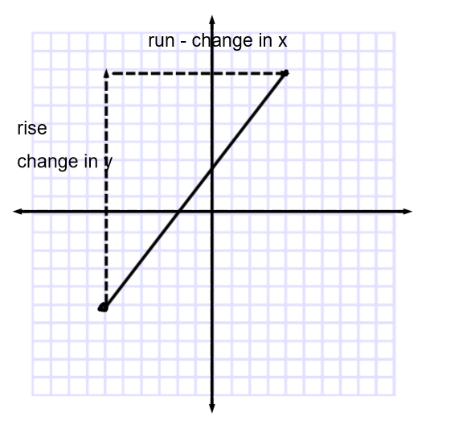

Examples:

Find the slope of each of the following:

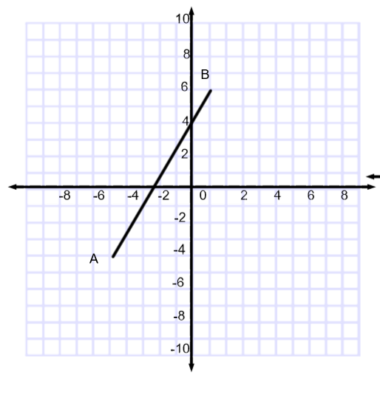
Answer:
Find the rise and run of the line

To get from A to B ( always move from the leftmost point to the rightmost point to avoid mixing up signs) we start with A which has a y co-ordinate of -4. B has a y co-ordinate of 6. To get from -4 to 6 we go up 10 units. The rise of the line is therefore 10.

To get from A to B we move from -5 on the x axis to 1 on the x axis, This is 6 units. The run of the line is 6.

Slope = $\frac{Rise}{\begin{aligned}Run \\ \end{aligned}}$
= $\frac{10}{6}$
= $\frac{5}{3}$ *** Always reduce fractions***
(b)

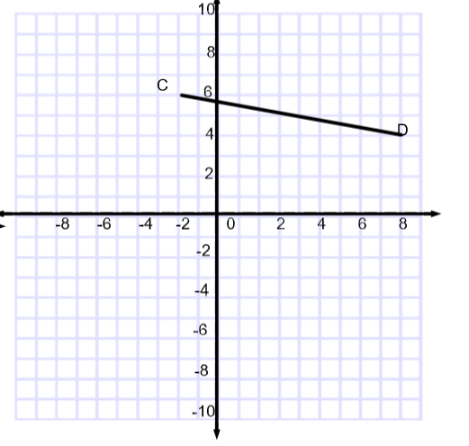

To go from C to D we have to go down 2 units. The rise is -2.
We have to go over 10 units so the run is 10.

Slope = $\frac{rise}{run}$
= $\frac{-2}{10}$
=$\frac{-1}{5}$

(c)
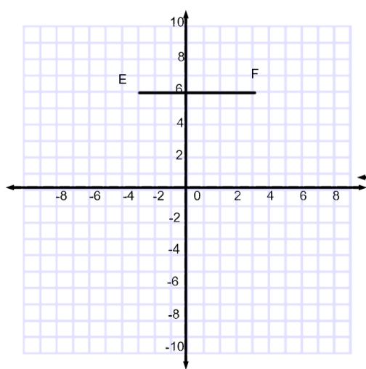

To get from E to F we don’t need to move up or down so the rise is 0. To get from E to F we go over 7 units.

Slope = $\frac{Rise}{Run}$
= $\frac{0}{7}$
= 0
EF is a horizontal line. It is a flat line, rise is 0, so slope 0. This is true of all horizontal lines.

(d)
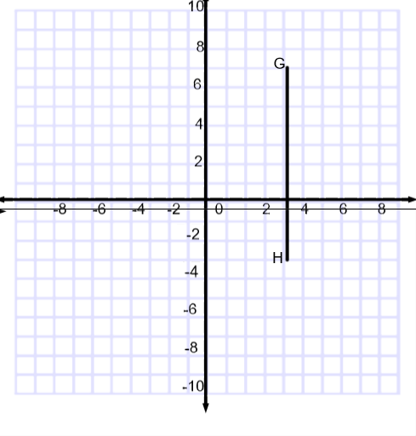

To get from G to H we go down 10 units. The rise is -10. GH is a vertical line so we don’t move along the x-axis to get from one point to another. The run is 0.

Slope = $\frac{rise}{run}$
= $\frac{10}{0}$
It is not possible to divide by zero so the slope here is called undefined.
Slopes of all vertical lines are undefined, because the run will always be zero.

Recap:
When a line segment goes up to the right, both y and x increase; both the rise and run are positive, so the slope of the line segment is positive.
Looks like

When a line segment goes down to the right, y decreases and x increases; the rise is negative and the run is positive, so the slope of the line segment is negative.

Looks like

For a horizontal line segment, the change in y is 0 and x increases. The rise is 0 and the run is positive.
Looks like

For a vertical line segment , y increases and the change in x is 0. The rise is positive and the run is 0.

Looks like

Using the slope formula to find slope.

We know slope is $\frac{rise}{run}$ . Rise is the change in the y values and run is the change in the x values. From this the slope formula is developed.

Slope Formula
Slope = $\frac{y2-y1}{x2-x1}$

When a line passes through A(x₁,y₁) and B(x₂,y₂)

Ex: Find the slope of the line passing through A(1,2) and B( -2, 0)
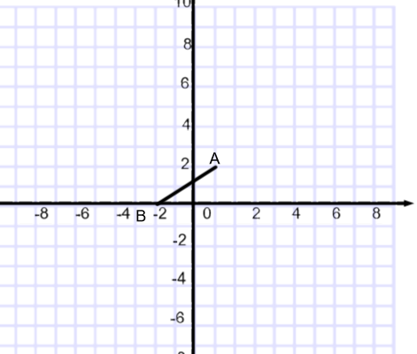
We could draw the graph

Slope = $\frac{Rise}{Run}$
= $\frac{2}{3}$
Or using the slope formula
Slope = y₂ -y₂
x₂ -x₁
= $\frac{0-2}{\begin{aligned}-2-1 \\ \end{aligned}}$
= $\frac{-2}{-3}$
= $\frac{2}{3}$
Ex: Find the slope of the line connecting P(-2,-4) to Q (6, -2)
Using the formula Slope = y₂ -y₂
x₂ -x₁
= $\frac{-2-(-4)}{\begin{aligned}6-\left(-2\right) \\ \end{aligned}}$
= $\frac{2}{8}$
=$\frac{1}{4}$

Practice questions from the textbook p. 339-341 #5-27

