Lesson 8
Goal: To use trigonometric ratios to calculate angle measurements in right triangles.

Recall from grade 8 & 9:
When we know two sides in a right triangle the third side can be found using the Pythagorean Theorem.
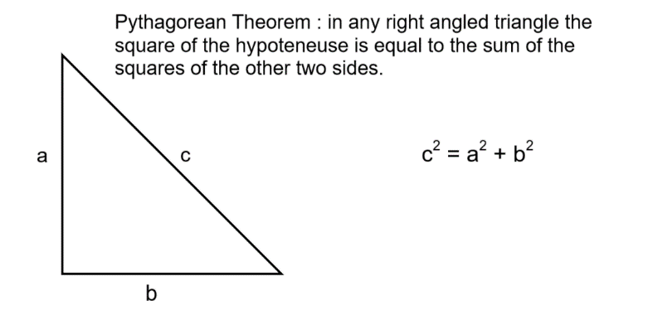

Examples :
Find the missing side in each
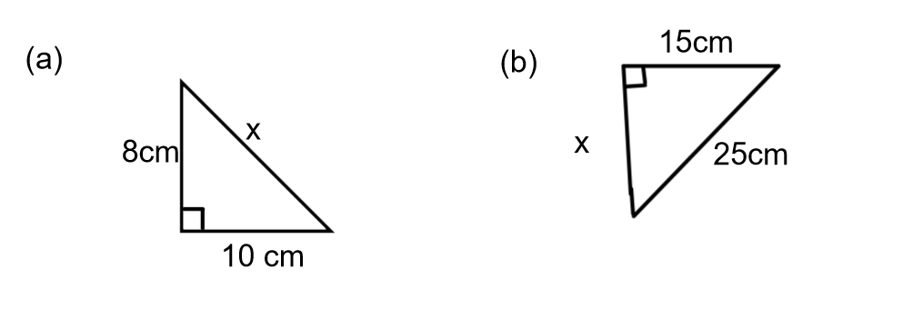
Answers:
- a² + b² = c²
8² + 10² = x²
64 + 100 =x²
164 = x²
√164 = √x²
12.8 = x

- c² – a² = b²
25²- 15² = x²
625-225 = x²
400 = x²
√400 = √x²
20 = x

Trigonometric ratios ( sine, cosine and tangent) can be used to find the angles in a right triangle if you know 2 sides.

Part 1: Using the tangent ratio to find angle measures.
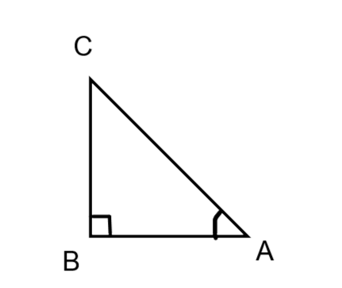

Opposite side hypotenuse

Adjacent side

∆ABC is a right triangle. We name the sides of a right triangle in relation to one of its acute angles. We are using <A to start. The side directly across from <A is the opposite side. The side across from the right angle is the hypotenuse. The side that is beside the <A is called the adjacent side.

These should always be labelled on the diagram before you start any trigonometry problem.

The Tangent Ratio
If <A is an acute angle in a right triangle, then

Tan A = length of the side opposite <A
Length of the side adjacent to <A

Example:

Determine tan D and tan F

D

3cm

E 4cm F

First use < D and label the sides.

D
hyp
3cm
adj

E 4cm F
opp

Tan < D = opposite side
adjacent side
= 4
3
= 1.33

Now use < F and label the sides

D

3cm hyp
opp

E 4cm F
Adj

Tan < F = opposite side
adjacent side
= 3
4
= 0.75

Knowing the tangent ratio will allow us to take the process one step further and find the size of the angles.

Before doing any calculations using trigonometric ratios make sure your calculator is in degrees

Taking the examples one step further:

What is the size of angle D and angle F ?

We know tan <D = 1.33

To find the angle size use tan⁻¹ button on the calculator. ( On most calculators you would press the shift or or inverse button then tan)
< D = tan⁻¹ 1.33
<D = 53.1°

In a similar manner ,
Tan <F = 0.75
<F = tan⁻¹ 0.75
<F = 36.9°

You can check using SATT that this is correct (53.1 + 36.9 + 90 = 180)

Example 2:

Determine the measures of <G and <J to the nearest tenth degree.

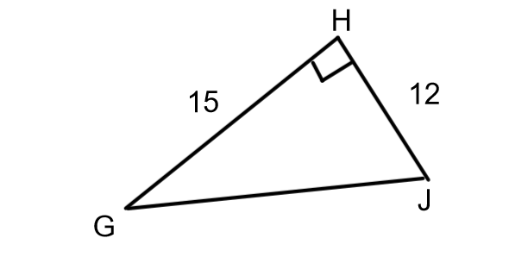

Find <G. Label the sides.

Adjacent side opposite side

hypotenuse

tan < G = opp side
adj side
= 12
15
= 0.80
<G =tan⁻¹ 0.80
<G = 38.7°

Label sides using <J
Opposite side

Adjacent side

hypotenuse
tan < J = opp side
adj side
= 15
12
= 1.25
<J = tan⁻¹ 1.25
<J = 51.3°

TRY THIS ONE:
Determine the measure of <K and <N to the nearest tenth of a degree.

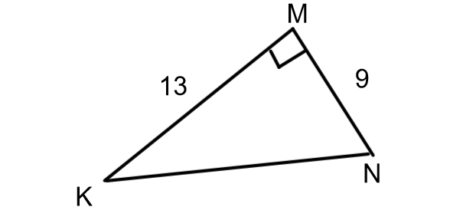
(Answers: <K = 34.7° and <N =55.3°)

Example 3:

A road rises 12ft in altitude for every 100ft of horizontal distance. What is the angle of inclination of the road?

Answer:

First draw the diagram and label the sides (O,A and H)
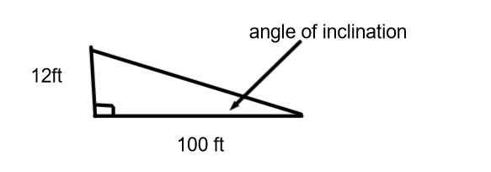

Opposite side

Adjacent side

We know the opposite side and the adjacent side so the tangent ratio can be used. The symbol Ꝋ (theta) is often used to denote an unknown angle, in the same way as we use x to denote an unknown side.

Setting up the ratio

Tan Ꝋ = opp
Adj
Tan Ꝋ = 12
100
Tan Ꝋ = 0.12
Ꝋ = tan⁻¹ 0.12
Ꝋ = 6.8°
The angle of inclination of the road is 6.8°.

Example 4:

A 12 ft ladder leans against the side of a building with the base 5ft from the wall.
What angle, to the nearest degree, does the ladder make with the ground?

Answer:

First draw and label a diagram

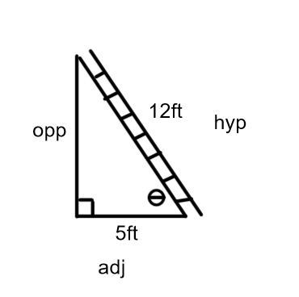

In this example the adjacent side and the hypotenuse are known. To use the tangent ratio the opposite side needs to be known

We can find the opposite side using the Pythagorean Theorem.

a² = c² – b²
a² = 12² – 5²
a² = 144 -25
a² = 119
a =√ 119
a = 10.9
Next use the tangent ratio.
Tan Ꝋ = 10.9
5
Tan Ꝋ = 2.18
Ꝋ = tan⁻¹2.18
Ꝋ = 65°

The ladder makes a 65° angle with the ground.

Practice Questions:
From Foundations & Pre-Calculus Mathematics 10 (orange book from last term) do p.75-77#3 to 5,8, 10,11, 13 to 18.

This link for this book can be found on my teacher page.

Part 2: Using Sine and Cosine ratios to find unknown angles in a right triangle.

In example 4 from the previous section, we knew the adjacent side and the hypotenuse . We use the Pythagorean Theorem to find the opposite side so we could use the tangent ratio to find the angle.

This step would not be necessary if we knew the other two primary trigonometric ratios.

Sine of an angle = length of the opposite side to the angle
length of the hypotenuse

Cosine of an angle = length of the adjacent side
length of the hypotenuse

Example 1:

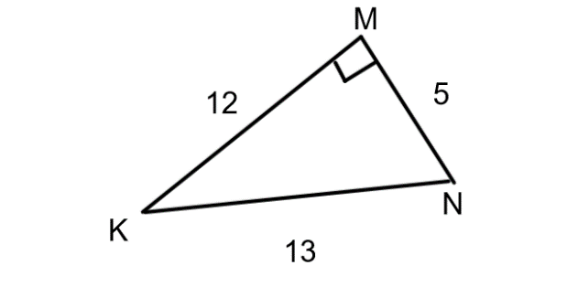

- Determine the sine of <K and the cosine of <K to the nearest thousandth.
- What is the measure of <K?

Step 1 is to label the sides

Adjacent opposite

Hypotenuse
Sin < K = opposite side cos <K = adjacent side
Hypotenuse hypotenuse
Sin <K = $\frac{5}{13}$ cos <K =$\frac{12}{13}$
= 0.385 =0.923
(B) To find the size of the angle when we know the ratio w could use either sine⁻¹ or cosine⁻¹ .
<K = sin⁻¹0.385 or <K = cos⁻¹ 0.923
<K = 22.6° or <K = 22.6°
They should be equal because we are using the same angle , just different ratios.

Example 2:

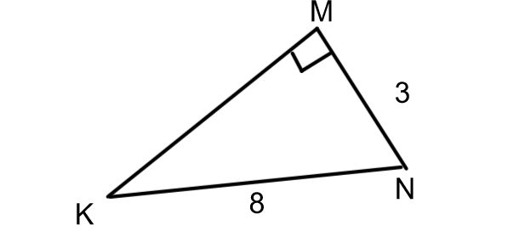
Find the measure of < N.
Answer
Label the sides
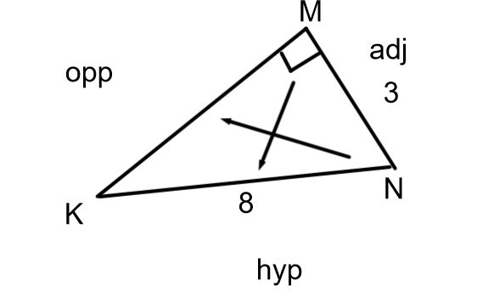

Take note of what 2 sides have numbers on them. In this case the adjacent and hypotenuse are both known. The trigonometric ratio with adjacent and hypotenuse in it is cosine, This is the ratio we should use

Set up the ratio

Cos <N = $\frac{adj}{hyp}$
=$\frac{3}{8}$
= 0.375
<N = cos⁻¹ 0.375
<N = 68°

Example 3:

Find <C

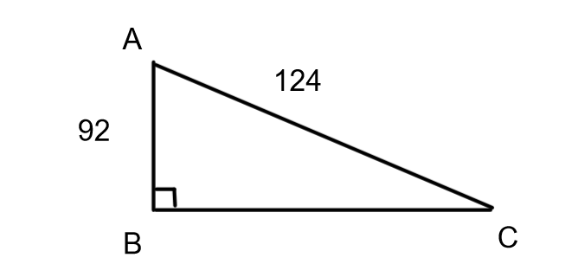

Label the diagram

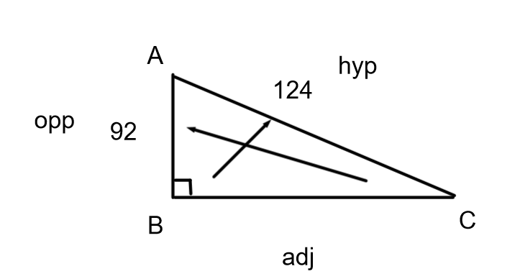
This time the opposite side and the hypotenuse are known so sine will be used.

Sin <C =$\frac{opp}{hyp}$
Sin<C = $\frac{92}{\begin{aligned}124 \\ \end{aligned}}$
Sin <C = 0.7419
<C = sin⁻¹ 0.7419
<C = 48°

TRY THESE:
- Find <K

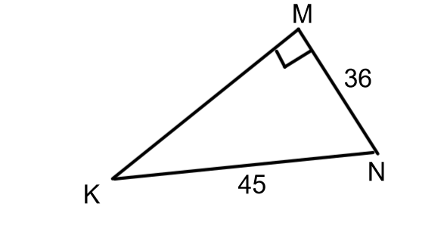
- Find <A

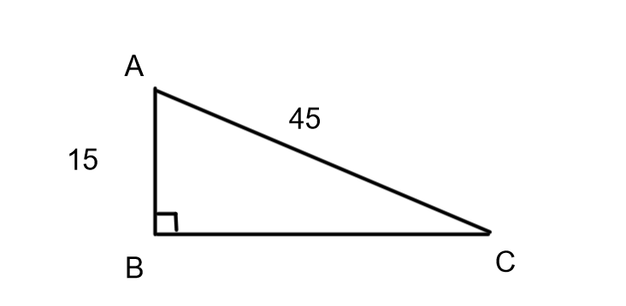

(Answers (1) <K = 53.1° (2) <A = 70.5°)

Example 4:

A water bomber is flying at an altitude of 6000ft. The plane’s radar shows that it is 9200ft from the target site. What is the angle of elevation of the plane measured from the target site, to the nearest degree?

(NOTE: Angle of elevation of an object above the horizontal is the angle between the horizontal and the line of sight from the observer)

Draw a diagram
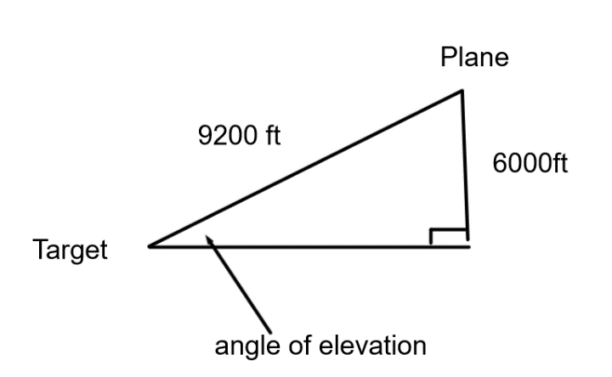

Label the diagram

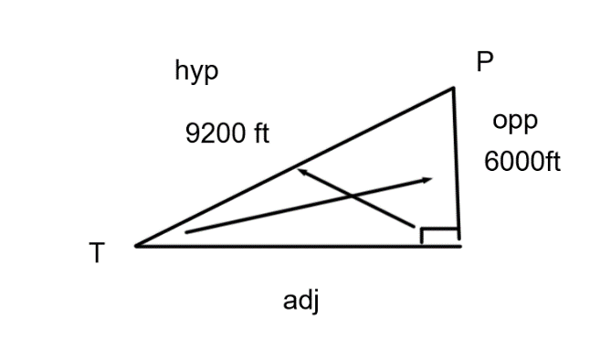
The angle of elevation is at <T. The opposite side from T and the hypotenuse are know so we will use sine to find <T

Sin <T = $\frac{opp}{hyp}$
Sin <T =$\frac{6000}{9200}$
Sin <T = 0.6522
<T = sin⁻¹ 0.6522
<T = 41°

The angle of elevation of the plane as measured from the target is 41°.

Practice Questions:
From Foundations & Pre-Calculus Mathematics 10 (orange book from last term) do p.95-96#4 to 14.

This link for this book can be found on my teacher page.

