Lesson 9
Goal: To use trigonometric ratios to calculate unknown side lengths in right triangle.

Recall the three Primary Trigonometric Ratios from the last lesson
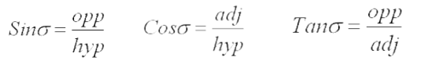

If we know one side and one of the acute angles in a right triangle, the trig ratios can be used to find the other side measures in the triangle.
For Example:
Find the length of AB

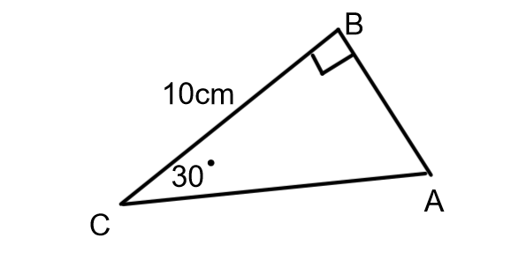
Label the sides using the known angle, <C, as the reference angle.

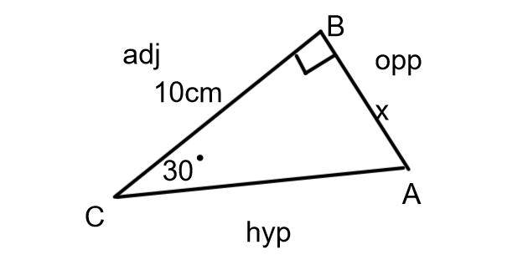
The side we are looking for is the opposite side. The side that we know the length of is the adjacent side. The trig ratio with opp and adj is tangent.
Once the ratio we need to use had been identified set it up.

tan 30° = $\frac{x}{10}$ For now use x to represent the side we need to find
Cross multiply to solve the equation
10 x tan 30 = x
5.8 cm = x (Note- Use tan not tan⁻¹. The size of the angle is known.)

Example 2:

Find the length of BC.

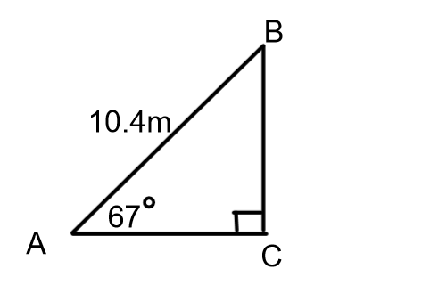
Label the sides using the known angle as the reference angle.

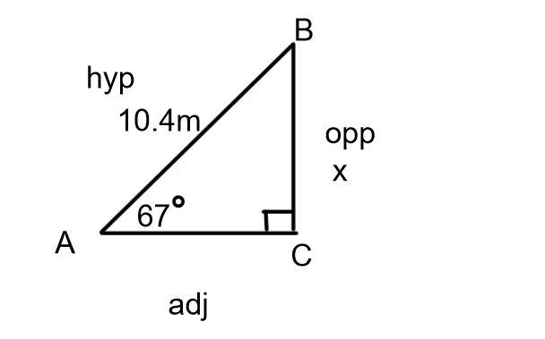
The opposite side is the side we are looking for and the hypotenuse is the known side. The trig ratio that uses opp and hyp is sine. Set up the ratio and solve.
Sin 67 = $\frac{x}{10.4}$
10.4 x sin 67 = x
9.6m = x ( This is a reasonable answer since the hypotenuse is always the longest side)

Example 3:

Find PR

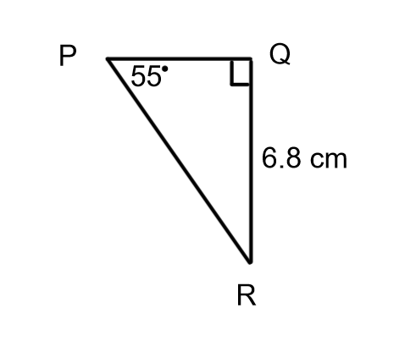
Label the sides using the known angle as the reference angle.
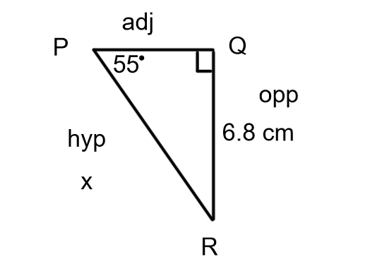
The opposite side in known and the hypotenuse is the side we are looking to find. Use the sine ratio.
Sin 55° = $\frac{6.8}{x}$ cross multiply
x sin 55° = 6.8 solving requires an extra step
x sin 55° = 6.8
sin 55° sin55°
x = 8.3 cm

Example 4:

Find XY
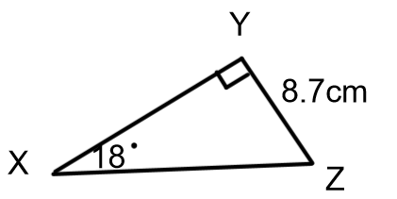

Label the sides

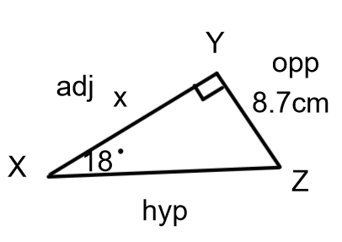
The opposite side is known and the adjacent side is the unknown. The ratio with opp and adj is tangent.

tan 18° = $\frac{8.7}{x}$
x tan 18°= 8.7
$\frac{x tan18}{\tan{18}}$ = $\frac{8.7}{\tan{18}}$
x = 26.8 cm

TRY THESE :
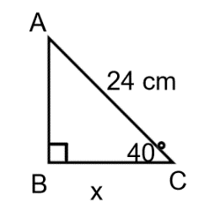
Find the indicated side

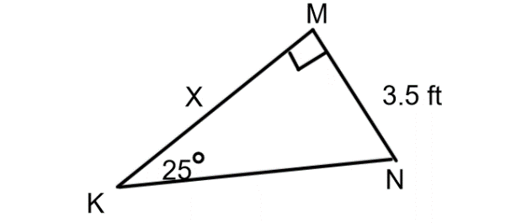

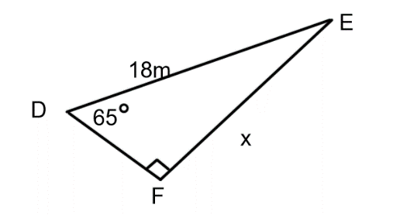

ANSWERS:
(1) 18.4 cm
(2) 7.5 ft
(3) 16.3 m
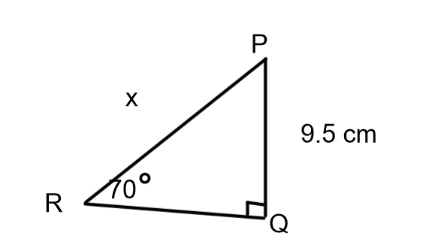
(4) 10.1 cm

WORD PROBLEMS:

Ex 5:
From a radar station, the angle of an approaching airplane is 36°. The horizontal distance between the plane and the radar station is 41.5 km. How far is the plane from the radar station to the nearest tenth of a km?

Answer:
Draw and label a diagram
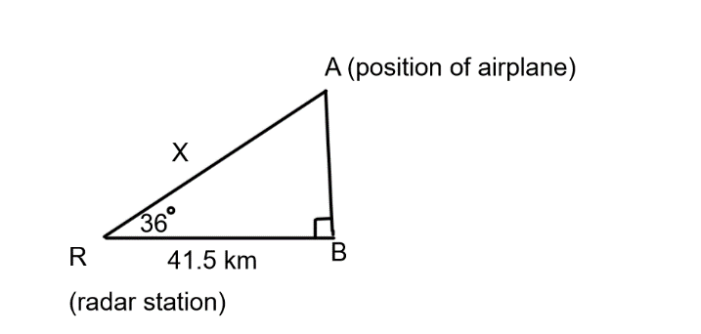

Determine which trig ratio to use

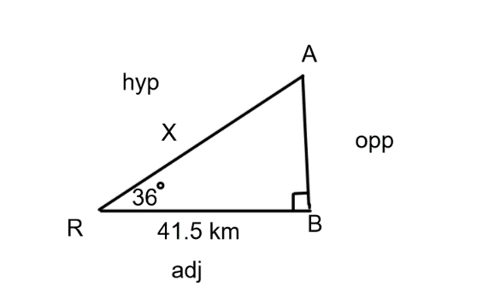
The known side is the adjacent side and the hypotenuse is the side that needs to be found so the cosine ratio should be used.

cos 36° = $\frac{41.5}{x}$
x cos 36° = 41.5
$\frac{x\cos{36}}{\cos{36}}$ = $\frac{41.5}{\cos{36}}$
x = 51.3
The airplane is 51.3 km from the radar station.

Ex 6:
A hiker saw a moose on top of a cliff. The hiker was 10.2m from the base of the cliff. The angle between the ground and the line of sight to the moose was 70°. How tall was the cliff?

Draw a diagram and label

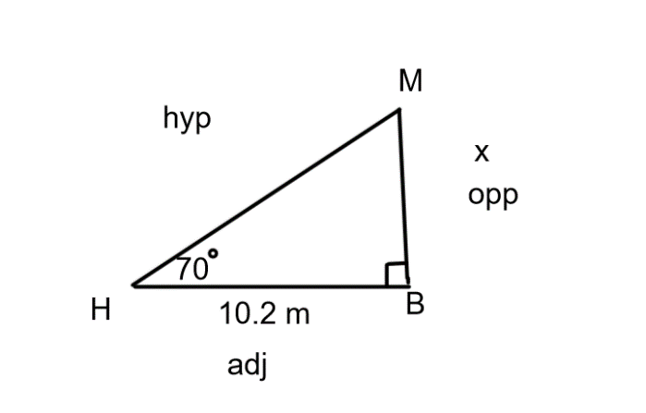
The opposite side is unknown and the adjacent side is known so tangent ratio will be used.

tan 70°= x
10.2
10.2 x tan 70° = x
28.0 = x
The cliff is 28 m tall.

Practice Questions:
From Foundations & Pre-Calculus Mathematics 10 (orange book from last term) do p.82-83#3 to 14 and p.101-102 #3 to 12

This link for this book can be found on my teacher page.

