Lesson 9
RF3 Demonstrate an understanding of slope with respect to rise and run, line segments and lines, rate of change, parallel lines, perpendicular lines.

Parallel Lines
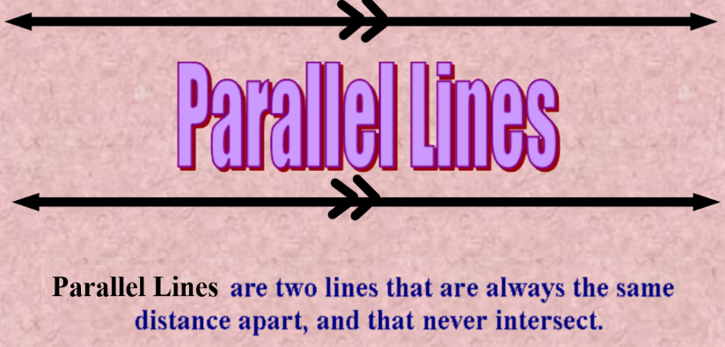

If two lines are parallel (symbol ǁ ) they have the same slope.
To prove ( or disprove) that two lines are parallel, find the slopes of the lines. If the slopes are equal then the lines are parallel.

Example 1:

Is AB parallel to BC?
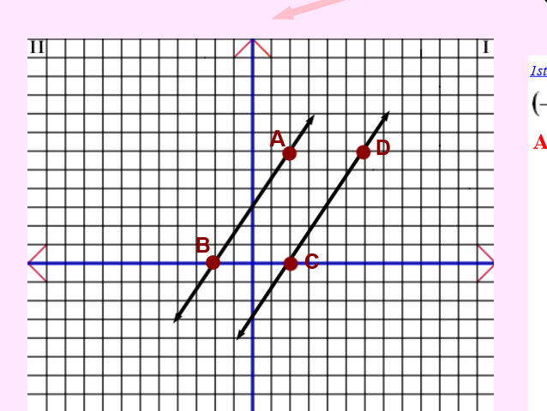

Find the slopes
m_{AB} = $\frac{rise}{run}$ m_{CD} = $\frac{rise}{run}$
= $\frac{6}{4}$ = $\frac{6}{4}$
= $\frac{3}{2}$ = $\frac{3}{2}$

The slopes are equal so AB ǁ CD

Example 2:
Line GH passes through G( -4,2) and H(2,-1). Like JK passes through J(-1,7) and K(7,3). Line MN passes through M(-4,5) and N(5,1). Are the lines parallel? Justify the answer.
If the lines are parallel then the slopes of the lines are equal. Find the slopes.

Slope Formula: Slope = $\frac{y2-y1}{x2-x1}$

m_{GH} = $\frac{-1-2}{2-(-4)}$ m_{JK}= $\frac{3-7}{7-(-1)}$ m_{MN}= $\frac{1-5}{5-(-4)}$
= $\frac{-3}{6}$ = $\frac{-4}{8}$ = $\frac{-4}{9}$
= $\frac{-1}{2}$ = $\frac{-1}{2}$

The slope of GH and JK are equal so GH ǁ JK.

Perpendicular Lines
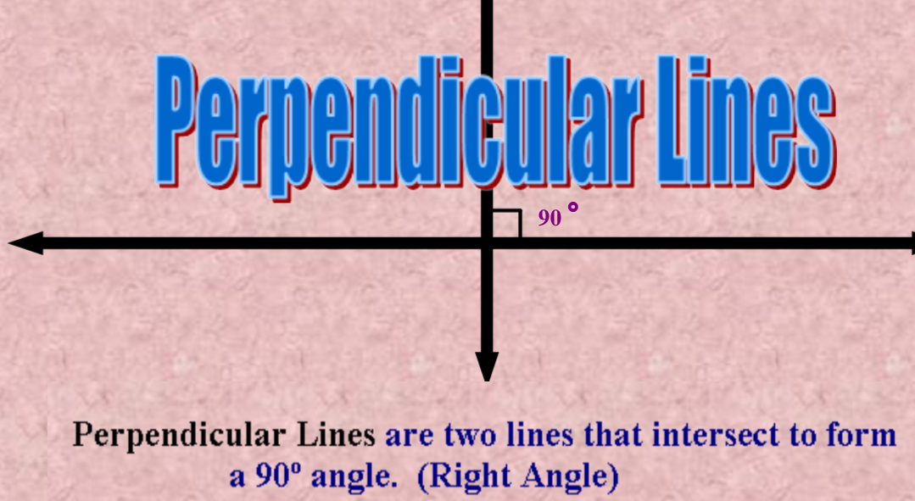

The slopes of two oblique perpendicular lines are negative reciprocals; that is a line with a slope of a, a ≠ 0, is perpendicular to a line with a slope of $\frac{-1}{a}$.

Example: Is AB perpendicular (ꓕ) to CD?

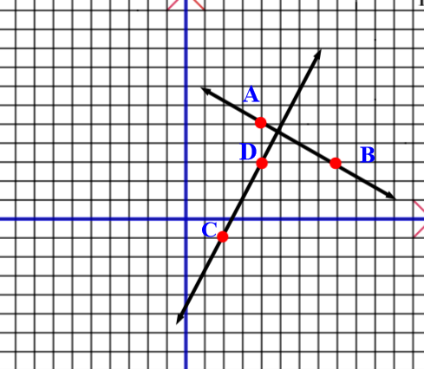

m_{AB} = $\frac{-2}{4}$ m_{CD} = $\frac{4}{2}$
= $\frac{-1}{2}$ = $\frac{2}{1}$

For the fraction $\frac{-1}{2}$ the reciprocal would be $\frac{2}{-1}$. To take the negative of the fraction - ($\frac{2}{-1}$) = ($\frac{2}{1}$). His is the slope of CD
Therefore AB ꓕ CD.

Example 3:
Line PQ passes through P(-7,2) and Q(-2,10). Line RS passes through R(-3,-4) and S(5,1). Are the lines parallel, perpendicular or neither? Justify your answer.

Answer:
m_{PQ} = $\frac{y2-y1}{x2-x1}$ m_{RS} = $\frac{y2-y1}{x2-x1}$
= $\frac{10-2}{-2-(-7)}$ = $\frac{1-(-4)}{5-(-3)}$
= $\frac{8}{5}$ = $\frac{5}{8}$
These lines are neither parallel or perpendicular.

TRY THIS
Line ST passes through S(-2,7) and T(2,-5). Line UV passes through U(-2,3) and V(7,6). Are the two lines parallel, perpendicular or neither? Justify your answer.

(Answer: The lines are perpendicular)

Example 4:
Determine the slope of the line that is perpendicular to the line through E(2,3) and F(-4,-1)

Answer:
m_{EF} = $\frac{-1-3}{-4-2}$
= $\frac{-4}{-6}$
= $\frac{2}{3}$
The negative reciprocal of $\frac{2}{3}$ is $\frac{-3}{2}$.
The slope of the line perpendicular to EF is $\frac{-3}{2}$.

Example 5:
Is quadrilateral ABCD a rectangle? Justify your answer.

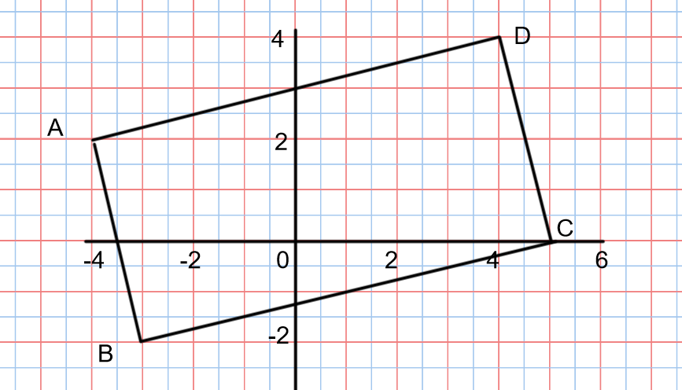

A quadrilateral is a rectangle if the opposite sides are parallel and the adjacent sides are perpendicular, To prove or disprove ABCD being a rectangle the slopes of the sides must be found.

m_{AB} = $\frac{-4}{1}$ m_{CD} = $\frac{-4}{1}$
m_{AD} = $\frac{2}{8}$ m_{BC} = $\frac{2}{8}$
= $\frac{1}{4}$ = $\frac{1}{4}$
The opposite sides of ABCD have equal slopes and the adjacent sides have slopes that are negative reciprocals so ABCD is a rectangle.

Practice Questions from the textbook p.349-350 #3 to 6, 8 to 17

