Home Learning 2020
Grade 7
Math #6

Here we are again, Math Word Problem time!! Remember, do what you can and DON’T STRESS OVER IT! These are only opportunities/suggestions for you to work on while we are away from our regular Math class. There is no formal assessment, but I am always available (phone, email, video) for help and guidance.

Again, this week I put together some Math Word Problems from all different stages of the grade 6 & 7 curriculum. I have them broken down by curriculum strand and have hints in italics after each question. DO NOT THINK YOU HAVE TO DO ALL OF THESE! I wanted to have a variety of questions available for the various levels we are all at in our Math learning. So, I repeat, YOU DO NOT HAVE TO DO EVERY QUESTION…unless you want to. I have also included an answer sheet and answer key for these problems so that you can keep track of your questions and check your answers. Feel free to send me a snap shot or email of your answers.

Remember to follow CUBES and read each question carefully!

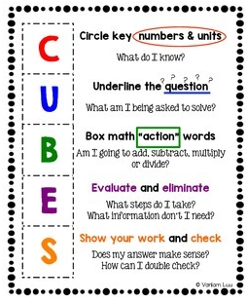

Remember, contact me at ANYTIME and do what YOU can do at YOUR own pace. Continue with the Waterloo site for Statistics & Probablity, DreamBox, Brain Genie and give some of those word problems a T-R-Y!

Have a great week! Miss seeing your faces!

Mrs. Foran, Mrs. Silliker & Mrs. Russell

Elaine.foran@nbed.nb.ca

