Home Learning 2020
Grade 7
Math #5

Wow! It’s May already! I hope you are taking advantage of some of these Home Learning Opportunities to help sharpen and solidify your awesome Math skills.

The next progression we will look at together will be “Statistics and Probability”. This one can be pretty fun and hands on if you want it to be! The courseware below covers all applicable outcomes from the Grade 7 curriculum and reviews a lot from previous years. I have also included a few additional resources you can use to help along the way and for extra practice. Remember you can always fire me off an email and I will help you through it the best way I can! (email/phone/video/pictures/miming)

Follow this link: https://courseware.cemc.uwaterloo.ca/27 , (University of Waterloo – Grade 7 & 8 Mathematics). On the left-hand side there will be three different units. We will look at certain lessons in each of these. They should be completed in this order: Unit – Data Collection and Graphs – lessons 1-5
Data Analysis – lessons 1 and 4 only
Probability – lessons 1 – 8

These lessons start with the basics, give a good background overview and then move into the different strategies and experiments. Complete the lesson videos, exercises and practice questions at your own pace and please reach out if you would like more clarification on something. This site works best if used on the Google Chrome web browser.

Go at your OWN PACE and don’t rush or become overwhelmed. Some of this will be a review from Grade 6 and some of it may be new. If you need dice or cards to do an experiment, you can always go online and find an interactive deck, spinner or die. Try these links for some interactive manipulatives:
- https://toytheater.com/category/teacher-tools/virtual-manipulatives/
- https://www.didax.com/math/virtual-manipulatives.html
- https://deck.of.cards/

Remember, if you get stuck or have no idea how to answer a question, drop me a line and I will do everything I can to help you through it.

Here are some additional resources that you may use for Statistics and Probability:

- Braingenie – there is a progression already set up for more practice with these.

- Previous “Word Problems” have a whole section for Statistics & Probability. Give them a shot!

- http://www.learnalberta.ca/content/mesg/html/math6web/index.html?page=lessons&lesson=m6lessonshell19.swf

- http://www.learnalberta.ca/content/mesg/html/math6web/index.html?page=lessons&lesson=m6lessonshell10.swf

- https://www.khanacademy.org/math/cc-seventh-grade-math/cc-7th-probability-statistics

- Continue using DreamBox

You are also encouraged to send some of your work to us for feedback. I would love to see how you are making out with everything. Take a picture of your work and send it! I would gladly look it over and offer some feedback.

I hope you are all doing well and that you are looking after each other.
Take care and remember to keep those paws washed!!
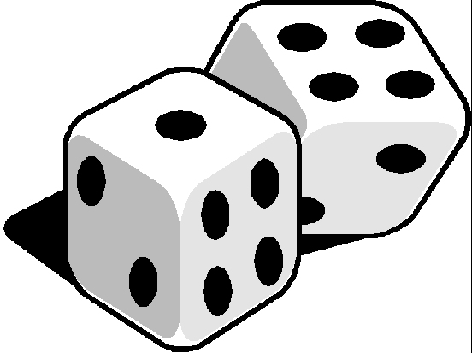
Mrs Foran

Elaine.foran@nbed.nb.ca

