Using Scale Diagrams

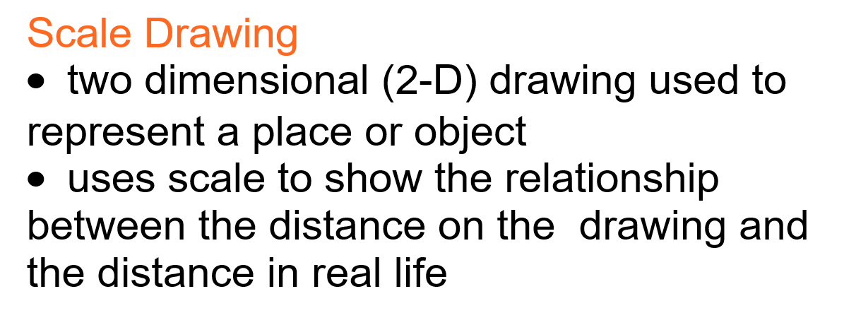

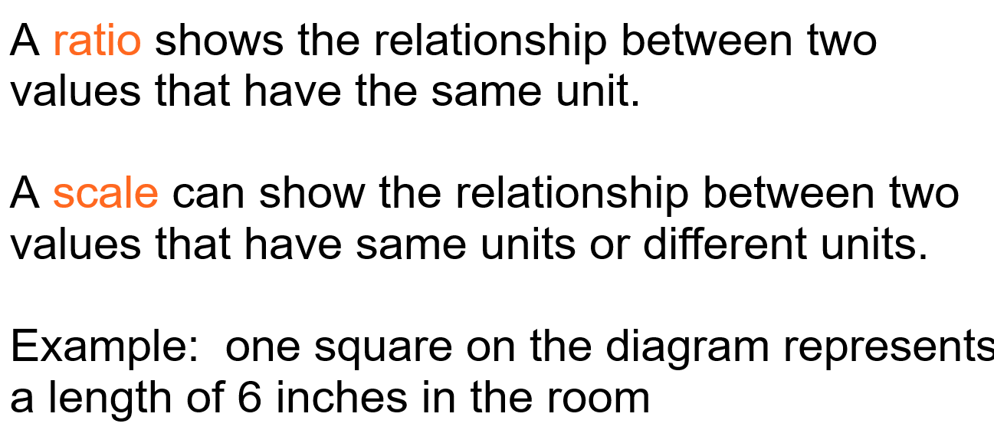

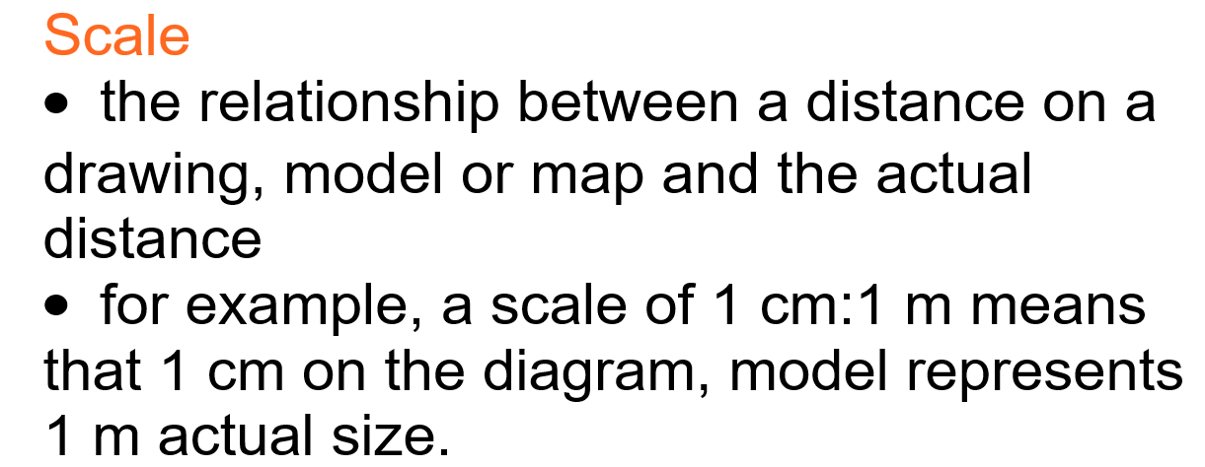
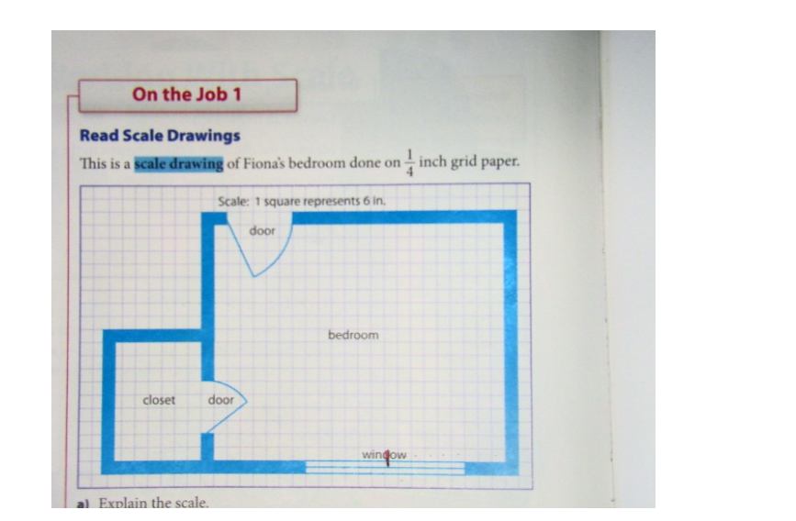
Example: p.62 in textbook
- Explain the scale.
One side of one square on the diagram represents a length of 6 inches in the room.
Since 1 foot = 12 inches, two squares on the diagram represent 1 foot.

- Convert the scale on the diagram to a 1 to ___ ratio.

$\frac{1}{4}$” represent 6”
$\frac{1}{4}$ x 4 = 1 so 6 x 4 = 24
Scale 1” represents 24”
Ratio 1:24
- What are the dimensions of Fiona’s room, in feet?
Length of the room = 22 squares
1 square = 6 inches = 0.5 ft
22 x 0.5 = 11 ft

Width of the room is 18 squares
18 x 0.5 = 9ft
The room is 11ft x 9ft

- How wide are the doors, in inches?
Closet door is 4 squares wide
4 x 6 = 24”
Bedroom door is 5 squares wide
5 x 6 = 30”
- How deep is the closet? Give the answer in feet and inches.
Depth of the closet is 6 ½ squares.
6 ½ x 6 = 39 inches
39 ÷ 12 = 3.25 ft
.25 ft = .25 x 12 = 3 inches
The closet is 3’3” deep.

Determining Missing Dimensions
To avoid clutter, many scale diagrams include a minimum amount of information. Use the measurements given to determine any missing dimensions.

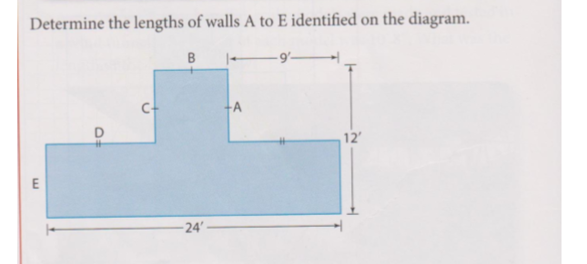

D is the same size as the wall with 2 hash marks on it. D = 9’
B = 24’ – 9’-9’ = 6’
A & C are the same size as B, so A=6’ and C=6’
E= 12 – 6 = 6’

TRY THESE:
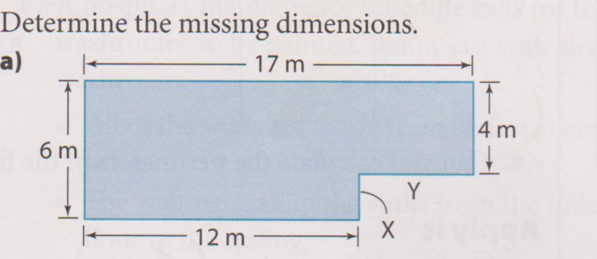
(1)

(2)
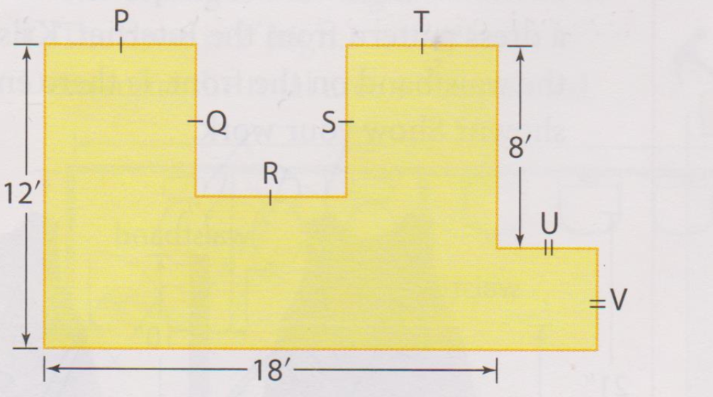

Answers:
- X = 2m Y= 5m
- V = 4’ U= 4’ P=Q=R=S=T = 6’

Extra Practice Questions from Textbook
p. 64-65 #1 to 5 & #7
p. 68-69 #1 to 7

