Simple Interest
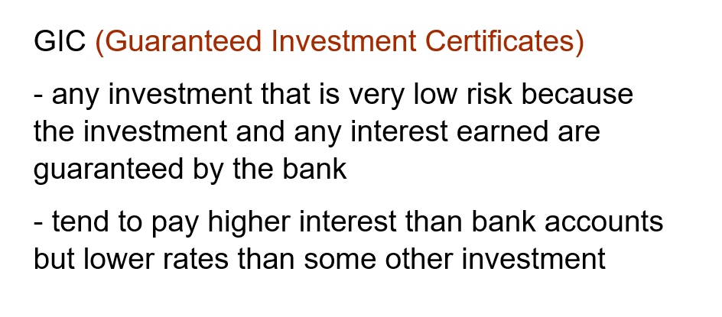

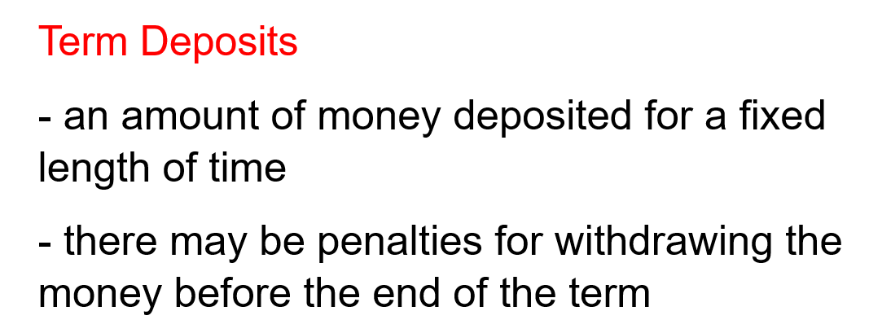

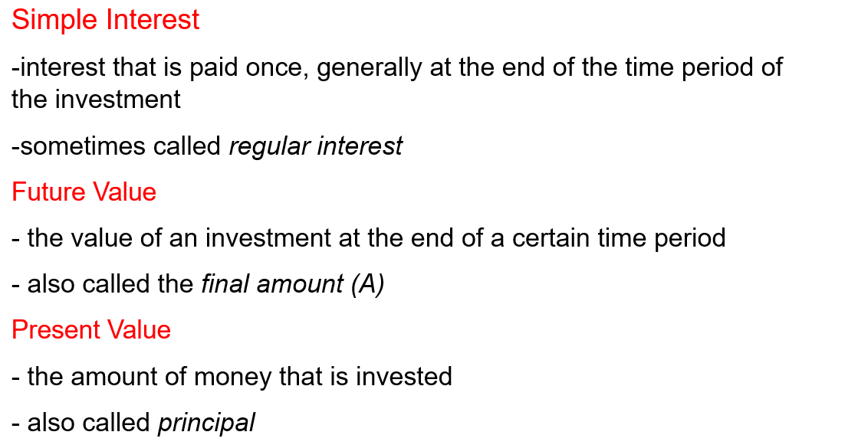

The formulas for calculating Simple Interest and Future Value are:

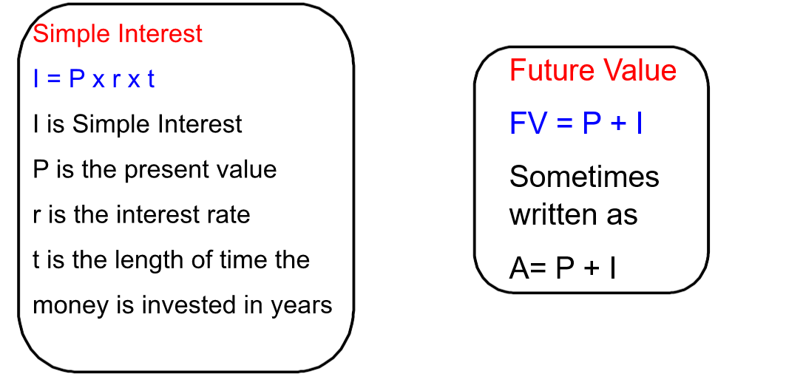
Examples:

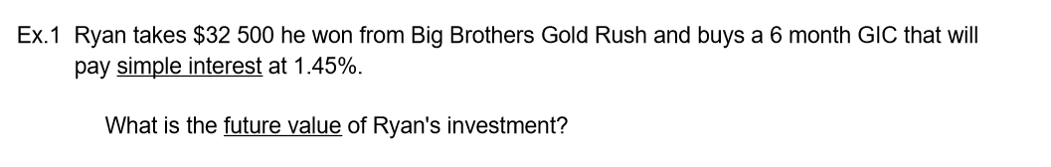

Answer
I = P x r x t
I = 32500 x 0.0145 x $\frac{6}{\begin{aligned}12 \\ \end{aligned}}$ **** Note: r must be a decimal and t must be in years****
I = 235.63

FV = 32500 + 235.63
=32 735.63
The future value of Ryan’s investment is $32 735.63.

Example 2: Cody borrows $300 from Chris to get his car fixed. He plans on paying Chris back on payday, which is 10 days from now. Chris charges Cody an interest rate of 35%/a on the loan.
- How much interest will Cody pay?
- What is the total amount Cody will pay Chris to clear the loan?

Answer:
(a) I = P x r x t
I = 300 x 0.35 x $\frac{10}{365}$
I = $2.88

(b) A = 300 + 2.88
A = 302.88
Cody will pay Chris $2.88 in interest. To repay the loan he must pay $302.88

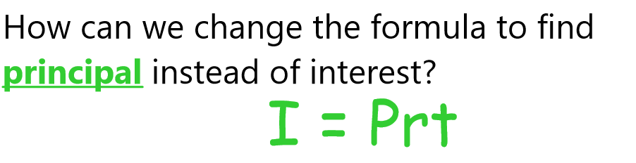

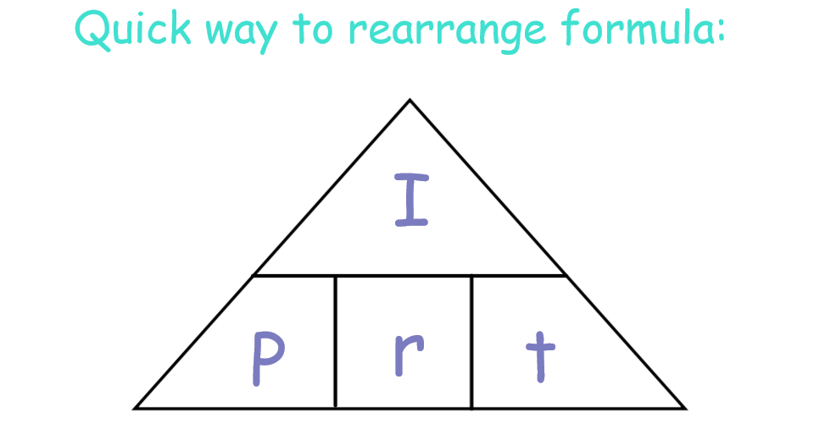

Ex 3:

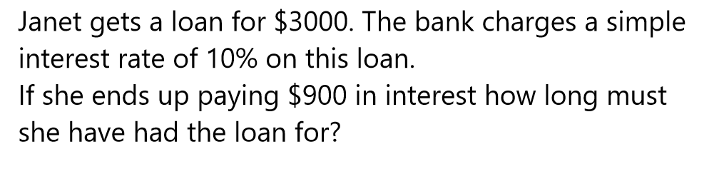
Answer:
P = 3000
r = 10% = 0.10
I = 900
t= ?

Rearranging the formula for t gives
t = $\frac{I}{Px r}$
t = $\frac{900}{\begin{aligned}3000x0.10 \\ \end{aligned}}$
t = $\frac{900}{300}$
t = 3

Janet had the loan for 3 years.

Ex 4:
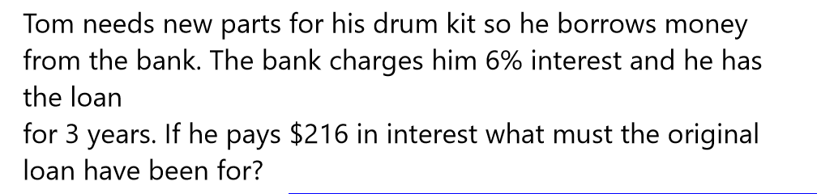

Answer:

I = 216
r= 6% = 0.06
t = 3
P = ?

P = $\frac{I}{r x t}$
P = $\frac{216}{0,06 x 3}$
P = $\frac{216}{\begin{aligned}0.18 \\ \end{aligned}}$
P = 1200
Tom’s loan was for $1200.

Extra Practice Questions from the book: p. 232-233 #1 to 8

