Lesson 7:
Goal: To solve problems involving temperature and mass, where measurements given are in Imperial and SI units.

Temperature Conversions
In Canada , where SI is used, temperature is measured using the Celsius scale.
In the US, where the Imperial Measurement System is used, temperature is measured using the Fahrenheit scale.
To convert from one Fahrenheit to Celsius we use the formula:
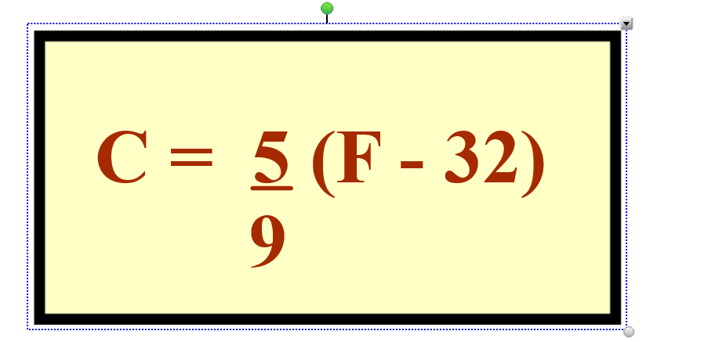

For example:

Convert 78°F to °C
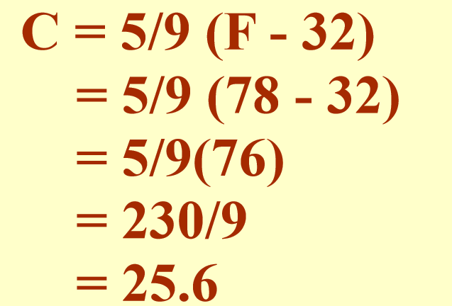

To convert from Celsius degrees to Fahrenheit degrees use the formula
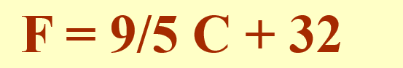

For example:

Convert 14°Celcius to degrees Fahrenheit
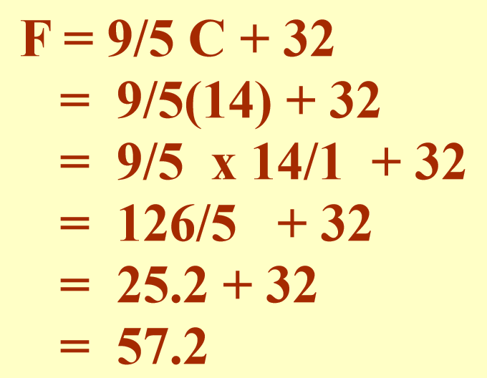

Try This:
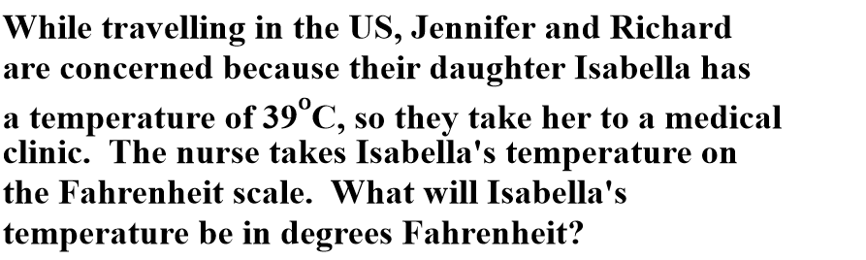

Answer:
F = $\frac{9}{5}$ C + 32
F = $\frac{9}{5}$ (39) + 32
F = 70.2 + 32
F = 102.2
Isabella’s temperature is 102.2°F

Extra Practice Questions from textbook p. 193-194 #1 to 5

Mass Conversions

Mass is the measure of the quantity of matter in an object.
Weight is the measure of the force of gravity on an object.
In the Imperial System there are three commonly used units of weight: the ounce, the pound and the ton. The pound is the basic unit of weight.
1 pound(lb) = 16 ounces (oz)
1 ton ( tn) = 2000 pounds(lb)
These and other conversions can be found on your conversions sheet.
Ex 1:
Stephen is building a rectangular water cisern to collect rainwater for his garden. The dimensions of the cistern are 10’8” by 8’4” by 4’6”. A cubic foot of water weighs 62lb8oz. If the cistern is completely filled with water, what will be the weight of the water expressed in tons.
Answer:
First calculate the volume of the cistern
10’8” = 10.67’
8’4” = 8.33’
4’6” = 4.5’
V = L x W X H
= 10.67 x 8.33 x 4.5
= 400 ft³
Next find the mass of the water in pounds
62 lb 8 oz = 62 $\frac{8}{16}$ lb = 62.5 lb
Mass = 62.5lb/ft³ x 400ft³ = 25 000lb
Then convert to tons
Mass = 25000 ÷ 2000 = 12.5
The cistern contains 12.5 tn when it is full.

Example 2:
A bale of hay weighs on average about 80lb. There are 500 bales of hay to be picked up in a large field. A truck can carry 8 tons in one trip. How many trips will the truck have to make to get all the hay?
Answer:
Mass of hay in pounds = 80 x 500 = 40 000 lb
Mass in tons = 40 000 ÷ 2000= 20 tons
Number of trips = 20 ÷ 8 = 2.5
The truck will have to make 3 trips.

In the SI measurement system, kilograms, grams and tonnes are used as measurements of mass.

***NOTE***
Tonne (t) = 1000 kg
This is not the same as the Ton (tn)
They are pronounced the same way but have different meaning and are different sizes.

Ex 3:
Barbara is catering a dinner for 20 people. She consults a recipe book that tells her she will need $\frac{3}{4}$ lb of beef for each person. Beef is on sale this week for $6.25/kg. How much will it cost Barbara for beef for her guests?

Answer:
$\frac{3}{4}$ x 20 = 15 lb
Convert to kg
15 ÷ 2.2 = 6.82 kg
Cost = 6.82 x 6.25 = 42.63
It will cost Barbara $42.63 to buy beef for her guests.

Extra Practice Questions from the textbook :
P201-203 #1-5
P 209-210 #3 to 7
P215-216 #1 to 7

