WORD PROBLEMS
Grade 7 – Week #6

The Number System – Skill Practice and Problem Solving
- A submarine is 50 metres below sea level. It goes up 15 metres, then goes down 40 metres. What is the submarines new position relative to sea level? (Integers) | - North West Middle School is holding a fundraiser. The 6th graders have raised 63% of their goal. The 7th and 8th graders have raised 0.61 and $\frac{2}{3}$ of their goal amounts, respectively. List the classes in order, by percent from least to greatest of their goal amounts. (Comparing fractions-decimal-percent)
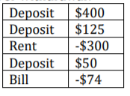  - The table shows amounts of money that Kallie deposited and withdrew from her bank account. What is the overall amount of deposit or withdrawal? (Integers) | - Sandy has $143 in the bank. She withdraws $40. Then she deposits $92. Write an addition expression to represent the situation. Then find the sum.
- The screen on Cade’s old phone is 3.15 cm long. What mixed number represents the length of the phone screen? (Decimal = Fraction) | - A hiker descends from a mountain peak. If the hiker descends at a rate of 700 feet every half hour, what is the hiker’s elevation relative to the peak after 3 hours?  (2 step - Multiplication)
- Solve:  5$\frac{1}{6}$ - 1$\frac{1}{3}$ | 8. The lowest temperature ever recorded is -89˚C. The highest temperature is 56.7˚C. What is the difference between the highest and lowest recorded temperatures? (Integers)
WORD PROBLEMS
Grade 7 – Week #6

Ratios & Proportional Relationships – Skill Practice and Problem Solving
- Andy went to get a haircut that cost $40. He wanted to tip the hair stylist 20% and tax is 6.25%. How much did he spend in total for the haircut?  Step 1 – tip on cost before tax  Step 2 – Tax on cost of haircut  Step 3 – Add cost, tip & tax | - At 3:30pm, the water level in a pool is 14 inches. At 4:00pm, the water level is 20 inches. At 5:00pm, the water level is 32 inches. What is the constant rate of change? (How much change each hour?)
- Blake burns 4.5 calories in 2/3 of a minute riding his bike. What is Blake’s unit rate per minute?  Step 1 – find out how many seconds 2/3 of a minute is  Step 2 – find ratio for 10 seconds  Step 3 – find ratio for 60 seconds | - Timmy can buy 2 pounds of bananas for $7. How much does 1 pound cost? (Unit Rate)
- A skydiver is falling at a rate at about 142 feet per second. How many feet per minute is she falling? (60 seconds in a minute) | - The price to download a digital book is $6.00 and the sales tax is 5%. What is the total cost to download a book plus tax?  (Tax is added on to the price)
- The regular price for a sweater is $48. The store is having a buy one get one ½ off sale. If you buy 2 sweaters for that deal, what is the final price after 15% tax?  Step 1 – find price for both sweaters with BOGO  Step 2 – add the tax to the price from Step 1 | - The Murray family paid $312 for their family of 12 to get into the exhibition. How much was each ticket? (Unit Rate)
WORD PROBLEMS
Grade 7 – Week #6

Expressions & Equations – Skill Practice and Problem Solving
- Simplify  (Collect like terms)  6n – 13 – 4n + 6 | - The expressions in the figure below represent the side lengths of the rectangle in feet. What is the simplified expression for the perimeter of this rectangle? (Collect like terms/Perimeter is the distance around)  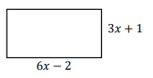
- Grace orders 3 chili hot dogs and a large bowl of cheese fries from a food truck. All taxes have been added into the prices. The cheese fries cost $5.50. The total cost of the food is $16. What is the price of one chili hot dog? (d=cost of one chili dog) | - Solve (Distributive Property)  Step 1 – Multiply everything in bracket by 5  Step 2 – Solve for t  5(t – 1.25) = 8.75
- Max needs $115 for a new cell phone. He has already saved $45. He earns $7 an hour at his job. Write and solve an equation to find how many hours he needs to work to buy the phone. (h =# of hours worked) | - Peter stacks some photo albums in a storage crate that weighs 5 pounds. Each album weigh 1 $\frac{3}{8}$ pounds. The total weight of the crate with all the albums in it is 60 pounds. Write and solve an equation to find n, the number of photo albums in the crate. (The weight of the crate plus the weight of the albums is 60) *Fractions can be decimals too*
- Steven receives a $70 gift card to use at a clothing store. He buys a pair of jeans for $36 and 8 pairs of socks! He does not use the entire amount of the gift card. Write and solve an inequality to find s, the price of each pair of socks. (Inequalities do not use = ; they use < >instead because answers may vary) | - Solve the inequality  9r + 3 < -15
WORD PROBLEMS
Grade 7 – Week #6

Statistics & Probability – Skill Practice and Problem Solving
- Cara buys a bag of 7 500 assorted beads. A random sample of 150 beads contains 17 gold beads. Predict the number of gold beads in the bag of assorted beads that Cara bought.  Step 1 – ratio  Step 2 – equivalent ratio | - A survey shows that 60% of students would select bumper cars rather than roller coasters as their favourite ride at the exhibition. Out of 4 000 students, predict how many students would select roller coasters as their favourite ride. (Percent)
- Ten cards numbered 1 through 10 are mixed together and then one card is drawn. Find the probability of pulling a number greater than 7. | - A box contains 10 red pens and 10 black pens. Is it more likely that you will pick a red pen or a black pen out of the box?
- Find the mean (average), median (middle) and mode (repeat) of following heights of students:  181.5, 126.8, 141.7, 151.2, 140.9, 126.3, 139.4, 137.4, 122.9  (Remember to put in order!) | - Alicia flips a coin 60 times. How many times would you expect it to land heads up?
- A spinner is divided into 6 equal sections as shown. Find the probability of the arrow stopping on number 2.  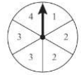 | - The results of a survey are shown in the table. Based on this data, how many of the 600 students at the school would choose baseball? (Equivalent Fraction)  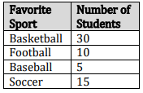
WORD PROBLEMS
Grade 7 – Week # 6

Geometry – Skill Practice and Problem Solving
- Write and solve an equation to find the value of x. (Angles in a triangle = 180˚)  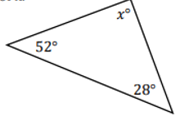 | - Write and solve an equation to find the value of x. (Straight angle = 180˚)  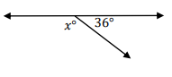
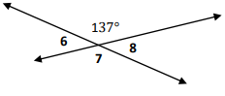  - Find the measurements of the numbered angles. (Opposite angles are =) | - Container A is 13 inches by 19 inches by 25 inches. Container B is 13 inches by 13 inches by 31 inches. In cubic inches, how much greater is volume of Container A? (V= l x w x h)
- Holly runs 3.5 laps around the circular track in the gym. The track has a diameter of 0.5 of a mile. About how far does Holly run? ( C=πd) (Find 1 lap distance and then the rest) | - Find the circumference (C=πd) and area (A=πr²) of the circle below.  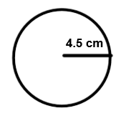
- Find the value of x  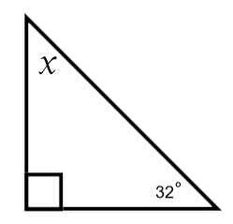 | - Find the volume of the right rectangular prism below. (V = l x w x h )  2  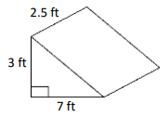
Word Problems Week #6 – Student Answer Sheet

No. | The Number System | Ratios & Propotional Relationships | Expressions & Equations | Statistics & Probability | Geometry
1
2
3
4
5
6
7
8

