PSSC Meeting Agenda
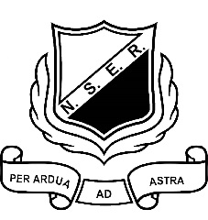
North & South Esk Regional
Feb. 11th, 2019

- Call to order
- Welcome new members
- Adoption of Agenda
- Minutes from October 22nd meeting
- New Business
  - Declaration of office
  - Terms of Office
    - April Tozer – 3rd year
    - Starlene Matchett – 3rd year
    - Tammy Scott – 1st year
    - Bertha Taylor – 2nd year
    - Tara Sherrard – 2nd year - Declaration
  - NSER Staffing
  - Policy 711 Update.
  - School Mission and Vision
  - Student Perception Surveys CARR
  - Positive Learning and Working Environment Plan
  - Principal Report
  - Sports and Clubs
  - School Projects
- Other Items:
______________________________________________________________________________________________________________________

- Next Meeting Date?
- Adjournment

NSER Mission: It is the mission of NSER to support and challenge students to meet and exceed their potential.

NSER Vision: NSER's number one priority is the intellectual development of its students while giving priority to social, emotional and physical development.

NSER Values: The intellectual, emotional, physical, and social needs of each child will be developed to his or her fullest potential. Expectations for students will be age appropriate and pedagogically based. A spirit of cooperation will be fostered among students, staff, and community. All students and staff will show respect for students, staff and the campus. All students will be encouraged and given the opportunity to participate in extra and co-curricular activities. A high moral standard will be exemplified by the staff, and expected of our students

